**EXPERIMENT - 1**

**INTRODUCTION TO COMPUTER HARDWARES**

Computer hardware refers to the physical/tangible components that a computer system requires to function. It integrates all the input, output and functional devices with a circuit board that operates within a PC or laptop; including the motherboard, graphics card, CPU (Central Processing Unit), ventilation fans, webcam, power supply, and so on.

The design and size of computers may differ when compared between laptops and desktops but even so, all the core components remain the same in both.Without hardware, there would be no way of running the essential software that makes computers so useful. Software is defined as the virtual programs that run on your computer; that is, operating system, internet browser, word-processing documents, etc.

**IMPORTANT HARDWARE COMPONENTS**

**MOTHERBOARD**

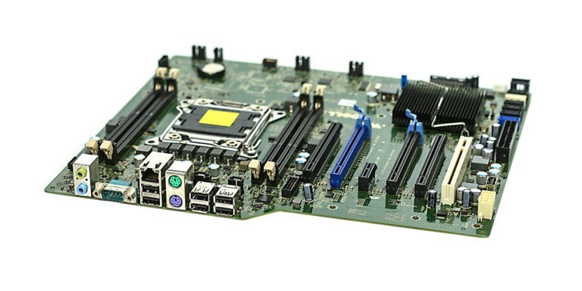

A motherboard is the main printed circuit board(PCB) in general-purpose computers and other expandable systems. It also known as mainboard, main circuit board, system board, baseboard, planar board, logic board,and in short mobo. It holds and allows communication between many of the crucial electronic components of a system, such as the central processing unit (CPU) and memory, and provides connectors for other peripherals. A motherboard usually contains significant sub-systems, such as the central processor, the chipset's input/output

and memory controllers, interface connectors, and other components integrated for general use. Motherboard means specifically a PCB with expansion capabilities. As the name suggests, this board is often referred to as the "mother" of all components attached to it.

**CENTRAL PROCESSING UNIT & PROCESSOR (CPU)**

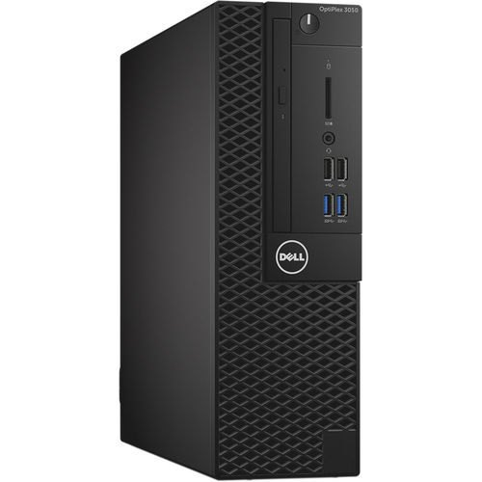 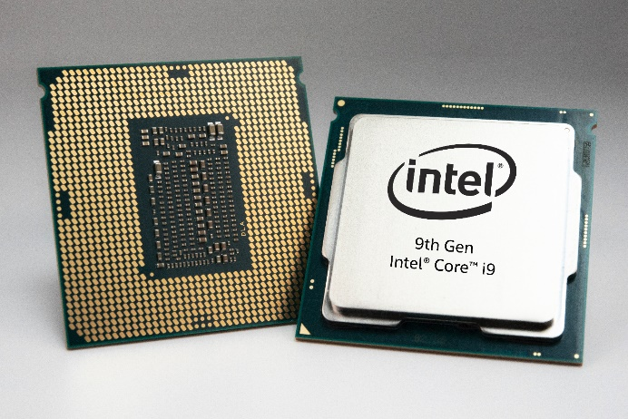

The computer's central processing unit (CPU) is the portion of a computer that retrieves and executes instructions. The CPU is essentially the brain of a CAD system. It consists of an arithmetic and logic unit (ALU), a control unit, and various registers. The CPU is often simply referred to as the processor. The ALU performs arithematic operations , logic operations, and related operations, according to the program instructions.

The control unit controls all CPU operations, including ALU operations, the movement of data within the CPU, and the exchange of data and control signals across external interfaces (system bus). Registers are high-speed internal memory-storage units within the CPU.

The CPU Chip or Processor is responsible for processing all information from programs run by your computer. The ‘clock speed’, or the speed at which the processor processes information, is measured in gigahertz (GHz). This means that a processor advertising a high GHz rating will likely perform faster than a similarly specified processor of the same brand and age.

**RANDOM ACCESS MEMORY (RAM)**

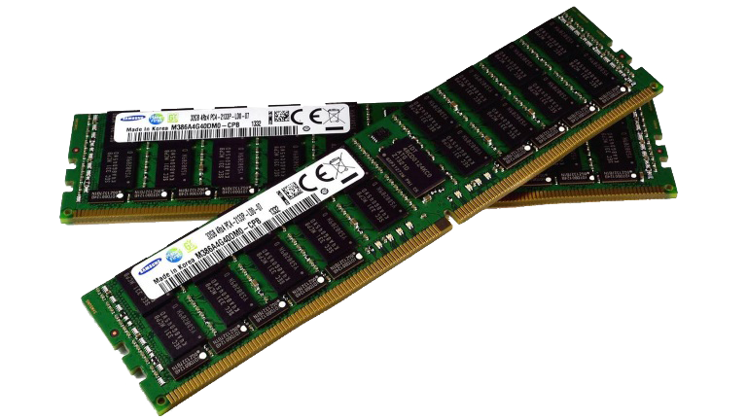

Random Access Memory, or RAM, is hardware found in the memory slots of the motherboard. The role of RAM is to temporarily store on-the-fly information created by programs and to do so in a way that makes this data immediately accessible. The tasks that require random memory could be; rendering images for graphic design, edited video or photographs, multi-tasking with multiple apps open (for example, running a game on one screen and chatting via Discord on the other).

**DAUGHTER CARD**

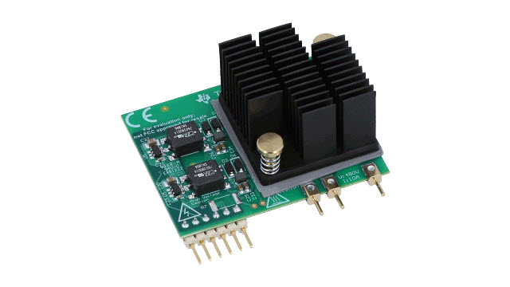

A daughterboard (or daughter board , daughter card , or daughtercard ) is a circuit board that plugs into and extends the circuitry of another circuit board. The other circuit board may be the computer's main board (its motherboard ) or it may be another board or card that is already in the computer, often a sound card.

The daughter board is a computer hardware. It is also known as the piggyback board, riser card, daughter board, daughtercard or daughter card. A daughter board is a printed circuit board which is connected to the motherboard or expansion card. As compared to the motherboard, it is smaller in size. A daughter board does not act as an expansion card. An expansion card adds extra new functions to the computer. But a daughter board that is connected to the motherboard adds or supports the main functions of the motherboard.

**BUS SLOTS**

Bus slot or expansion port, an expansion slot is a connection or port inside a computer or motherboard or riser cards . It provides an installation point for a hardware expansion card to be connected. For example, if you wanted to install a new video card in the computer, you'd purchase a video expansion card and install that card into the compatible expansion slot.

Commonly founded are

• AMR - Modem, sound card.

• CNR - Modem, network card, sound card.

• EISA - SCSI, network card, video card.

• ISA - Network card, sound card, video card.

• PCI - Network card, SCSI, sound card, video card.

• PCI Express - Video card, modem, sound card, network card.

• VESA - Video card.

**SMPS**

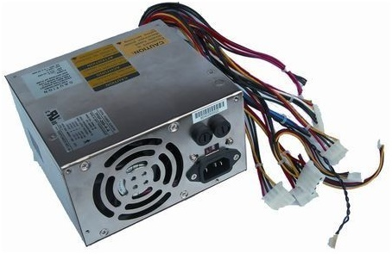

The working of SMPS is simply understood by knowing that the transistor used in LPS is used to control the voltage drop while the transistor in SMPS is used as a controlled switch.

The disadvantages of LPS such as lower efficiency, the need for large value of capacitors to reduce ripples and heavy and costly transformers etc. are overcome by the implementation of Switched Mode Power Supplies.

**READ-ONLY MEMORY (ROM)**

The ROM is also made of electronic microchips and is able to retain its content when power switches off. ROM is used for holding program instructions that can't be changed throughout the life of the computer because the content of ROM is impossible or very difficult to remove. For instance, ROM is used mainly for storing a boot program which is the instructions that the computer follows to perform self-diagnosis when it's switched on. This tells the computer how it will load the OS from secondary storage. ROM has different forms which include PROM (Programmable Read-Only Memory), EPROM (Erasable Programmable Read-Only Memory,) and EEPROM (Electrically Erasable Programmable Read-Only Memory).

**HARD DRIVE**

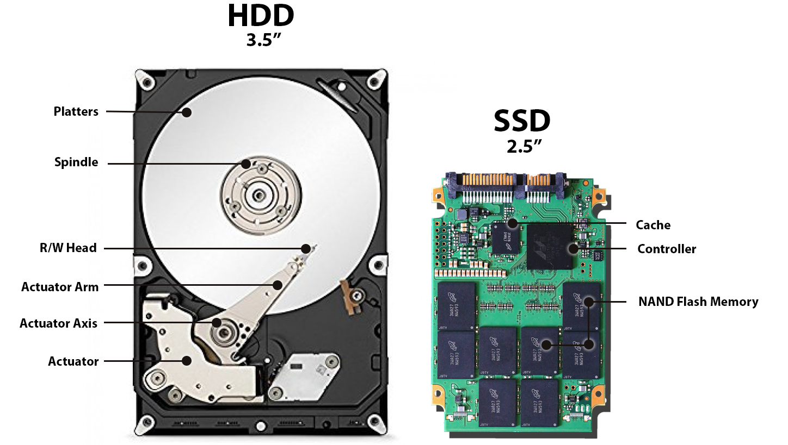

The hard drive is a storage device responsible for storing permanent and temporary data. This data comes in many different forms, but is essentially anything saved or installed to a computer: for example, computer programs, family photos, operating system, word-processing documents, and so on. Find out more about hard drives and how they work. There are two different types of storage devices: the traditional hard disk drive (HDD) and the newer solid state drives (SSD). Hard disk drives work by writing binary data onto spinning magnetic disks called platters that rotate at high speeds, while a solid-state drive stores data by using static flash memory chips. Find out more about computer storage and how solid state drives work.

**GRAPHICS PROCESSING UNIT (GPU)**

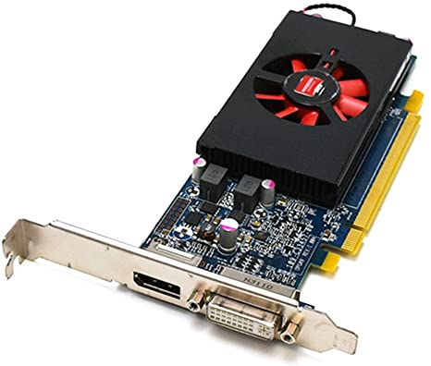

Especially important for 3D rendering, the GPU does exactly what its name suggests and processes huge batches of graphic data. You will find that your computer’s graphics card has at least one GPU. As opposed to the basic on-board graphic capabilities that PC motherboards supply, dedicated graphics cards interface with the motherboard via an expansion slot to work almost exclusively on graphic rendering. This also means you can upgrade your graphics card if you want to get a bit more performance from your PC, not only this, but modern GPUs fulfil a broad computational workload beyond just rendering, making them an extension to the central processing unit.broad computational workload beyond just rendering, making them an extension to the central processing unit.

**INTERFACING PORTS**

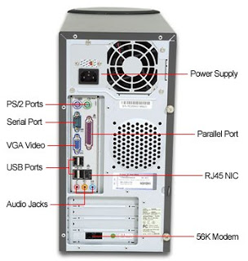

A connection point that acts as interface between the computer and external devices like mouse, printer, modem, etc. is called port. Ports are of two types −

**• Internal port** − It connects the motherboard to internal devices like hard disk drive, CD drive, internal modem, etc.

**• External port** − It connects the motherboard to external devices like modem, mouse, printer, flash drives, etc.

Some of them are given below

**SERIAL PORT**



Serial ports transmit data sequentially one bit at a time. So they need only one wire to transmit 8 bits. However it also makes them slower. Serial ports are usually 9-pin or 25-pin male connectors. They are also known as COM (communication) ports or RS323C ports.

**PARALLEL PORT**

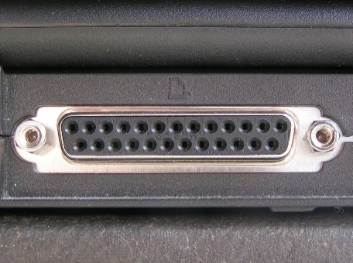

Parallel ports can send or receive 8 bits or 1 byte at a time. Parallel ports come in form of 25-pin female pins and are used to connect printer, scanner, external hard disk drive, etc.

**USB PORT**

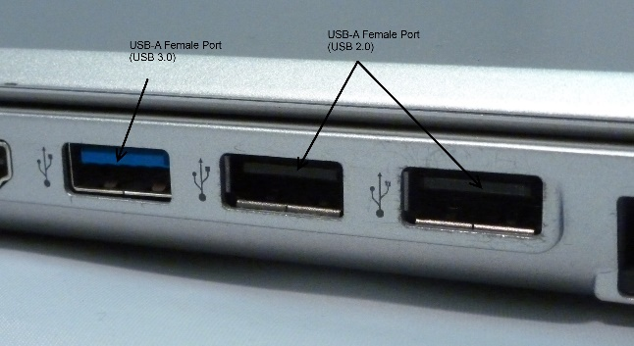

USB stands for Universal Serial Bus. It is the industry standard for short distance digital data connection. USB port is a standardized port to connect a variety of devices like printer, camera, keyboard, speaker, etc.

**PS/2 PORTS**

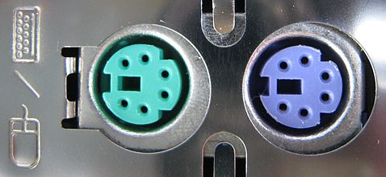

PS/2 stands for Personal System/2. It is a female 6-pin port standard that connects to the male mini-DIN cable. PS/2 was introduced by IBM to connect mouse and keyboard to personal computers. This port is now mostly obsolete, though some systems compatible with IBM may have this port.

**VGA PORT**

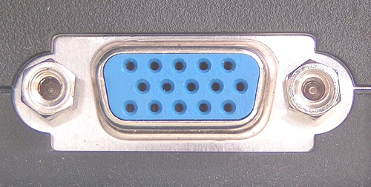

This port is commonly found in computers, projectors, and high definition TVs. It is a D-sub connector called DR-15 as it has 15 pins, which are arranged in 3 rows with five pins in each row. It was most often used to connect CPU with CRT monitors. Still, most of the LCD and LED monitors come with VGA ports. However, these ports don't assure high picture quality as VGA can carry only analogue video signals up to a resolution of 648X480.

As the demand and emphasis on video quality kept growing, the VGA ports were gradually replaced by more advanced ports that can assure high video quality such as HDMI and Display Ports.

**HDMI PORT**

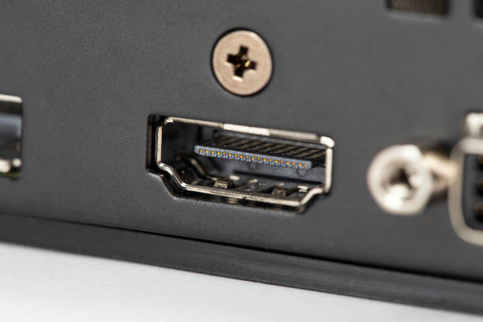

HDMI (High Definition Media Interface) is a digital interface developed to connect high definition devices such as digital cameras, gaming consoles, etc., to computers and TVs with HDMI ports. Besides this, it can carry uncompressed video and uncompressed or compressed audio signals. The advanced version of HDMI, such as 2.0, can transfer video signals of up to a resolution of 4096x2160.

**EXPERIMENT - 2**

**COMPUTER HARDWARE SPECIFICATIONS**

Computer hardware specifications are technical descriptions of the computer's components and capabilities.

* Processor speed, model and manufacturer. Processor speed is typically indicated in gigahertz (GHz). The higher the number, the faster the computer.
* Random Access Memory (RAM), This is typically indicated in gigabytes (GB). The more RAM in a computer the more it can do simultaneously.
* Hard disk (sometimes called ROM) space. This is typically indicated in gigabytes (GB) and refers generally to the amount of information (like documents, music and other data) your computer can hold.
* Other specifications might include network (ethernet or wi-fi) adapters or audio and video capabilities.

**EXPERIMENT-3**

**LINUX INSTALLATION USING VIRTUAL MACHINE ON WINDOWS 10**

**REQUIREMENTS**

• Good internet connection to download software and Linux ISO.

• Windows system with at least 12 GB of free space.

• Windows system with 4GB of RAM. (It can work with less RAM as well, but your system will start to lag while using Linux in the virtual machine.)

• Make sure to enable virtualization in the BIOS

**STEPS**

Step 1: Download and install VirtualBox

• Go to the website of Oracle VirtualBox and get the latest stable version from here:

https://www.virtualbox.org/wiki/Downloads

• Just double-click on the downloaded .exe file and follow the instructions on the screen.

• It is like installing any regular software on Windows.

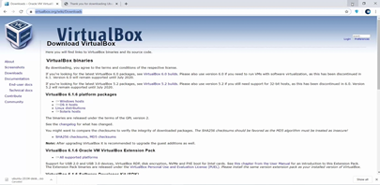

Step 2: Download the Linux ISO

• Next, you need to download the ISO file of the Linux distribution.

• You can get this image from the official website of the Linux distribution you are trying to use.

• I am using Ubuntu in this example, and you can download ISO images for Ubuntu from the link below:

Creating a VirtualBox VM:

In this section, steps are shown how to create a VirtualBox VM for installing Ubuntu 20.04 LTS.

• Open VirtualBox.

• Then, click on Machine > New…

• Now, type in a name for the VM, select Linux from the Type dropdown menu, and Ubuntu (64-bit) from the Version dropdown menu. Then, click on Next >.

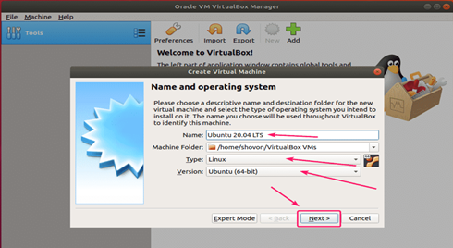

Now, you have to set the memory size for the VM.

• For Ubuntu Desktop 20.04 LTS, it should be at least 2048 MB (2 GB).

• For Ubuntu Server 20.04 LTS, it should be at least 512 MB.

• Once you’re done, click on Next >.

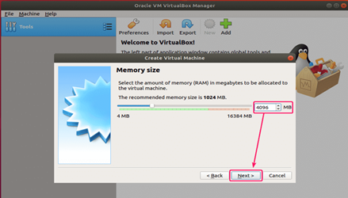

• Now, select Create a virtual hard disk now and click on Create . This serves as the hard disk of the virtual Linux system.

• It is where the virtual system will store its files.

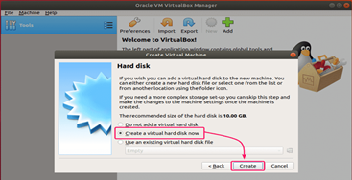

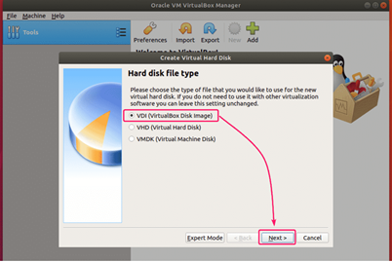

• select Dynamically allocated and click on Next >.

• You can choose either the “Dynamically allocated” or the “Fixed size” option for creating the virtual hard disk.

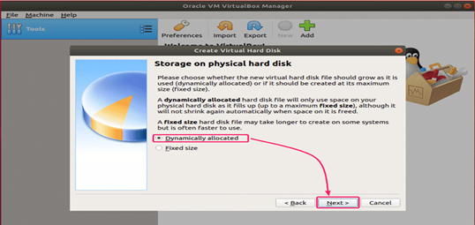

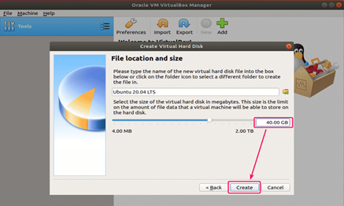

• set the virtual hard disk size for the VM.

• It should be at least 20.0 GB.

• Once you’re done, click on Create

Starting the VM:

Now, select the VM and click on Start.

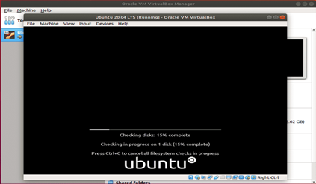

The VM should start and boot from the Ubuntu 20.04 LTS ISO image.

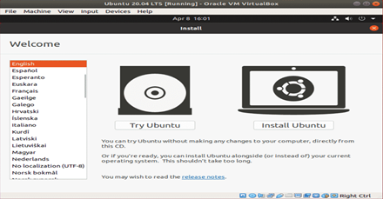

• From here, you can do a Normal installation or Minimal installation.

• Normal installation comes with all the apps as usual.

• Minimal installation comes with a limited number of apps. It saves a lot of disk spaces.

• If you have internet connection on your computer, you can check Download updates while installing Ubuntu to download all the necessary updates while installing Ubuntu on your computer.

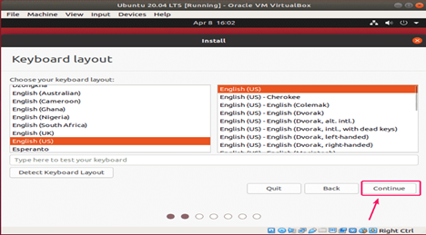

Once you’re done, click on Continue.

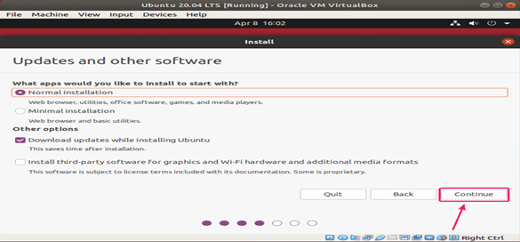

• As this is a VM, I won’t go through the trouble of manually partitioning the hard drive.

• Just select Erase disk and install Ubuntu and click on Install Now.

• The Ubuntu installer will automatically create all the necessary partitions in your virtual hard drive.

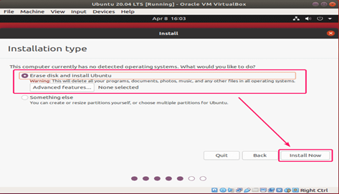

Try to choose a password that you can remember.

You can also reset the password in Ubuntu if you forget it.

After creating an account , you can start using Ubuntu**.**

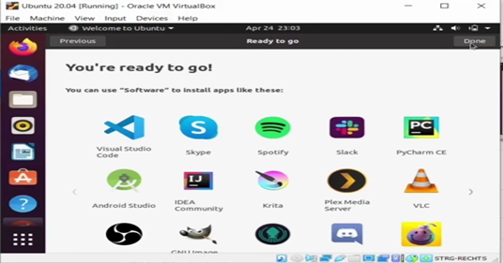

**EXPERIMENT-4**

**INSTALLATION OF WINDOWS ON VIRTUAL BOX IN UBUNTU**

**Step 1: Download Windows 10 ISO**

First and foremost, you need to download a Windows 10 ISO. You can download Windows 10 32-bit or 64-bit, depending on your system.

**Step 2: Install VirtualBox on Ubuntu**

Install VirtualBox on Ubuntu using the command sudo apt install virtualbox

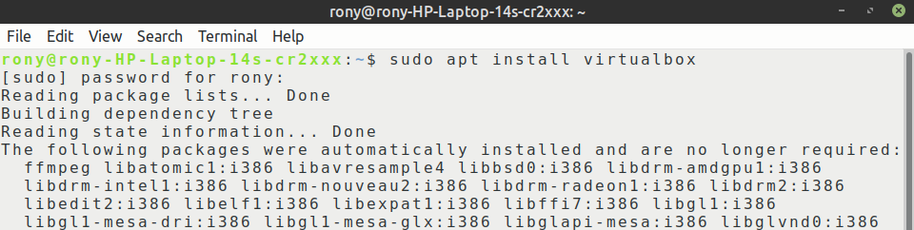

### Step 3: Install Windows 10 in VirtualBox

* Start VirtualBox. You should see a screen like the one below.

[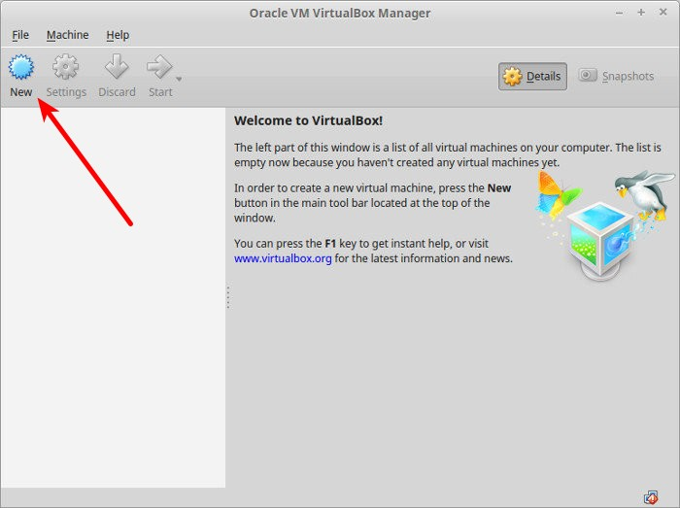](https://i0.wp.com/itsfoss.com/wp-content/uploads/2016/02/Vitualbox-Windows-Linux.jpeg?ssl=1)

* Click on new and name the VM anything you like. Also select the operating system and version. In this case I’ve chosen Windows 10 and 64-bit.

[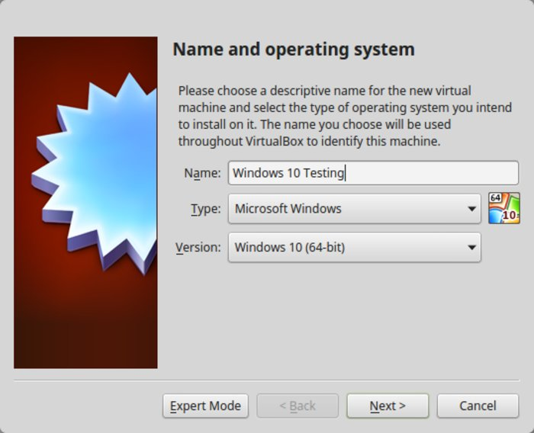](https://i0.wp.com/itsfoss.com/wp-content/uploads/2016/02/Screenshot_from_2016-02-15_232011.jpeg?ssl=1)

* Choose the RAM size. The recommended RAM size for 64-bit Windows 10 is 2 GB, while for 32-bit Windows 10 it’s 1 GB. But I suggest you have a little more than that for a smoother experience.

[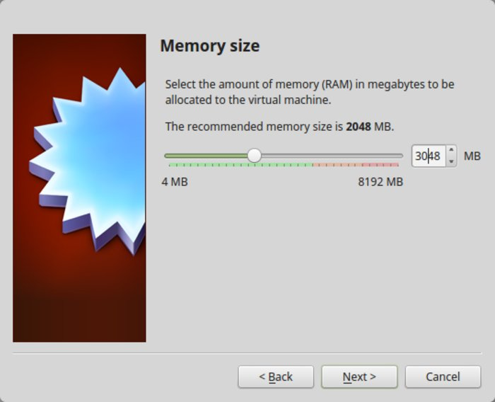](https://i2.wp.com/itsfoss.com/wp-content/uploads/2016/02/Vitualbox-Windows-Linux-2.jpeg?ssl=1)

* Next is the size for the virtual machine. If you’re crunched on space choose the recommended size, otherwise make it a little more than the recommended size.

[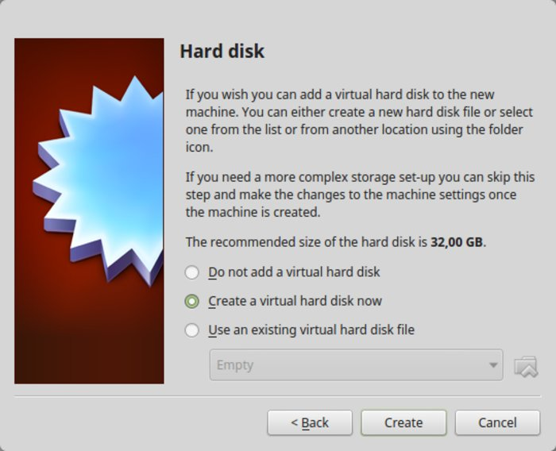](https://i2.wp.com/itsfoss.com/wp-content/uploads/2016/02/Vitualbox-Windows-Linux-3.jpeg?ssl=1)

* Select Create a virtual disk now, for the format, go ahead with the VDI format.

[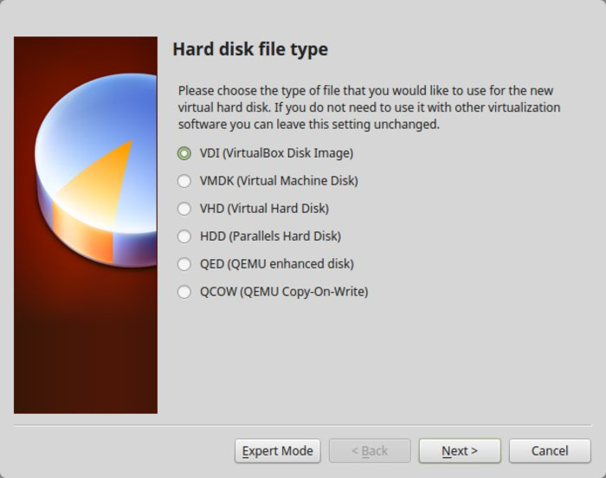](https://i0.wp.com/itsfoss.com/wp-content/uploads/2016/02/Vitualbox-Windows-Linux-5.jpeg?ssl=1)

* Click on start to install Windows 10

[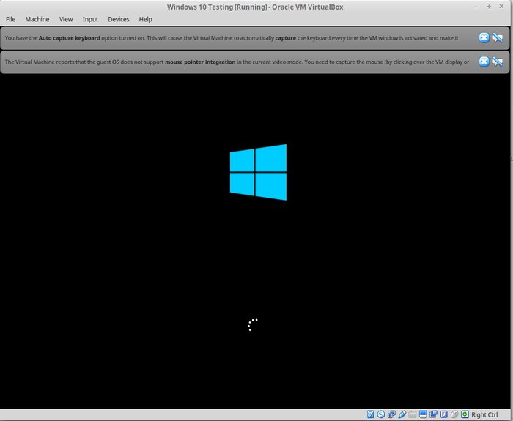](https://i0.wp.com/itsfoss.com/wp-content/uploads/2016/02/Vitualbox-Windows-Linux-12.jpeg?ssl=1)

**EXPERRIMENT-5**

**INSTALLATION OF WINDOWS OPERATING SYSTEM ON A BARE MACHINE**

**INTRODUCTION**

Our Objective is to install Windows 10 Operating system to our PC/Machine via a bootable medium. We will be installing the OS from scratch assuming that we want to update/format/fix the OS in our system by making a fresh installation.

**Requirements :**

1. PC/Machine with at least 4GB RAM

2. An 8GB DVD or USB Flash drive.

3. Rufus software (https://rufus.ie/en_US/).

4. Required Windows 10 OS/OEM.

5. Strong stable internet connection.

**STEP 1 : ACQUIRING REQUIRED OS/OEM**

Before installing Windows 10, we must decide which OS version image we should install in our computer. Most users have the option to choose between the official Windows image from Microsoft or the official OEM Image from their Machine manufacturer like. HP, Dell, Asus and so on.

**Acquiring Official Windows 10 OS from Microsoft :**

1. Go to the Windows 10 official page and select the latest build of the os in dropdown menu and press

‘confirm’.(https://www.microsoft.com/en-us/software download/windows10ISO).

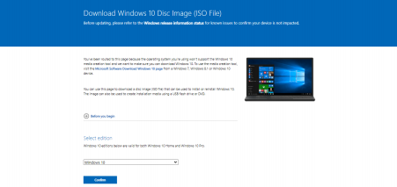

2. A new dropdown menu appears which allows us to choose the preferred language for our OS. Please choose the required language from the same and press ‘confirm’.

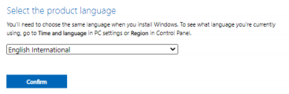

3. Next we see a menu to download the 32-bit & 64-bit architecture versions of the OS for download. Please verify your hardware and download the required version.

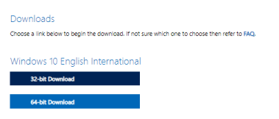

4. The download takes time as the image file is usually 5-6 GB in size. Once the download is complete, we will have file with extension (.iso).

**STEP 2: PREPARING BOOTBALE MEDIUM**

To install the OS onto a machine, we need a bootable medium containing the installation files. The two common media are bootable Flash drive & bootable DVD. We must prepare either one of them in order to install the OS.

**Preparing Bootable DVD:**

In order to create a bootable medium, we must burn the downloaded disk image of the OS (.iso) onto an empty DVD. Use either built-in functionality or 3rd-party software for the same.

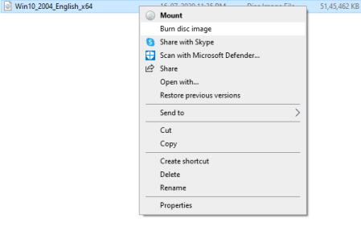

**Preparing Bootable Pen Drive:**

1. Download the Rufus software from the official website. ([https://rufus.ie/en_US/)&(https://github.com/pbatard/rufus/r eleases/download/v3.14/rufus-3.14.exe](https://rufus.ie/en_US/)&(https://github.com/pbatard/rufus/r%20eleases/download/v3.14/rufus-3.14.exe))

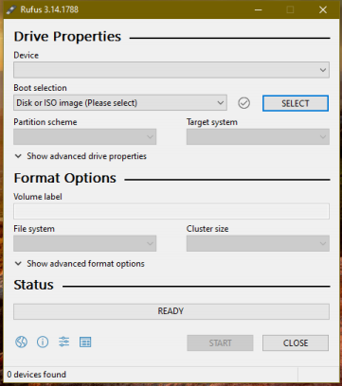

2.Open the Rufus software and the below UI opens.

3. Insert an empty flash drive with at least 8GB space into your computer and it will appear in the Rufus UI. Now, click the ‘Select’ button and choose the downloaded Windows OS Image (.iso) and click ‘start’ to initiate the process. Remember the flash drive will be formatted on conversion to bootable medium.

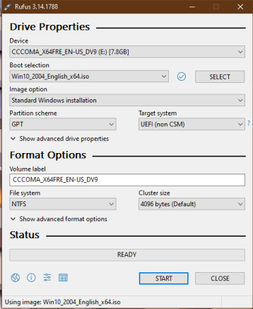

4. After the process finishes, the software will notify us the same and our flash drive is now successfully converted into a bootable medium.

**STEP 3 : SYSTEM BOOTING & INSTALLATION**

Once the bootable medium is ready, we can use it to boot the machine/PC and install the OS to the hard-disk.

1. Insert the bootable DVD or flash drive into the computer and restart it.

2. Usually the BIOS will automatically boot using the bootable medium, otherwise manually bot it up on the boot menu.

3. Choose the required language and layout settings in the initial installation window and press next and install button.

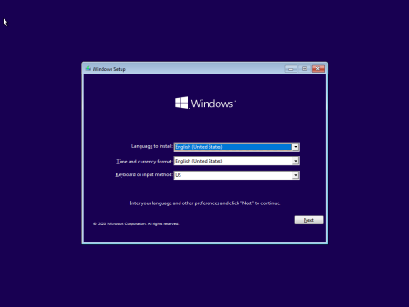

4. Now the installer will prompt you to input a valid License Key. If you do not have one, you can purchase and input it later.

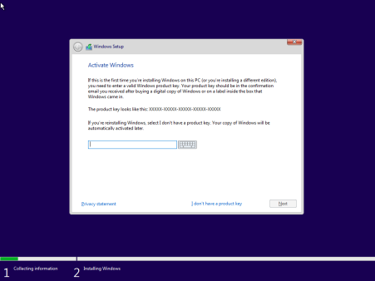

5. Next choose the version of Windows 10 you like to install. Make sure you purchase or have a matching License Key.

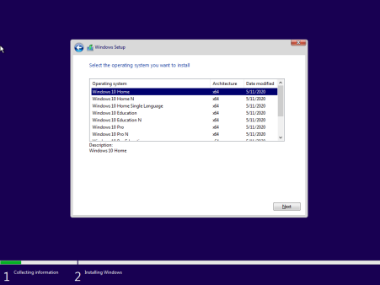

6. Accept the software license terms by ticking the checkbox and click next.

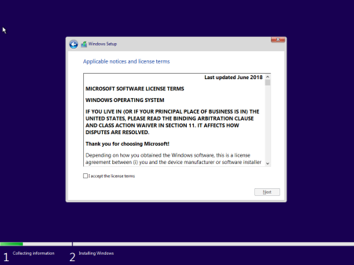

7. If you want to upgrade an existing version of Windows, select upgrade option, else select Custom Install for a fresh installation.

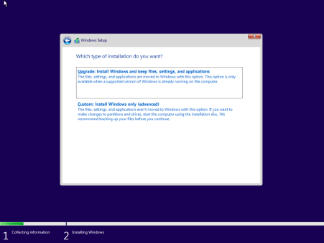

8. Next, inside the disk partition screen, you can create disk partitions and select the drive to install windows which will become the C:\ Drive.

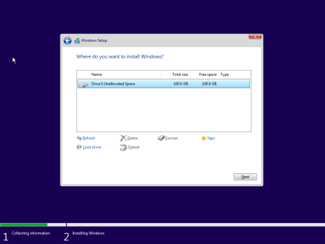

9. On clicking next, the installer starts to install the Windows OS to the Hard Disk, please wait as it will take a few minutes to complete the same.

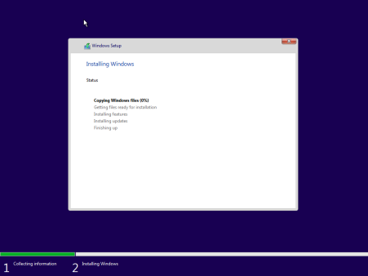

10. On complete installation, the PC will restart and move to a initial screen to configure your region, keyboard layout, time zone settings. Once they are setup, you will be introduced to the Windows 10 Desktop Screen.

11. Now, make sure you update the windows system immediately download and install updates to install necessary drivers and software patches to the system. In case of some proprietary hardware, the user may have to install the drivers manually.

12. Monitor your system performance on Task manager, if everything is working normally, your installation is complete and your system is ready for use.

**EXPERIMENT-6**

**INSTALLATION OF LINUX OVER WINDOWS OPERATING SYSTEM**

**REQUIREMENTS**

1. Pc with at least 2GB RAM

2. 8GB flash drive

3. Rufus

4. Linux ISO file

**Steps**

1) Partition a Hard Drive in Windows 10

1. Open cmd

2. Type the command “diskmgmt.msc” and hit enter

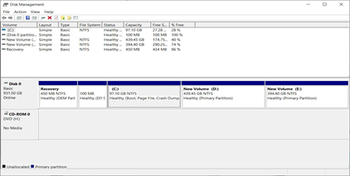

3. Right-click on your main hard drive and select Shrink Volume.

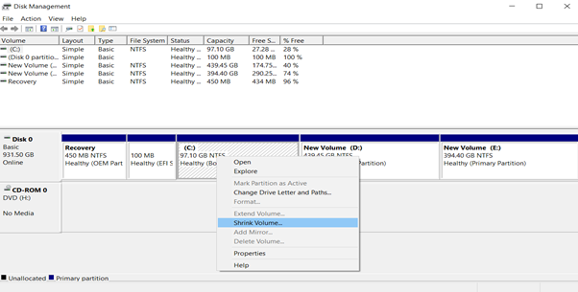

4.choose how much you want to shrink your drive

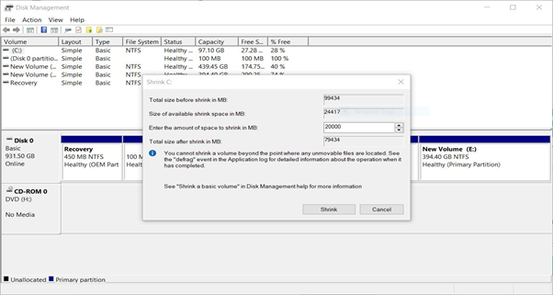

2) Make a Linux Bootable USB

1. Download a Linux distro in ISO format.

https://ubuntu.com/

2. Insert the USB drive into your computer.

3. Download Rufus

https://rufus.ie/en_US/

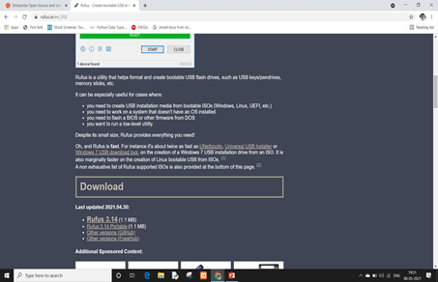

4. Open Rufus and select your USB drive from the Device list

5. Under Boot Selection, click the Select button and choose the ISO file you downloaded

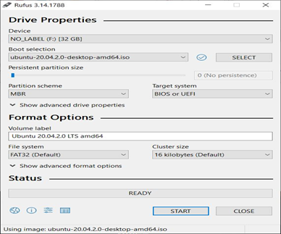

3) Install Linux from USB

1. Place the USB stick,reboot the machine and instruct the UEFI to boot-up from the USB by pressing a special function key (usually F12, F10 or F2 depending on the vendor specifications).

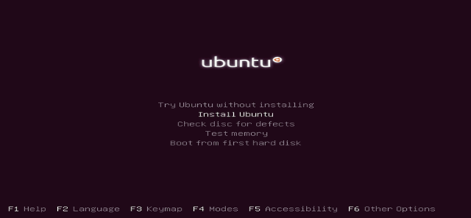

2. Choose the language you wish to perform the installation and click on the Continue

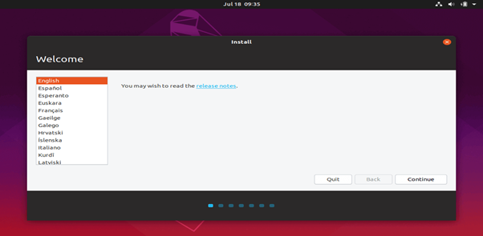

3. choose the first option “Normal Installation” and hit on the Continue button

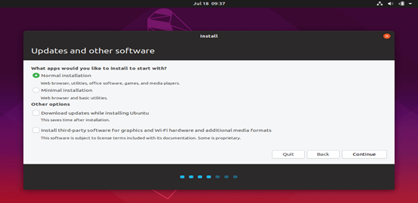

4. check the Something else option and hit on the Continue button

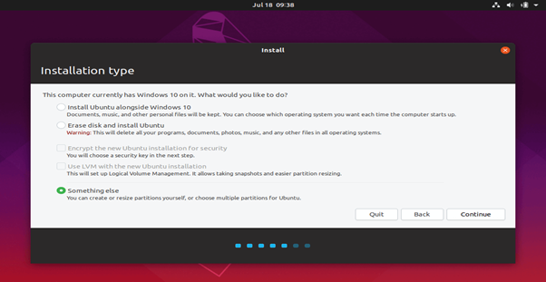

5. we’ll create our custom partition layout for Ubuntu

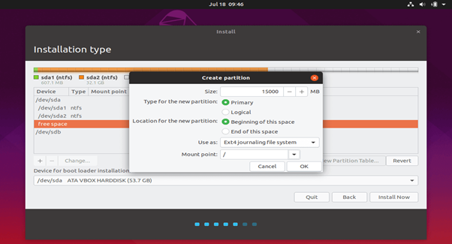

6. hit the Install Now button in order to apply changes to disk and start the installation process.

7. set your machine physical location by selecting a city nearby from the map. When done hit Continue to move ahead.

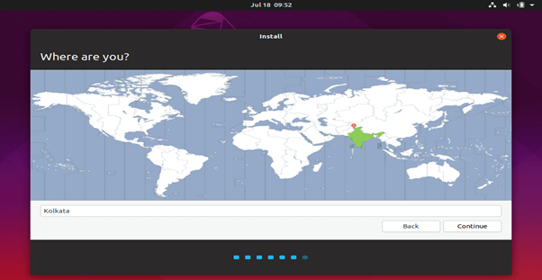

8. Pick up a username and password for your administrative sudo account, enter a descriptive name for your computer and hit Continue to finalize the installation.

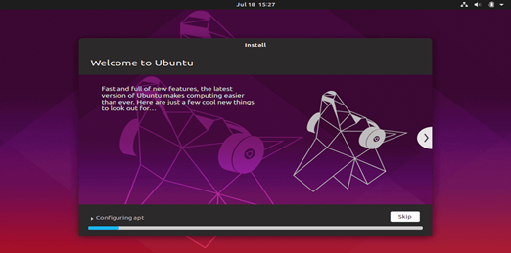

9. After the installation process reaches its end hit on the Restart Now button in order to complete the installation.

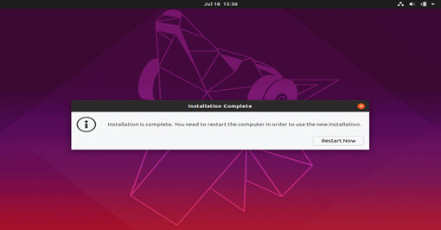

10. Ubuntu has successfully installed on your system.

**INSTALLATION OF COMMON OPERATING SYSTEMS FOR DESKTOP**

**Check the system requirements.** If you've decided that you want to install a new operating system, you'll first need to figure out which one you want to use. Operating systems have varying system requirements, so if you have an older computer, make sure that you can handle a newer operating system.

· Most Windows installations require at least 1 GB of RAM, and at least 15-20 GB of hard disk space. Also, your CPU needs to be powerful enough to run the OS you want to run. Make sure that your computer can accommodate this. If not, you may need to install an older operating system, such as Windows XP.

· Linux operating systems typically don't require as much space and computing power as Windows operating systems. The requirements vary depending on the distribution you choose (Ubuntu, Fedora, Mint, etc.).

**Determine your installation order.** If you are installing a Linux distribution that you want to run alongside Windows, you need to install Windows first and then Linux. This is because Windows has a very strict boot loader that needs to be in place before Linux is installed, otherwise Windows won't load.

**Boot from your installation disc.** Insert the installation disc into your optical; drive, and reboot your computer. Normally a computer boots from the hard drive first, so you will need to adjust some settings in your BIOS in order to boot from the disc drive. You can enter the BIOS by hitting the designated Setup key during the boot process. The key will be displayed on the same screen as your manufacturer's logo.

Common Setup keys include F2, F10, F12, and Del/Delete.Once you are in the Setup menu, navigate to the Boot section. Set your DVD/CD drive as the first boot device. If you are installing from a USB drive, make sure that the drive is inserted and then select it as the first boot device.Once you've selected the correct drive, save your changes and exit Setup. Your computer will reboot.

**Wait for the Setup program to load.** No matter which operating system you choose, the setup program will need to copy some files to your computer before it can continue. This can take several minutes, depending on the speed of your computer's hardware.You will most likely need to choose some basic options, such as language and keyboard layout.

**Enter your product key.** If you are installing Windows 8, you will need to enter your product key before you can begin the installation. Older Windows versions will ask for the product key after installation is complete. Linux users will not need a product key unless it is a purchased version such as Red Hat.

**Choose your installation type.** Windows will give you the option of Upgrading or performing a Custom installation. Even if you are upgrading an older version of Windows, it is highly recommended that you choose Custom and start from scratch. This will minimize problems that may arise later from combining old settings and new ones.

If you are installing Linux, you will be given the option to install alongside your existing operating system (Windows), or to erase the disk and install Linux by itself. Choose the option that best meets your needs. If you choose to install alongside Windows, you will be given the option to choose how much hard disk space you want to designate for Linux.

**Format your partitions.** If you are installing Windows, you will need to choose which hard drive partition you want to install it on. Deleting partitions will wipe the data on the partition and return the space to the Unallocated section. Select the unallocated space and create a new partition.

If you are installing Linux, the partition needs to be formatted in the Ext4 format.

**Set your Linux options.** Before installation begins, your Linux installer will ask you for your timezone, and you will need to create a username and password. You will use this to log in to your Linux distribution as well as authorize system changes.Windows users will fill out personal information after the installation is complete.

**Wait for the installation to complete.** Depending on the speed of your computer, this can take up to an hour to finish. Most installations are hands-off at this point. Your computer may reboot several times during the installation process.

**Create your Windows login.** Once your Windows installation is complete, you will need to create a username. You can also choose to create a password, though this is not necessary. After creating your login info, you will be asked for your product key.

**Install your drivers and programs.** Once the installation is complete, you will be taken to your new desktop. From here, you can begin installing your programs and make sure that your [drivers are installed and up to date](https://www.wikihow.com/Find-and-Update-Drivers). Make sure to install an [antivirus program](https://www.wikihow.com/Install-an-Antivirus) if you are going to be connecting to the internet.

**EXPERIMENT-7**

**HOW TO INSTALL A SERVER SYSTEM**

**Phase 1: Collecting Information**

In the first installation phase, the setup program asks for the preliminary information that it needs to begin the installation. A setup wizard prompts you for the following information:

* **Language:** Select your language, time-zone, and keyboard type.
* **Product Key:** Enter the 25-character product key that came with the installation media. If setup says you entered an invalid product key, double-check it carefully. You probably just typed the key incorrectly.
* **Operating System Type:** The setup program lets you select Windows Server 2008 Standard Edition or Core. Choose Standard Edition to install the full server operating system; choose Core if you want to install the new text-only version.
* **License Agreement:** The official license agreement is displayed. You have to agree to its terms in order to proceed.
* **Install Type:** Choose an Upgrade or Clean Install type.
* **Disk Location:** Choose the partition in which you want to install Windows.
* **Upgrade to NTFS:** If you want to upgrade a FAT32 system to NTFS, you’ll need to say so now.

**Phase 2: Installing Windows**

In this phase, Windows setup begins the actual process of installing Windows. The following steps are performed in sequence:

1. Copying Files: Compressed versions of the installation files are copied to the server computer.

2. Expanding Files: The compressed installation files are expanded.

3. Installing Features: Windows server features are installed.

4. Installing Updates: The setup program checks Microsoft’s website and downloads any critical updates to the operating system.

5. Completing Installation: When the updates are installed, the setup program reboots so it can complete the installation.

**Configuring Your Server**

After you’ve installed Windows Server 2008, the computer automatically reboots, and you’re presented with the Initial Configuration Tasks Wizard. This wizard guides you through the most important initial tasks for configuring your new server.

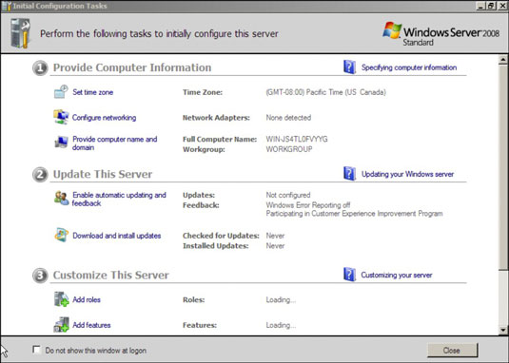

The following list describes the server configuration settings available from this wizard:

* **Set the Administrator Password:** The very first thing you should do after installing Windows is set a secure administrator password.
* **Set the Time Zone:** This is necessary only if the indicated time zone is incorrect.
* **Configure Networking:** The default network settings are usually appropriate, but you can use this option to change the defaults if you wish.
* **Provide Computer Name and Domain:** This option lets you change the server’s computer name and join a domain.
* **Enable Automatic Updating:** Use this option if you want to let the server automatically check for operating system updates.
* **Download and Install Updates:** Use this option to check for critical operating system updates.
* **Add Roles:** This option launches the Add Roles Wizard, which lets you configure important roles for your server.
* **Add Features:** This option lets you add more operating system features.
* **Enable Remote Desktop:** Use this option to enable the Remote Desktop feature, which lets you administer this server from another computer.
* **Configure Windows Firewall:** If you want to use the built-in Windows firewall, this option lets you configure it.

**EXPERIMENT-8**

**STUDY ON COMMAND LINE TEXT EDITORS**

**Text editors**

* Program used to create and edit plain text files.
* The main purpose of the text editor is to create a file to be used by another program.
* For example:
* HTML for a Web Browser
* Source code that a compiler can process.

There are two types of text editors:

* Terminal Based editors

E.g.: Vi, Pico, Nano, Emacs.

* GUI editors  
   E.g.: Gedit, Kwrite

**The Emacs Editor**

Emac is a very popular editor on Unix until recently. Emacs has so many available features like a calculator, calendar, email client. Commands in emacs are either control characters (hold down the <Ctrl> key while typing another character).

Syntax: emacs filename

**Pico Editors**

The UNIX Pico editor is a full screen editor which is very easy to use.

Syntax: pico filename

**Nano Editors**

The nano is improved open source of pico available for GNU/Linux.

Syntax: nano filename

**Vim Editor**

The vi command-line text editor is included with most versions of UNIX and Linux. Vim is an improved version of vi.The vi commands is now linked to the vim commands. There are three modes in vi editor:

1. Command mode: Use key combinations as commands instead of typing text.
2. Insert mode: Typed text is displayed on screen.
3. Extend mode: Used for more advanced commands, such as saving files, exiting vim, or searching and replacing text.

**Command Mode**

* Advanced Navigational Commands

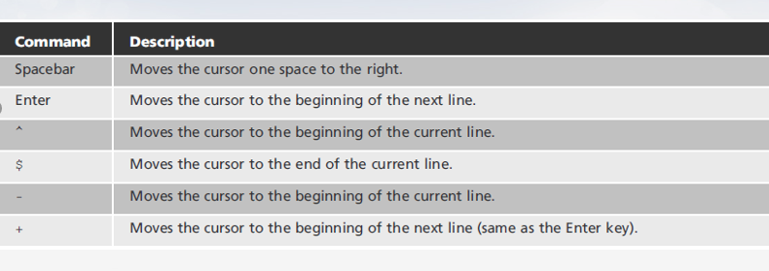

**Insert Mode**

* Must be in insert mode to type text
* vim editor displays -- INSERT -- at the lower left to indicate insert mode
* **Switching modes**

i ->from command mode to insert mode

Esc ->from insert mode to command mode

**Cut, Yank, and Paste**

* **Cut text**
  + Store text in a buffer. Cutting text is referred to as deleting in Vim
  + **Paste text**
  + Move from buffer to cursor location
* **Yank (copy) text**

Keep in current location and copy to buffer

**Undo Commands**

* Undo changes
  + Type u
  + Keep typing u until you have reached your oldest change

**EXPERIMENT-9**

**BASIC LINUX COMMANDS**

**1**. **pwd**

Use the pwd command to find out the path of the current working directory (folder) you’re in.

The command will return an absolute (full) path, which is basically a path of all the

directories that start with a forward slash (/). An example of an absolute path is

/home/username.

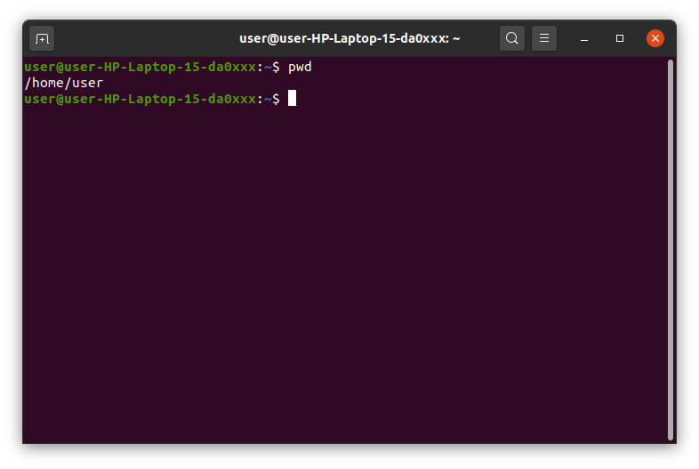

**2. cd**

To navigate through the Linux files and directories, use the cd . It requires either the full

path or the name of the directory, depending on the current working directory that you’re

in.

Let’s say you’re in /home/username/Documents and you want to go to Photos, a

subdirectory of Documents. To do so, simply type the following command: cd Photos.

Another scenario is if you want to switch to a completely new directory, for

example,/home/username/Movies. In this case, you have to type cd followed by the

directory’s absolute path: cd /home/username/Movies.

There are some shortcuts to help you navigate quickly:

● cd .. (with two dots) to move one directory up

● cd to go straight to the home folder

● cd- (with a hyphen) to move to your previous directory

On a side note, Linux’s shell is case sensitive. So, you have to type the name’s directory

exactly as it is.

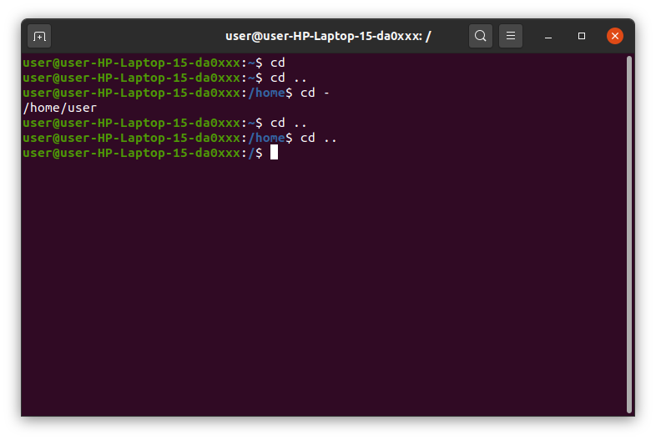

**3. ls**

The ls command is used to view the contents of a directory. By default, this command will

display the contents of your current working directory.

If you want to see the content of other directories, type ls and then the directory’s path. For

example, enter ls /home/username/Documents to view the content of Documents.

There are variations you can use with the ls command:

● ls -R will list all the files in the sub-directories as well

● ls -a will show the hidden files

● ls -al will list the files and directories with detailed information like the permissions, size,

owner, etc.

● ls -t lists files sorted in the order of “last modified”

● -r option will reverse the natural sorting order. Usually used in combination with other

switches such as ls -tr. This will reverse the time-wise listing.

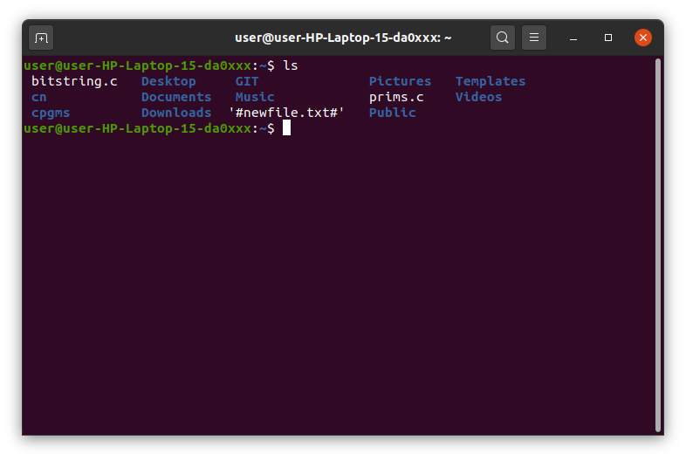

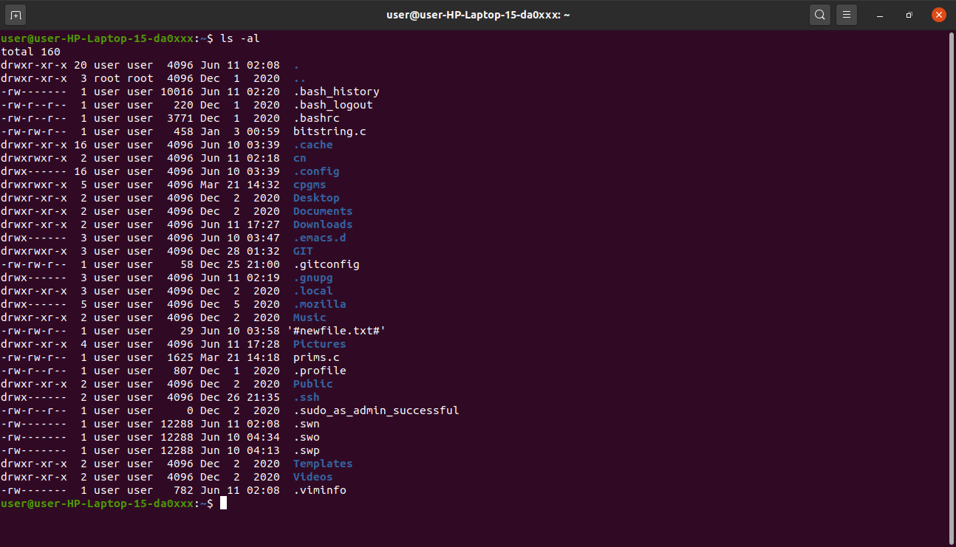

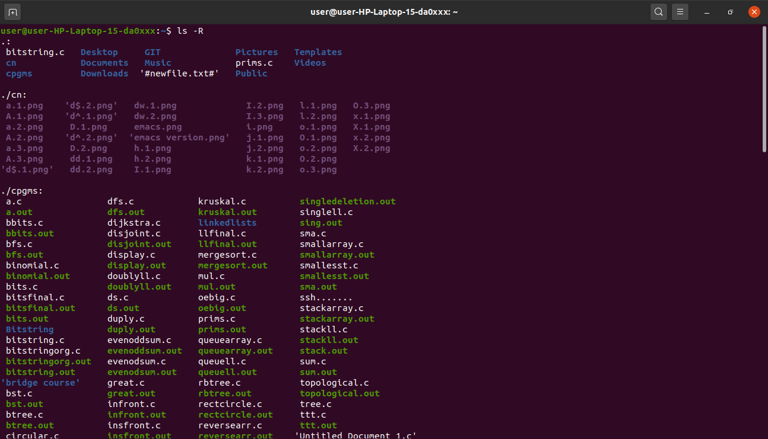

**4. cat**

cat (short for concatenate) is one of the most frequently used commands in Linux. It is used

to list the contents of a file on the standard output stdout . To run this command, type cat

followed by the file’s name and its extension. For instance: cat file.txt.

Here are other ways to use the cat command:

● cat > filename creates a new file

● cat filename1 filename2>filename3 joins two files (1 and 2) and stores the output of

them in a new file (3)

● to convert a file to upper or lower case use, cat filename | tr a-z A-Z >output.txt

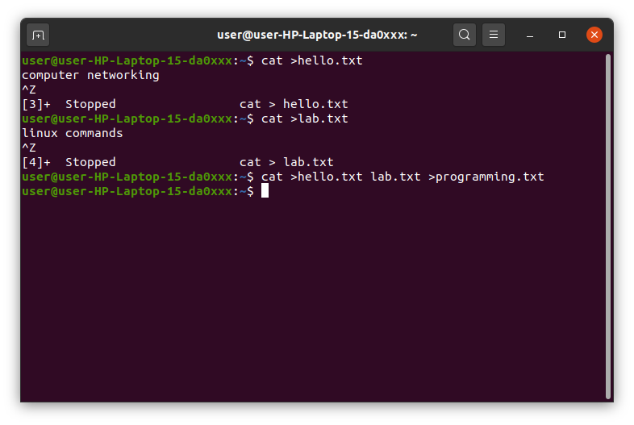

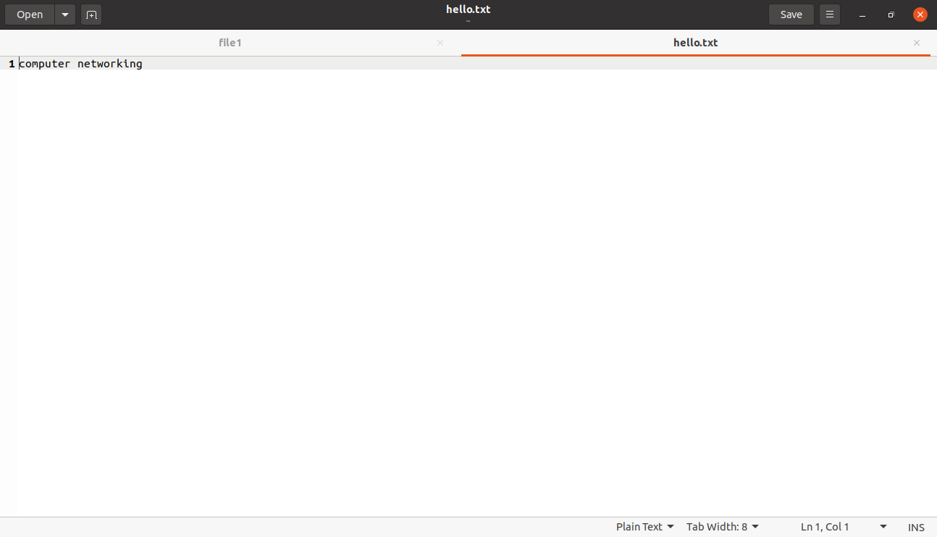

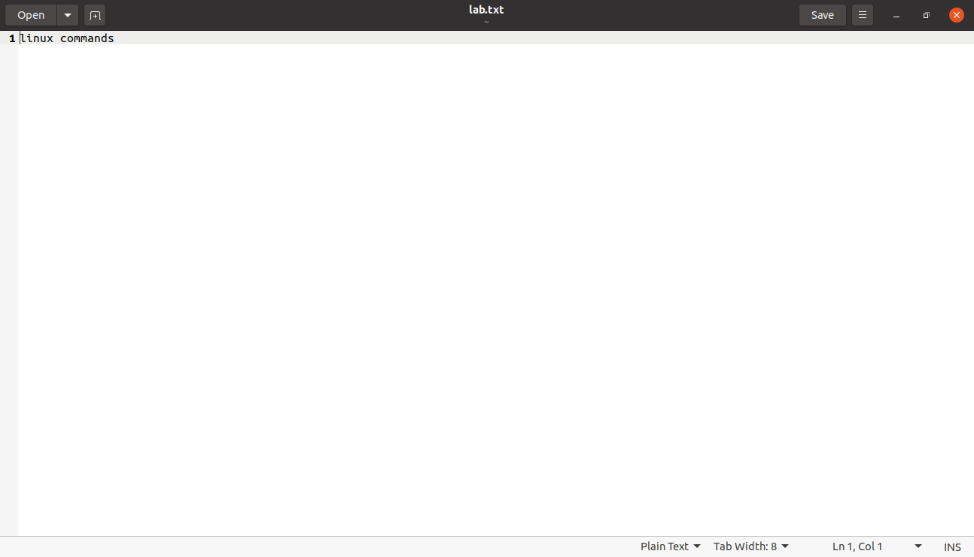

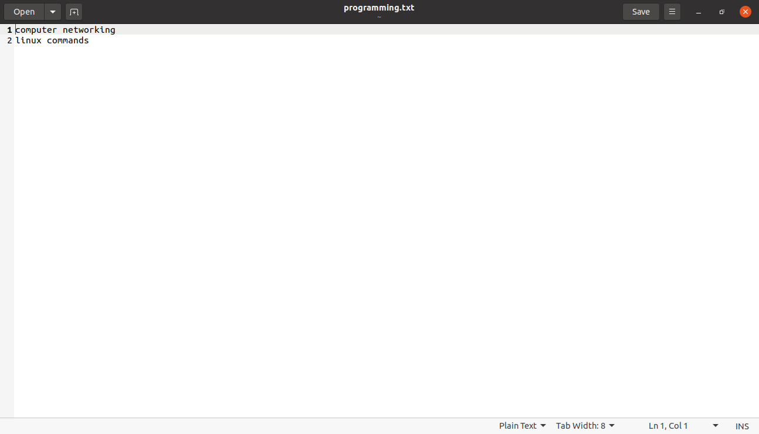

**5. cp**

Use the cp command to copy files from the current directory to a different directory. For

instance, the command cp scenery.jpg /home/username/Pictures would create a copy

of scenery.jpg (from your current directory) into the Pictures directory.

● cp -i will ask for user’s consent in case of a potential file overwrite.

● cp -p will preserve source files’ mode, ownership and timestamp.

● cp -r will copy directories recursively.

● cp -u copies files only if the destination file is not existing or the source file is newer than

the destination file.

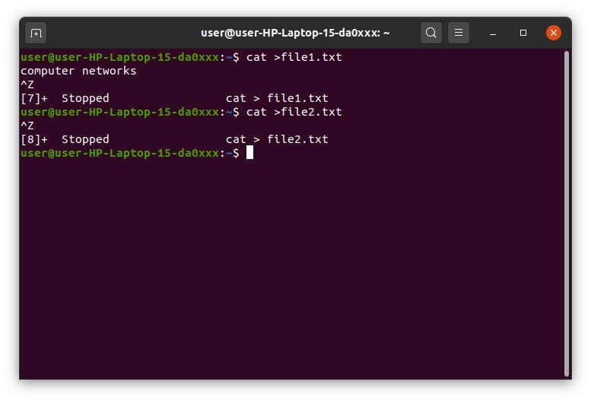

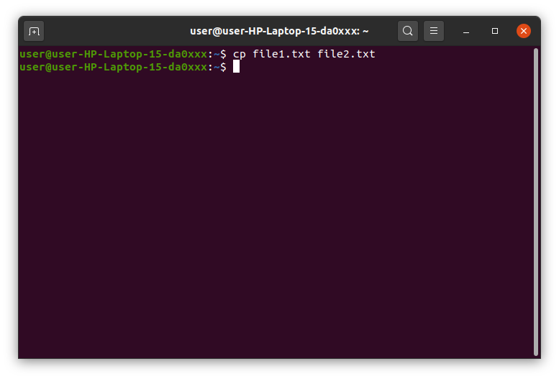

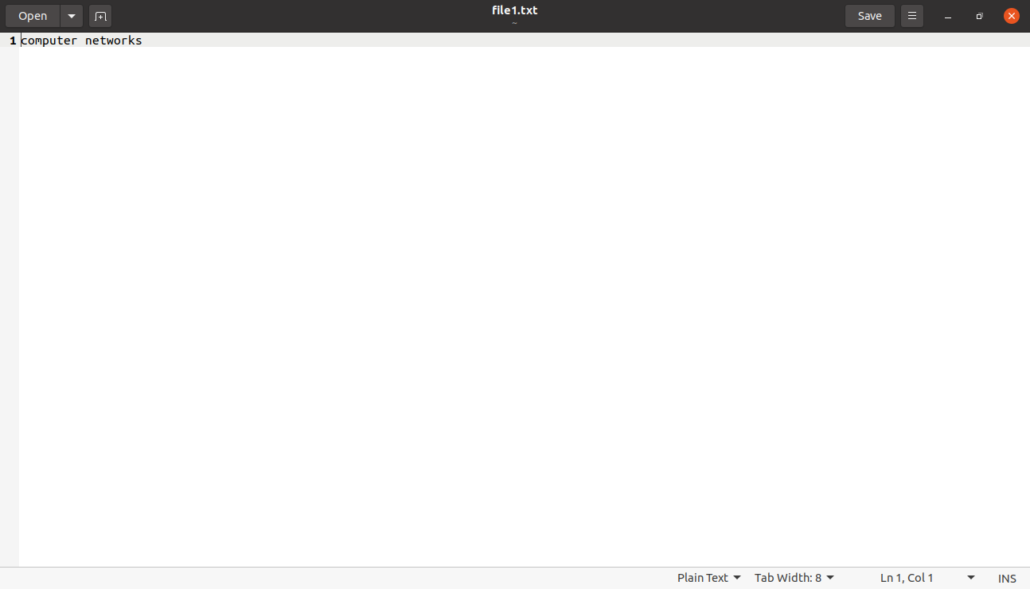

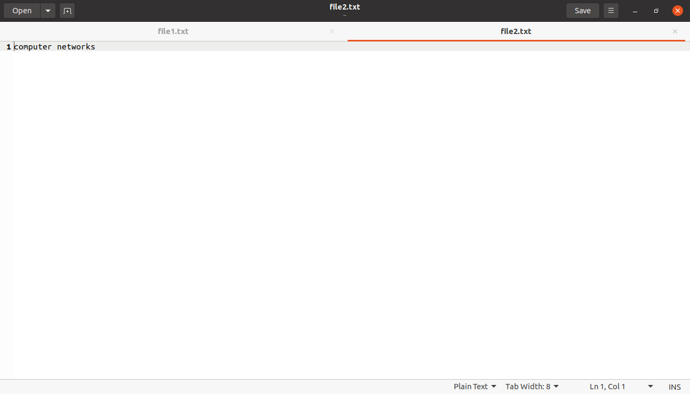

**6. mv**

The primary use of the mv command is to move files, although it can also be used to

rename files.

The arguments in mv are similar to the cp command. You need to type mv, the file’s name,

and the destination’s directory. For example: mv file.txt /home/username/Documents.

To rename files, the Linux is mv oldname.ext newname.ext

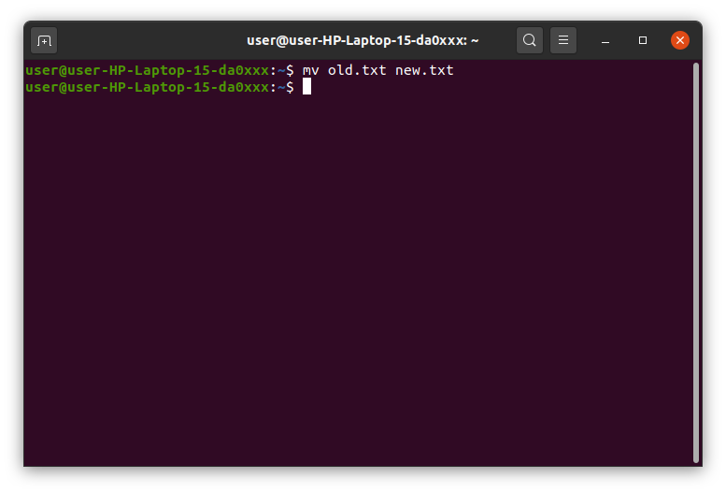

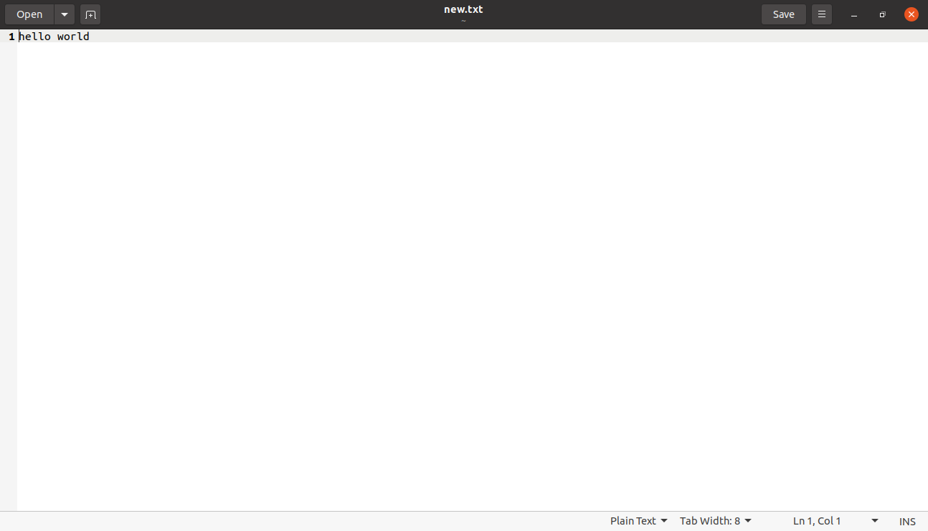

**7. mkdir**

Use mkdir command to make a new directory — if you type mkdir

Music it will create a directory called Music.

There are extra mkdir commands as well:

● To generate a new directory inside another directory, use this Linux basic command

mkdir Music/Newfile

● use the p (parents) option to create a directory in between two existing directories. For

example, mkdir -p Music/2020/Newfile will create the new “2020” file.

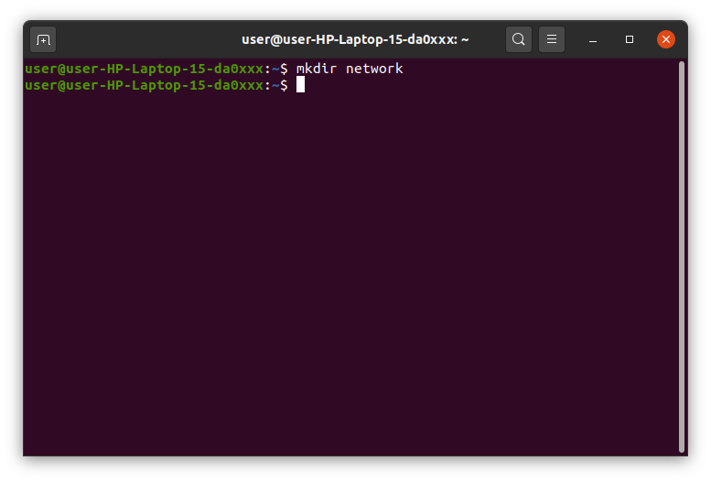



**8. rmdir**

If you need to delete a directory, use the rmdir command. However, rmdir only allows you to

delete empty directories.

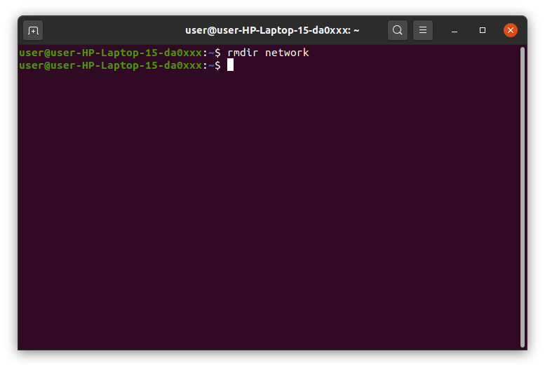

**9. rm**

The rm command is used to delete directories and the contents within them. If you only want

to delete the directory — as an alternative to rmdir — use rm -r.

Note: Be very careful with this command and double-check which directory you are in. This

will delete everything and there is no undo.

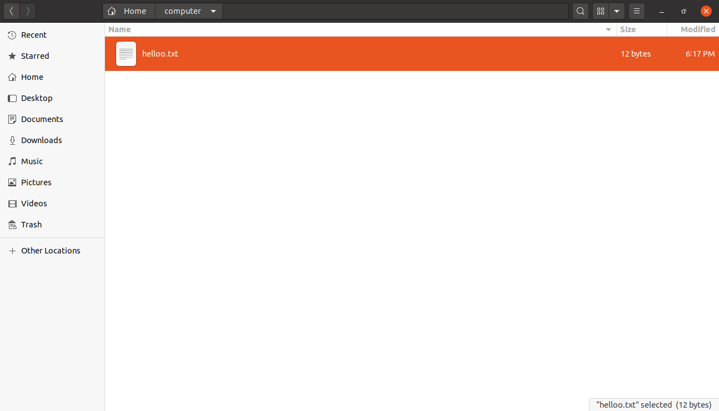

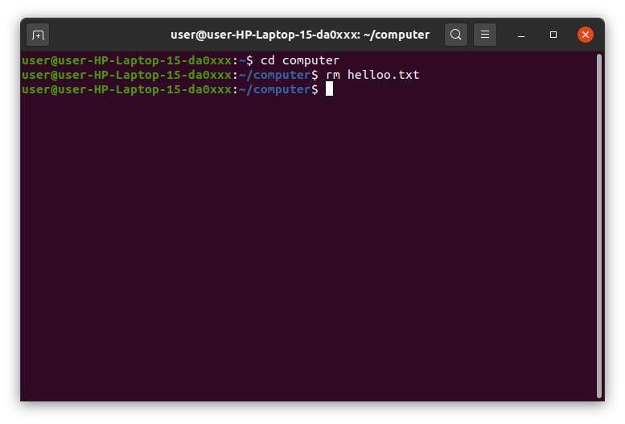

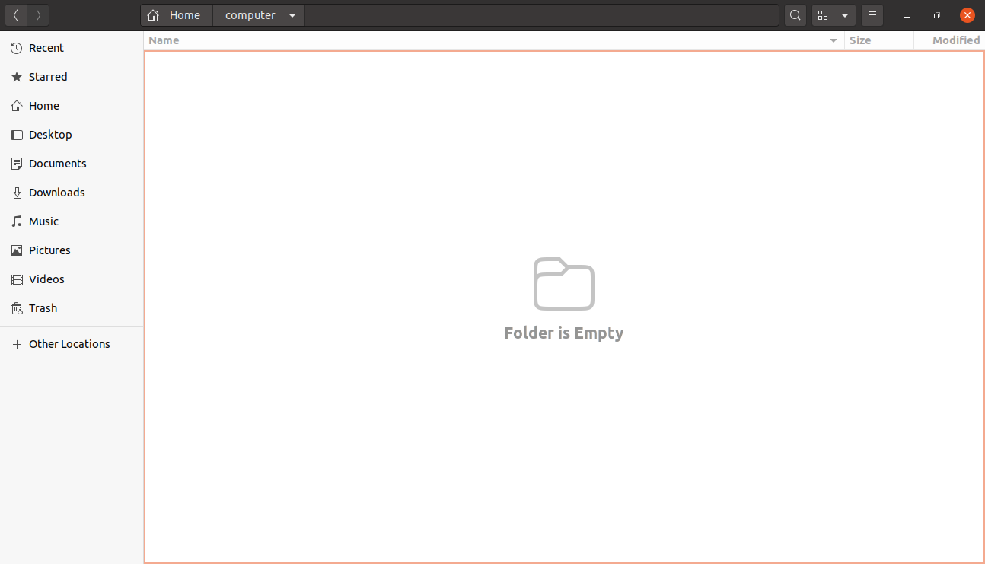

**10. touch**

The touch command allows you to create a blank new file through the Linux command line.

As an example, enter touch /home/username/Documents/Web.html to create an

HTML file entitled Web under the Documents directory.

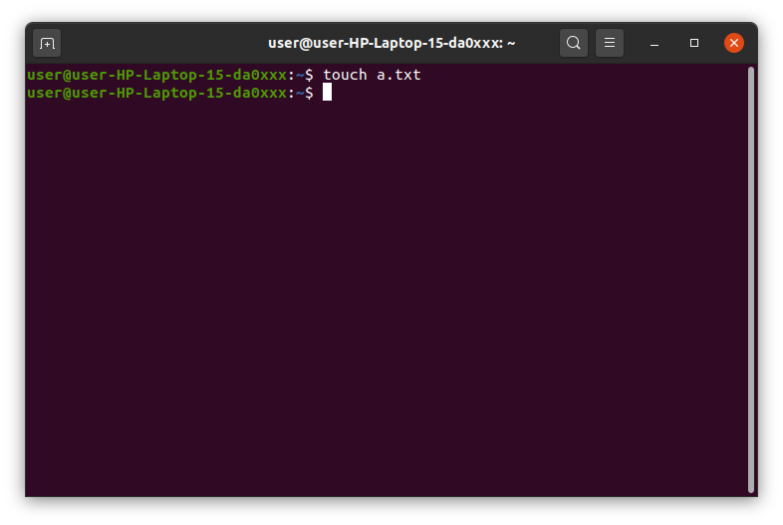

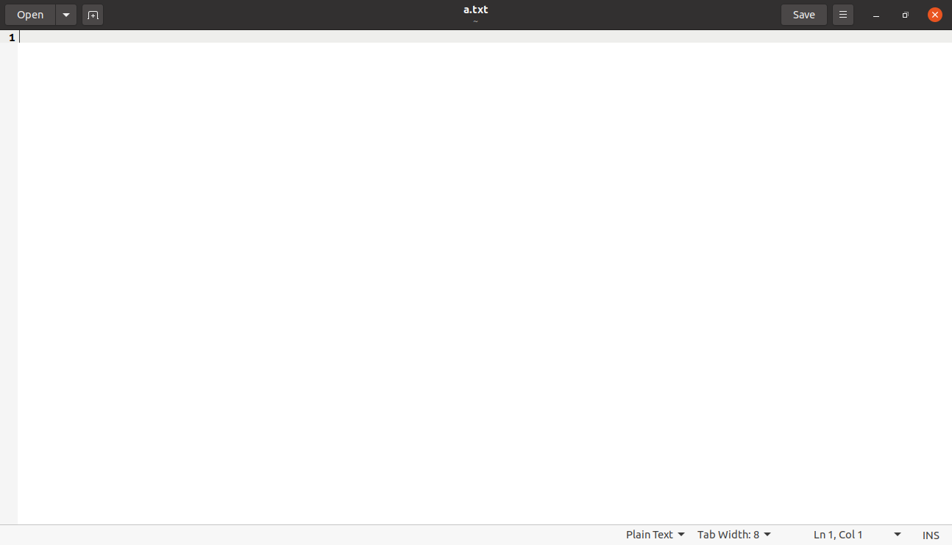

**11. locate**

You can use this command to locate a file, just like the search command in Windows.

What’s more, using the -i argument along with this command will make it

case-insensitive, so you can search for a file even if you don’t remember its exact name.

To search for a file that contains two or more words, use an asterisk (*). For example, locate

-i school*note command will search for any file that contains the word “school” and

“note”, whether it is uppercase or lowercase.

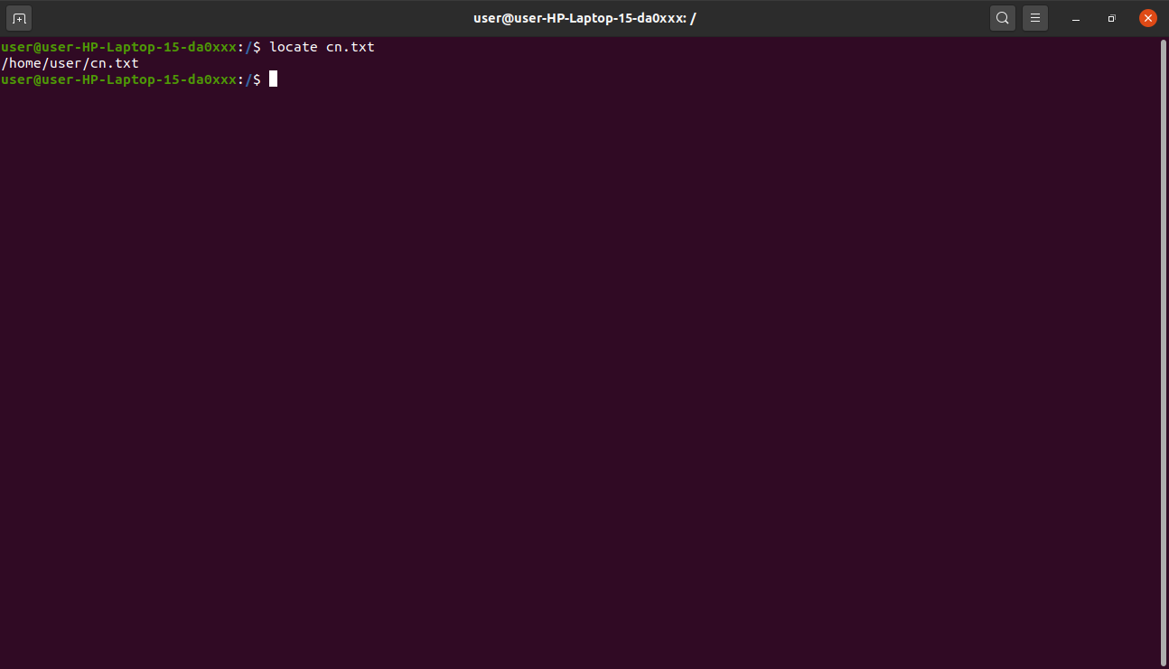

**12. find**

Similar to the locate command, using find also searches for files and directories. The

difference is, you use the find command to locate files within a given directory.

As an example, find /home/ -name notes.txt command will search for a file called notes.txt

within the home directory and its subdirectories.

Other variations when using the find are:

● To find files in the current directory use, find . -name notes.txt

● To look for directories use, / -type d -name notes. txt

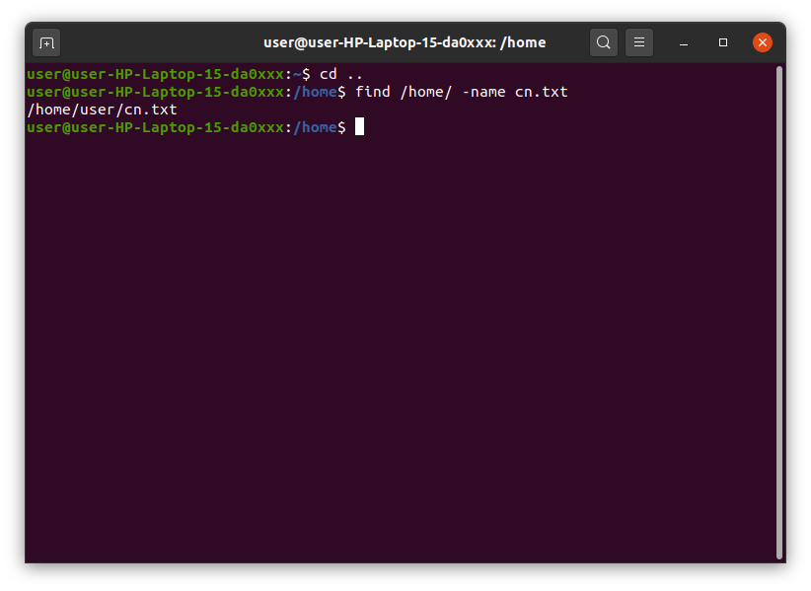

**13. grep**

Another basic Linux command that is undoubtedly helpful for everyday use is grep. It lets

you search through all the text in a given file.

To illustrate, grep blue notepad.txt will search for the word blue in the notepad file. Lines

that contain the searched word will be displayed fully. You should refer to some grep

tutorial

Useful for command line use as well. Usually output of a previous command is piped into the

grep command. For example ls -l | grep “kernel”

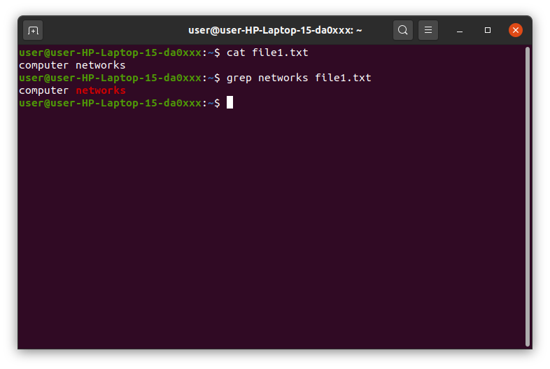

**14. sudo**

Short for “SuperUser Do”, this command enables you to perform tasks that require

administrative or root permissions. You must have sufficient permissions to use this

command.

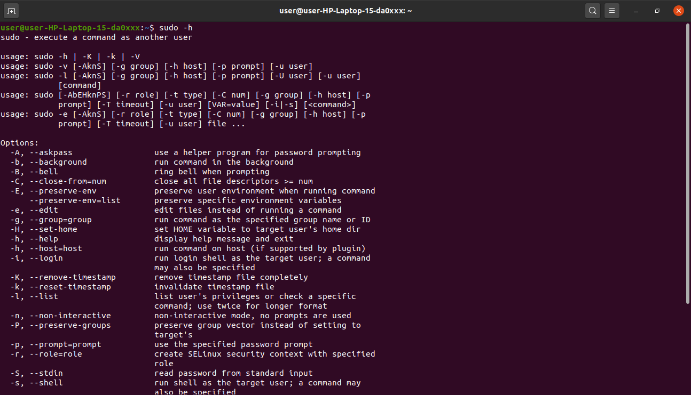

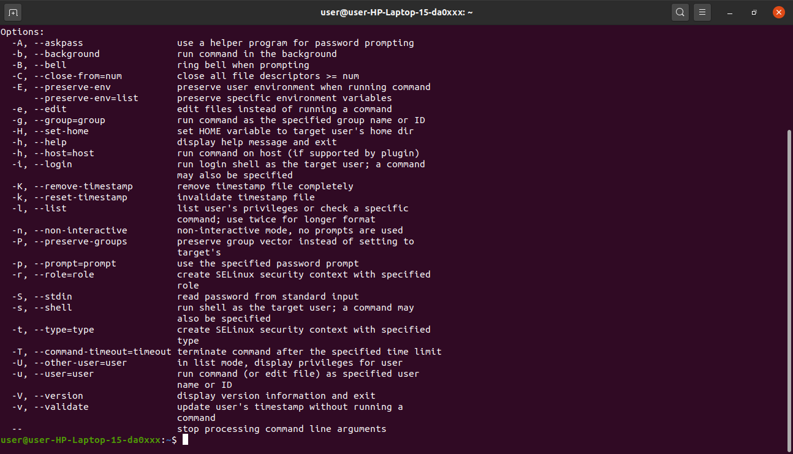

**15. df**

Use df command to get a report on the system’s disk space usage, shown in percentage

and KBs. If you want to see the report in megabytes, type df -m.

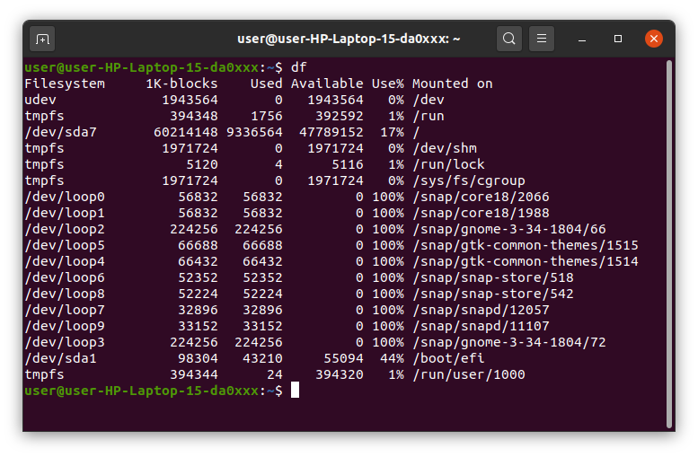

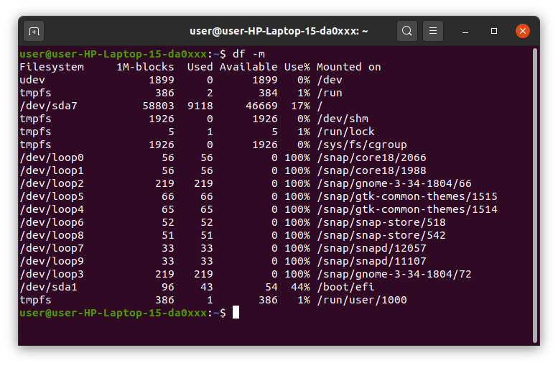

**16. du**

If you want to check how much space a file or a directory takes, the du (Disk Usage)

command is the answer. However, the disk usage summary will show disk block

numbers instead of the usual size format. If you want to see it in bytes, kilobytes, and

megabytes, add the -h argument to the command line.

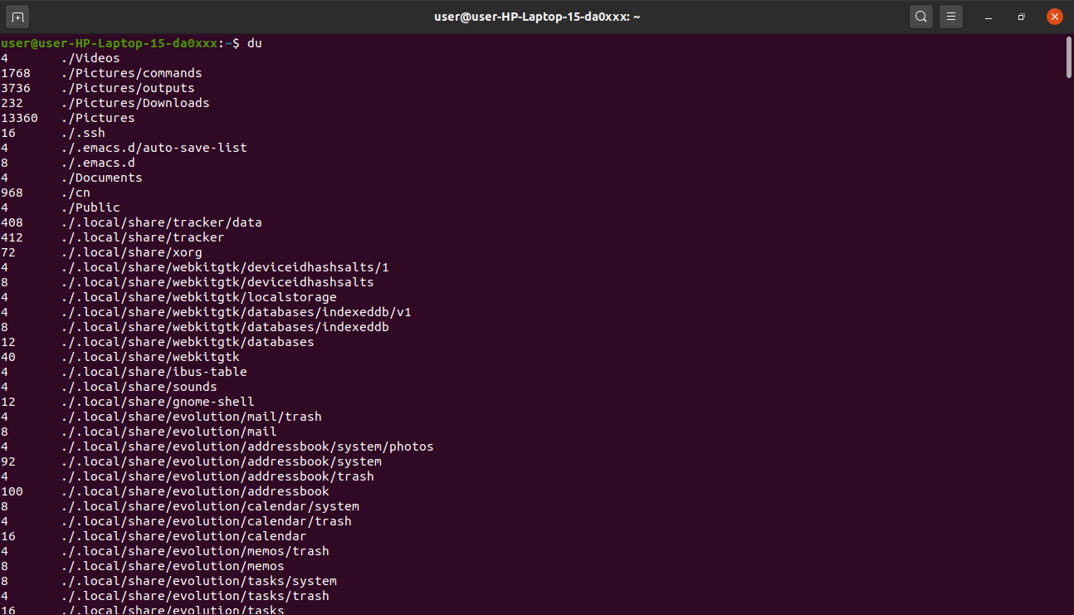

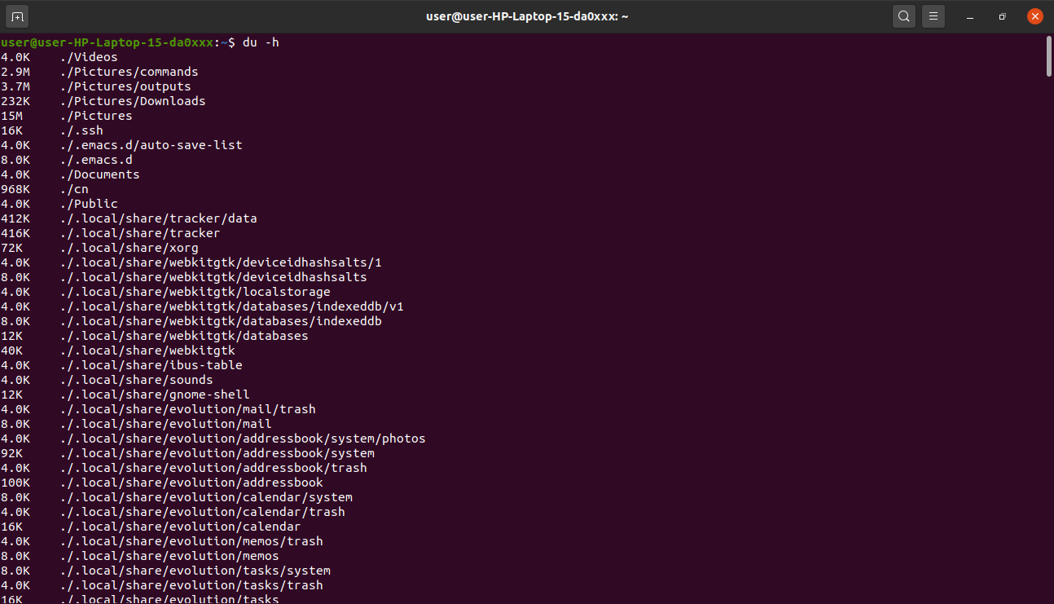

**17. head**

The head command is used to view the first lines of any text file. By default, it will show the

first ten lines, but you can change this number to your liking. For example, if you only

want to show the first five lines, type head -n 5 filename.ext. ( Read the manual )

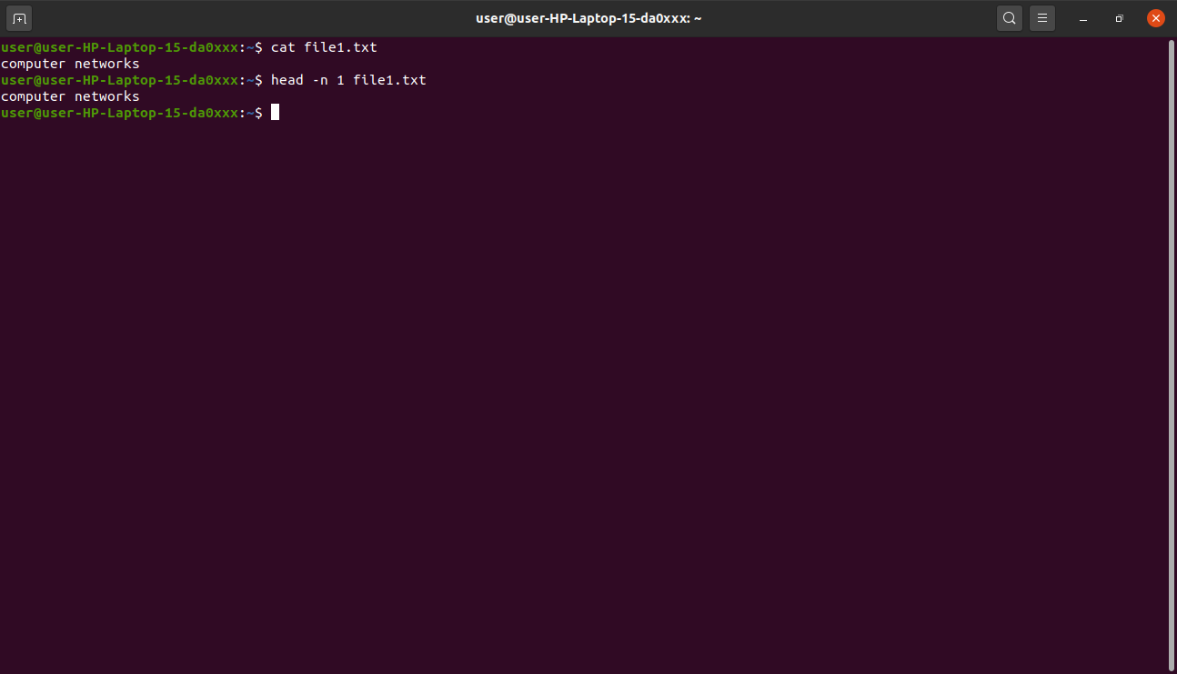

**18. tail**

This one has a similar function to the head command, but instead of showing the first lines,

the tail command will display the last ten lines of a text file. For example, tail -n

filename.ext.

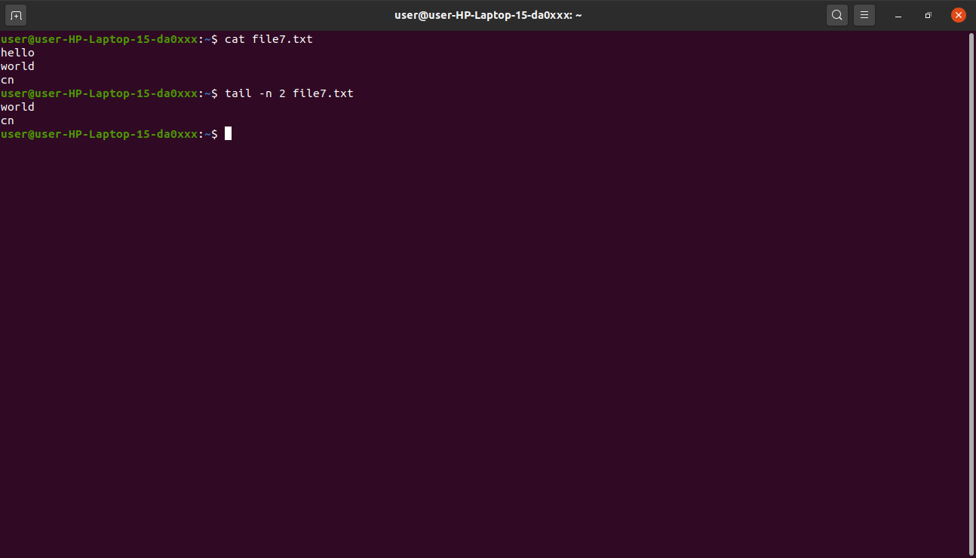

**19. diff**

Short for difference, the diff command compares the contents of two files line by line. After

analyzing the files, it will output the lines that do not match. Programmers often use this

command when they need to make program alterations instead of rewriting the entire

source code.

The simplest form of this command is diff file1.ext file2.ext

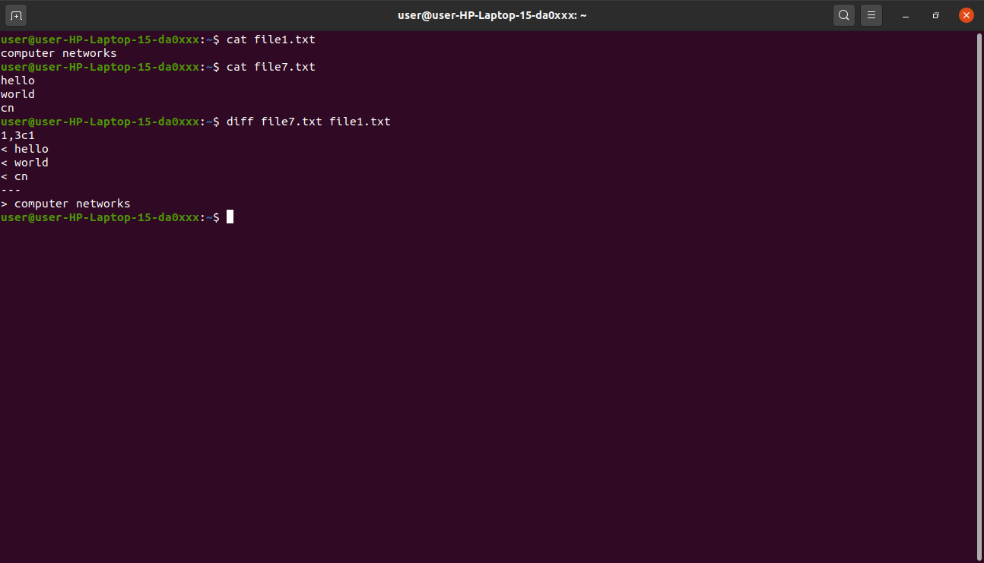

**20. tar**

The tar command is the most used command to archive multiple files into a tarball — a

common Linux file format that is similar to zip format, with compression being optional.

This command is quite complex with a long list of functions such as adding new files into an

existing archive, listing the content of an archive, extracting the content from an archive,

and many more. Read some tutorial on net.

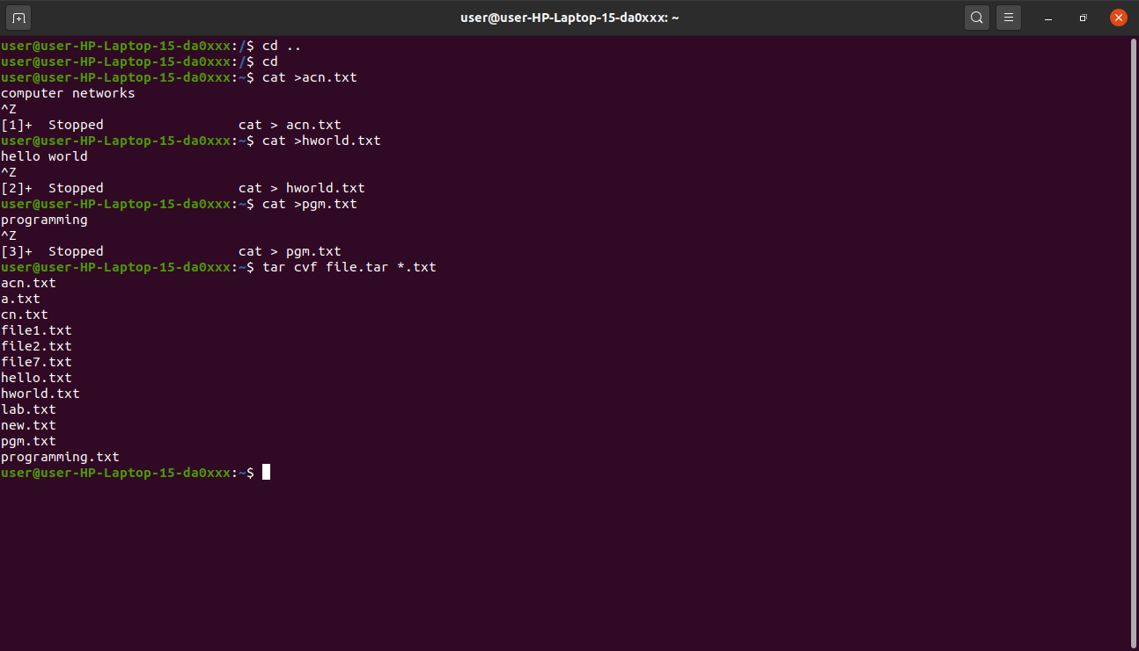

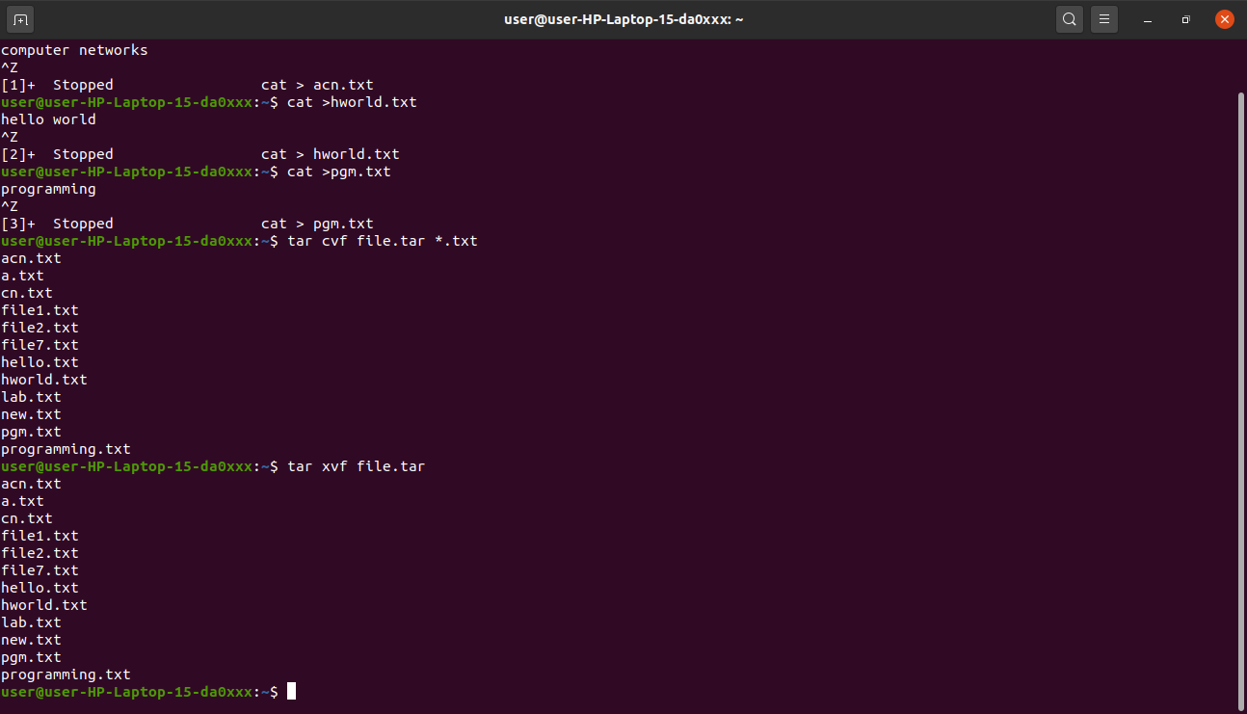

**21. chmod**

chmod is another Linux command, used to change the read, write, and execute permissions

of files and directories. Read about permissions and how to manipulate them .

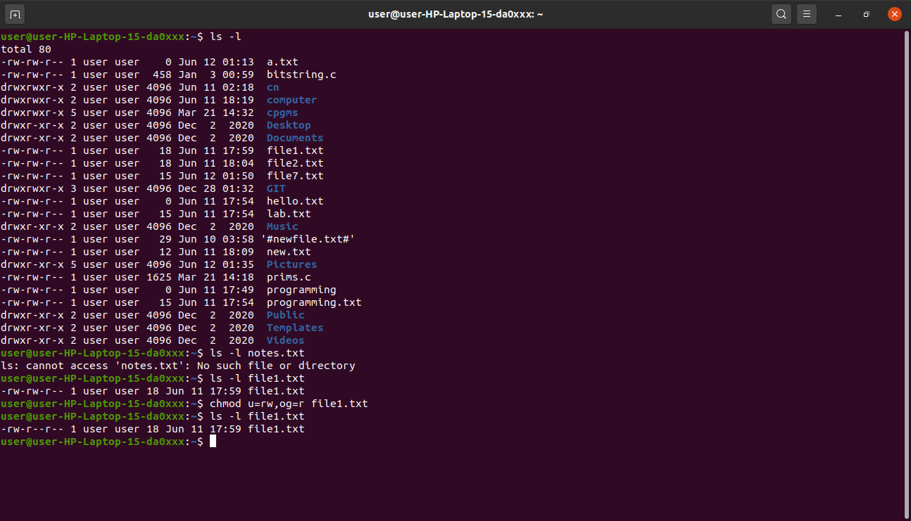

**22. chown**

In Linux, all files are owned by a specific user. The chown command enables you to change

or transfer the ownership of a file to the specified username. For instance, chown

linuxuser2 file.ext will make linuxuser2 as the owner of the file.ext.

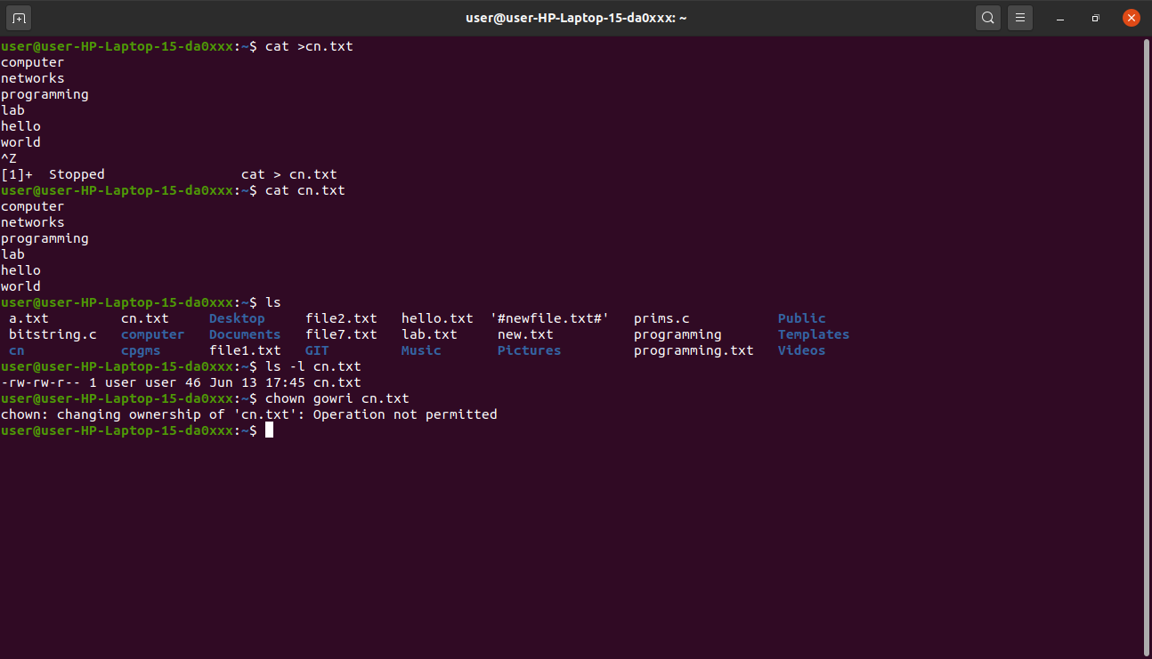

**23. ps**

Ps command will display all current processes along with their process ids (PID) . Read

manuals for various options.

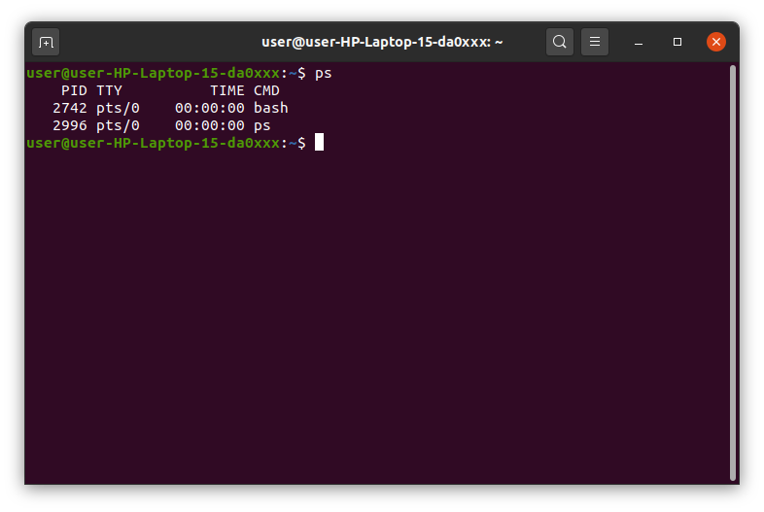

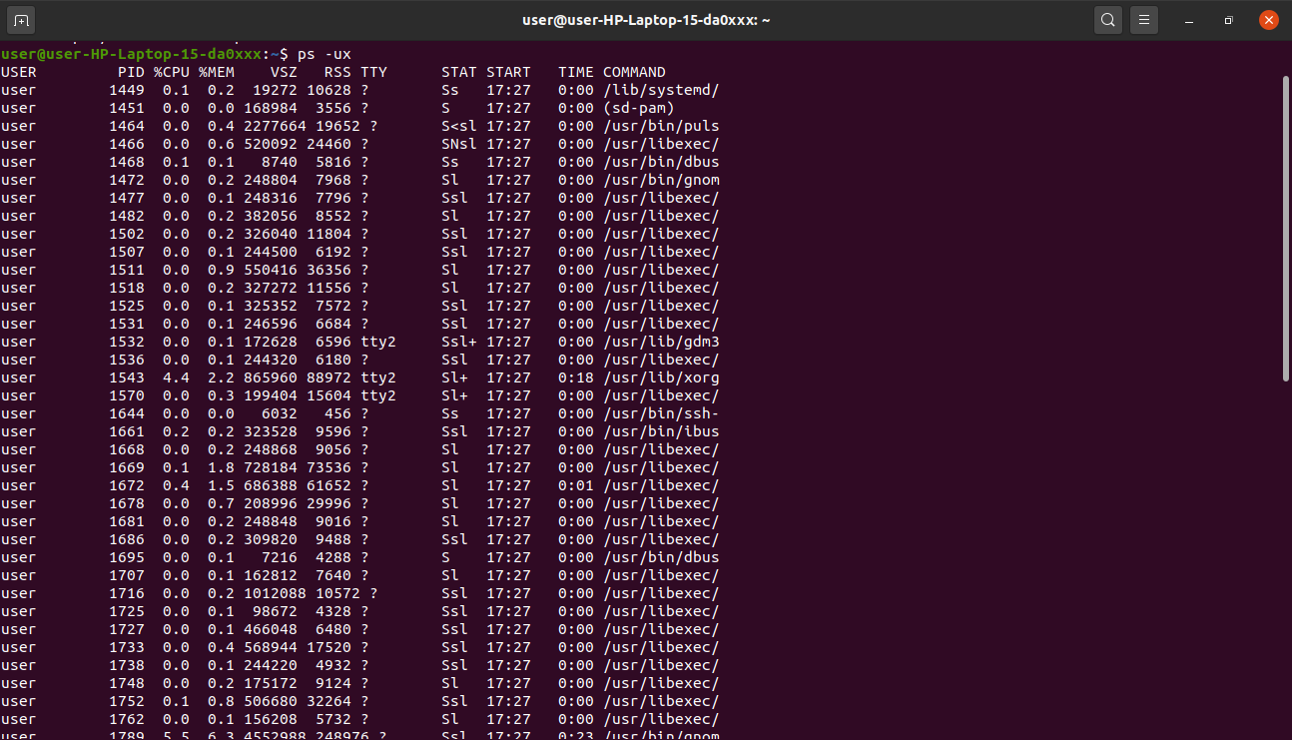

**24. Kill**

If you have an unresponsive program, you can terminate it manually by using the kill

command. It will send a certain signal to the misbehaving app and instructs the app to

terminate itself.

There is a total of sixty-four signals that you can use, but people usually only use two

signals:

● SIGTERM (15) — requests a program to stop running and gives it some time to save all

of its progress. If you don’t specify the signal when entering the kill command, this signal

will be used.

● SIGKILL (9) — forces programs to stop immediately. Unsaved progress will be lost.

Besides knowing the signals, you also need to know the process identification number (PID)

of the program you want to kill. If you don’t know the PID, simply run the command ps

ux.

After knowing what signal you want to use and the PID of the program, enter the following

syntax:

kill [signal option] PID.

You can issue kill -9 PID

**25. ping**

Use the ping command to check your connectivity status to a server. For example, by

simply entering ping google.com, the command will check whether you’re able to

connect to Google and also measure the response time.

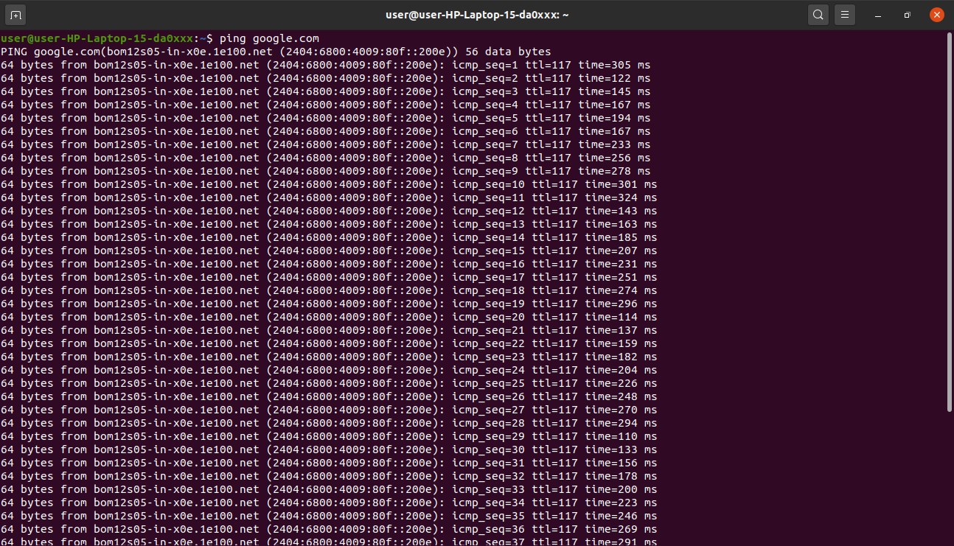

**26. wget**

The Linux command line is super useful — you can even download files from the internet

with the help of the wget command. To do so, simply type wget followed by the

download link.

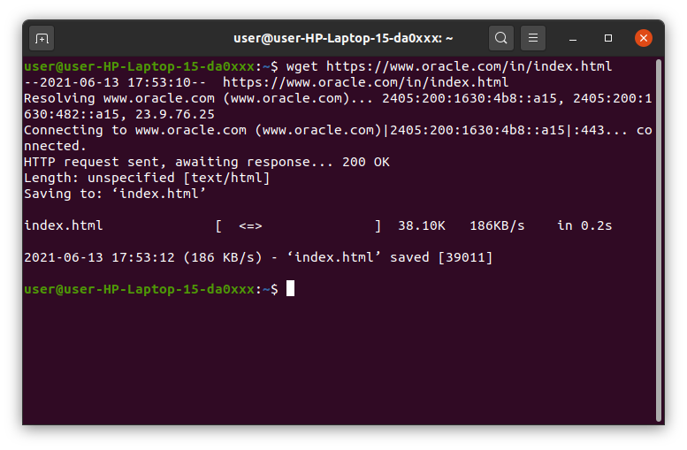

**27. uname**

The uname command, short for Unix Name, will print detailed information about your Linux

system like the machine name, operating system, kernel, and so on.

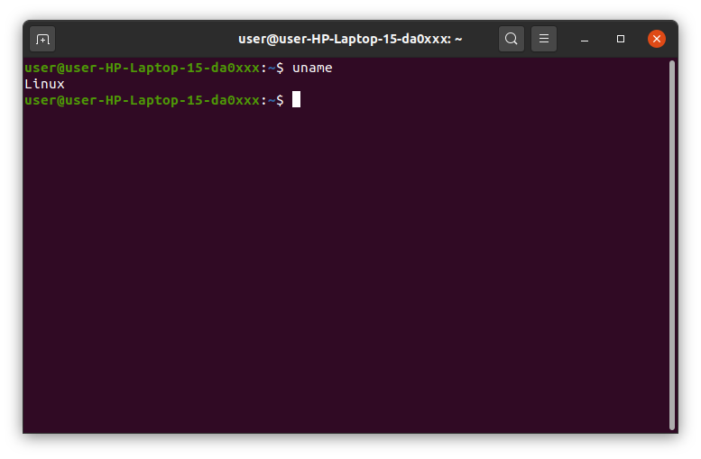

**28. top**

As a terminal equivalent to Task Manager in Windows, the top command will display a list of

running processes and how much CPU each process uses. It’s very useful to monitor

system resource usage, especially knowing which process needs to be terminated

because it consumes too many resources.

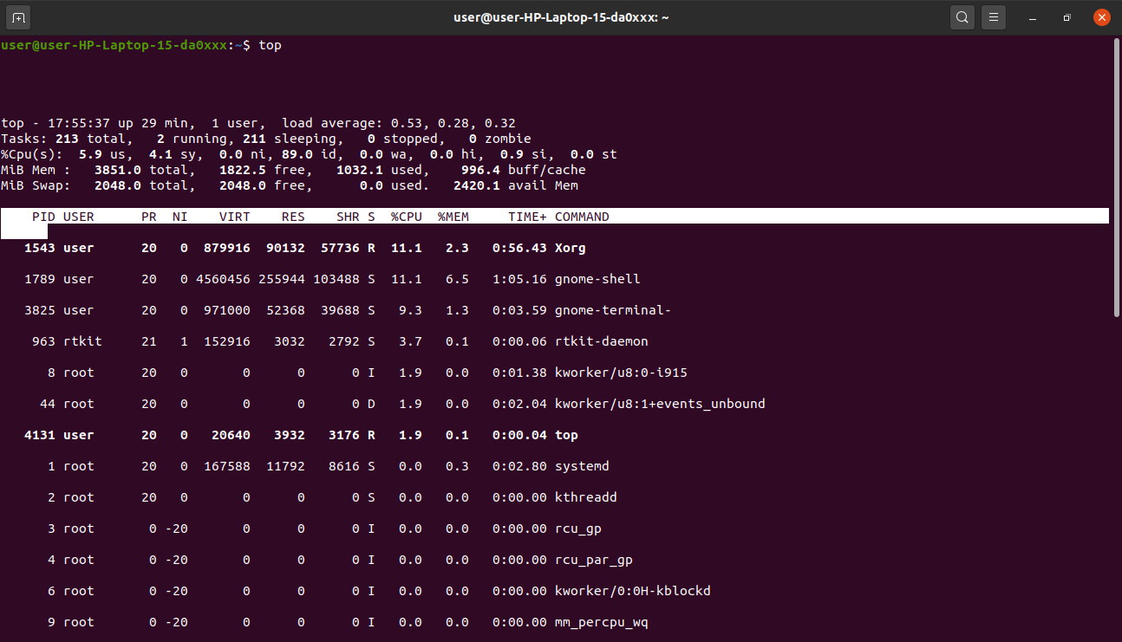

**29. history**

When you’ve been using Linux for a certain period of time, you’ll quickly notice that you can

run hundreds of commands every day. As such, running history command is particularly

useful if you want to review the s you’ve entered before.

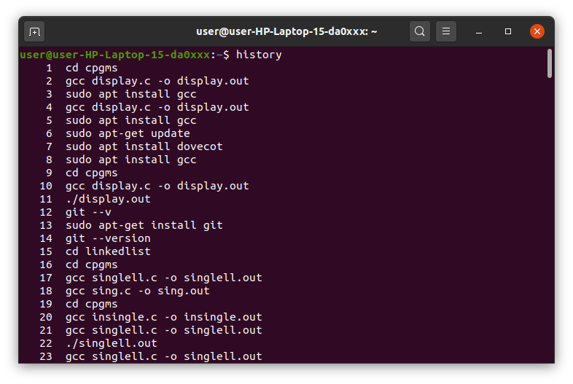

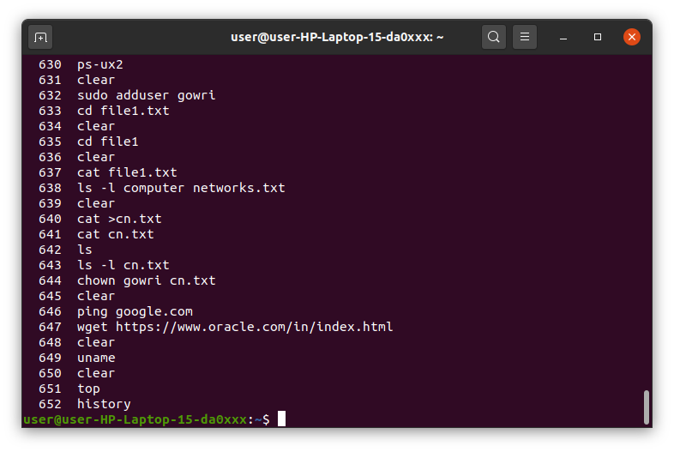

**30. man**

Confused about the function of certain Linux commands? Don’t worry, you can easily learn

how to use them right from Linux’s shell by using the man command. For instance,

entering man tail will show the manual instruction of the tail command.

Use the command: man man to start learning about man utility.

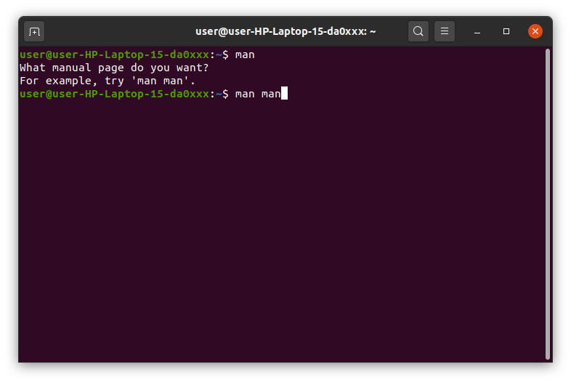

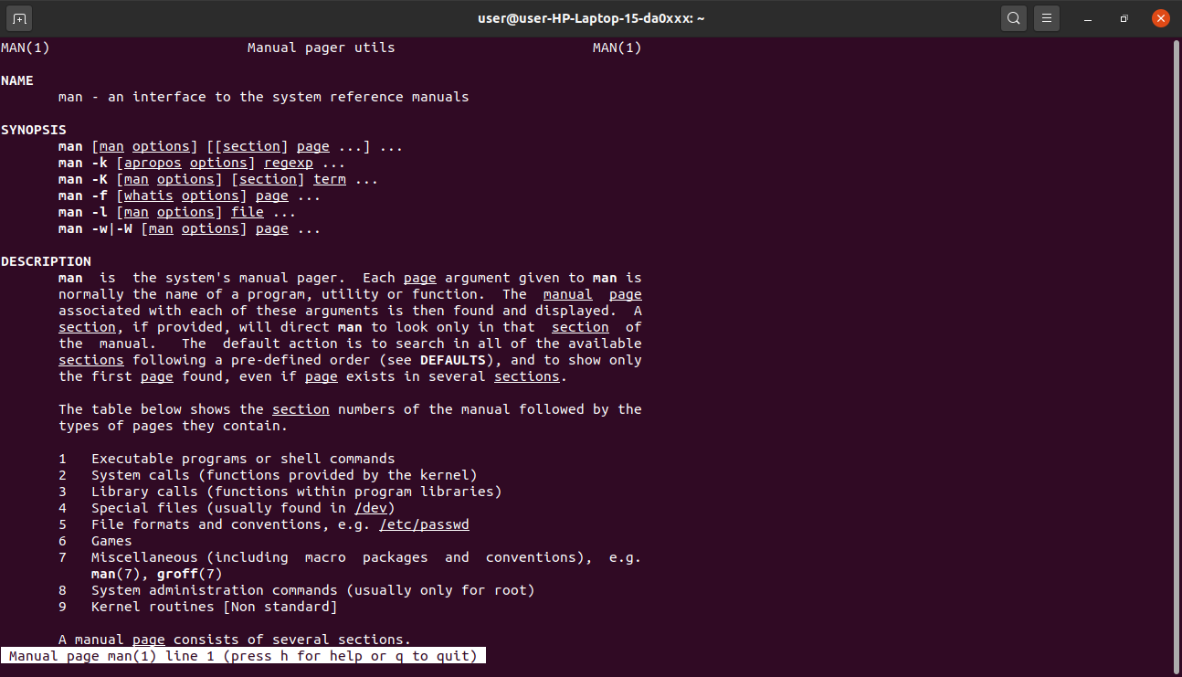

**31. echo**

This command is used to move some data into a file. For example, if you want to add the

text, “Hello, my name is John” into a file called name.txt, you would type echo Hello, my

name is John >> name.txt

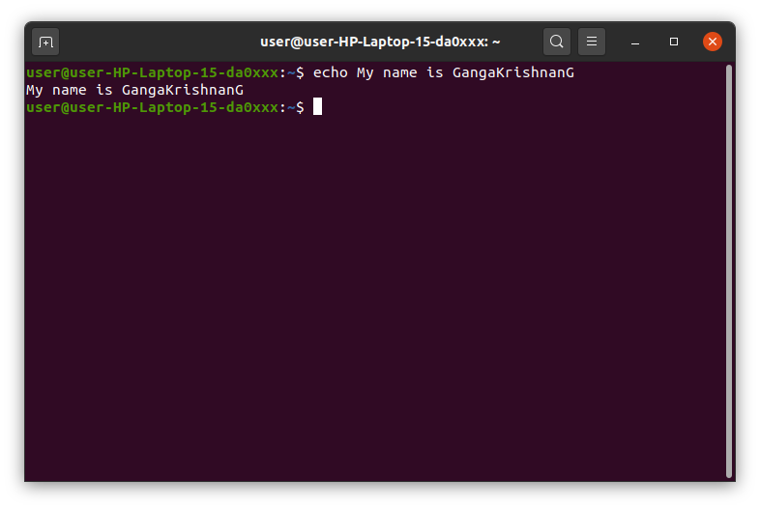

**32. zip, unzip**

Use the zip command to compress your files into a zip archive, and use the unzip command

to extract the zipped files from a zip archive. ( This program should be installed , some

distributions may not have them. You can also look at gzip and bzip commands)

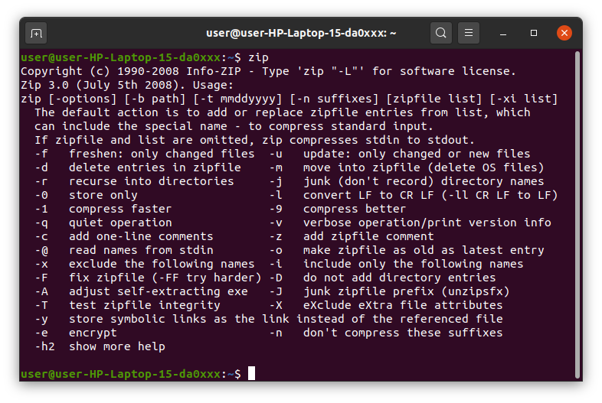

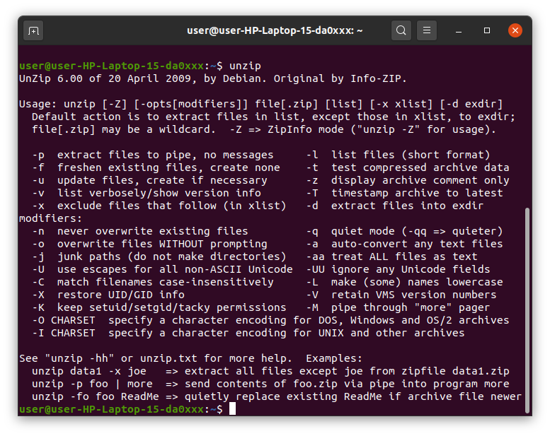

**33. hostname**

If you want to know the name of your host/network simply type hostname. Adding a -I to the

end will display the IP address of your network.

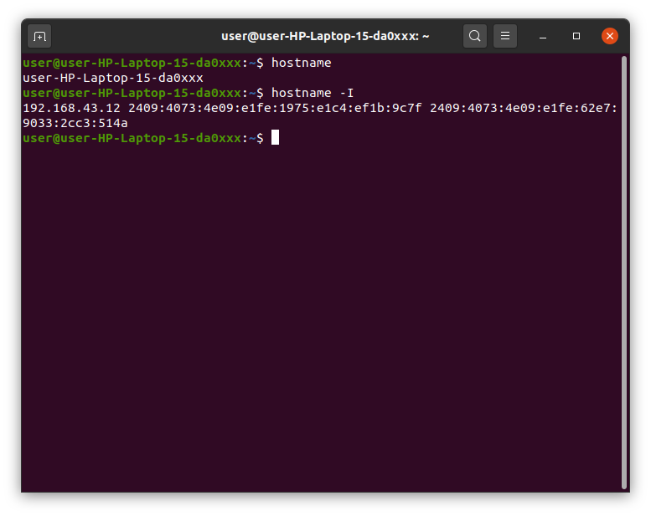

**34. useradd, userdel**

( This is available only to system admins) Since Linux is a multi-user system, this means

more than one person can interact with the same system at the same time. useradd is

used to create a new user, while passwd is adding a password to that user’s account.

To add a new person named John type, useradd John and then to add his password

type, passwd 123456789.

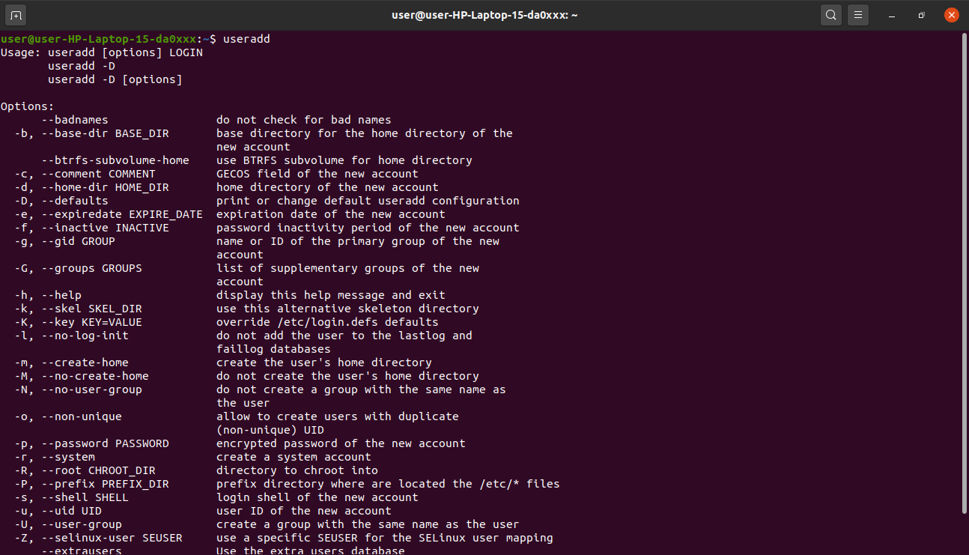

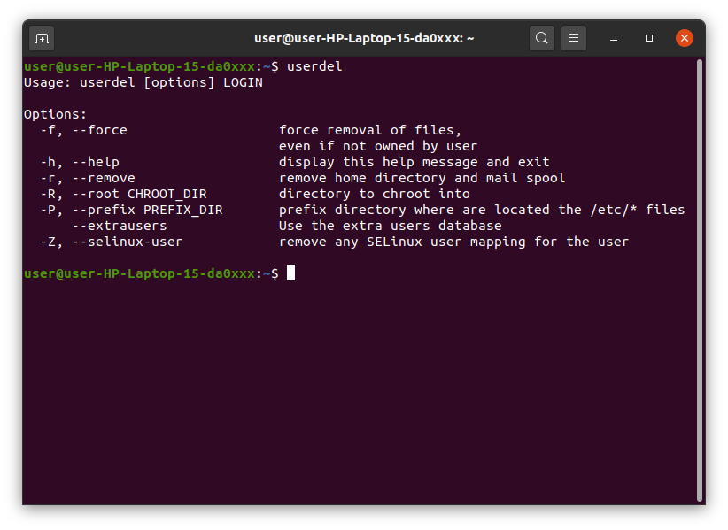

**EXPERIMENT-10**

**FAMILIARISATION WITH VI EDITOR**

The VI editor is the most popular and classic text editor in the Linux family. Below, are some reasons which make it a widely used editor –

1) It is available in almost all Linux Distributions

2) It works the same across different platforms and Distributions

3) It is user-friendly. Hence, millions of Linux use it for their editing needs

Nowadays, there are advanced versions of the vi editor available, and the most popular one is **VIM** which is **V**i **Im**proved. Some of the other ones are Elvis, Nvi, Nano, and Vile.

1. **VI OPERATIONAL MODES**

* Vi Command Mode:
* The vi editor opens in this mode, and it only understands commands.
* In this mode, you can perform administrative tasks such as move the cursor and cut, copy, paste the text.
* This mode also saves the changes you have made to the file.
* Commands are case sensitive. The right letter case should be used.
* Vi Insert Mode:
* This mode is for inserting text in the file.
* You can switch to the Insert mode from the command mode  **by pressing 'i' on the keyboard**
* Once you are in Insert mode, any key would be taken as an input for the file on which you are currently working.
* To return to the command mode and save the changes you have made you need to press the Esc key

**2. STARTING VI**

To open a file with vi, type: vi ‘filename’.txt

* 1. If the file does not exist, a screen will appear with just a cursor at the top followed by tildes (~) in the first column.
  2. If the file does exist, the first few lines of the file will appear.
  3. The status line at the bottom of the screen shows error messages and provides information and feedback, including the name of the file.

**3. Vi EDITING COMMANDS**

* i - Insert at cursor (goes into insert mode)
* a - Write after cursor (goes into insert mode)
* A - Write at the end of line (goes into insert mode)
* ESC - Terminate insert mode
* u - Undo last change
* U - Undo all changes to the entire line
* o - Open a new line (goes into insert mode)
* dd - Delete line
* 3dd - Delete 3 lines.
* D - Delete contents of line after the cursor
* C - Delete contents of a line after the cursor and insert new text. Press ESC key to end insertion.
* dw - Delete word
* 4dw - Delete 4 words
* cw - Change word
* x - Delete character at the cursor
* r - Replace character
* R - Overwrite characters from cursor onward
* s - Substitute one character under cursor continue to insert
* S - Substitute entire line and begin to insert at the beginning of the line
* ~ - Change case of individual character

**Note**: You should be in the "**command mode" to execute these commands**. VI editor is **case-sensitive** so make sure you type the commands in the right letter-case.

Make sure you press the right command otherwise you will end up making undesirable changes to the file. You can also enter the insert mode by pressing a, A, o, as required.

## **Moving within a file :**

* k - Move cursor up
* j - Move cursor down
* h - Move cursor left
* l - Move cursor right

You need to be in the command mode to move within a file. The default keys for navigation are mentioned below else; You can **also use the arrow keys on the keyboard**.

## Saving and Closing the file

* Shift+zz - Save the file and quit
* :w - Save the file but keep it open
* :q - Quit without saving
* :wq - Save the file and quit

You should be in the **command mode to exit the editor and save changes** to the file.

**RESULT**

* **‘i’ command**

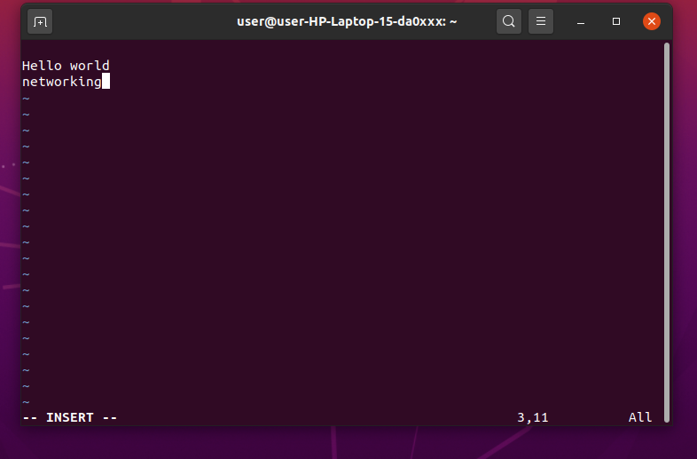

* **‘k’ command**: moves the cursor up one time.

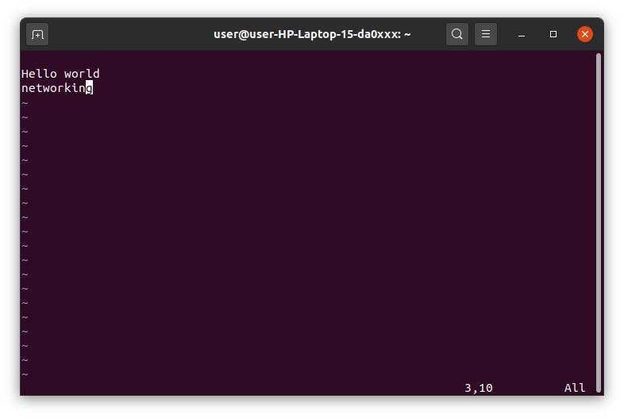

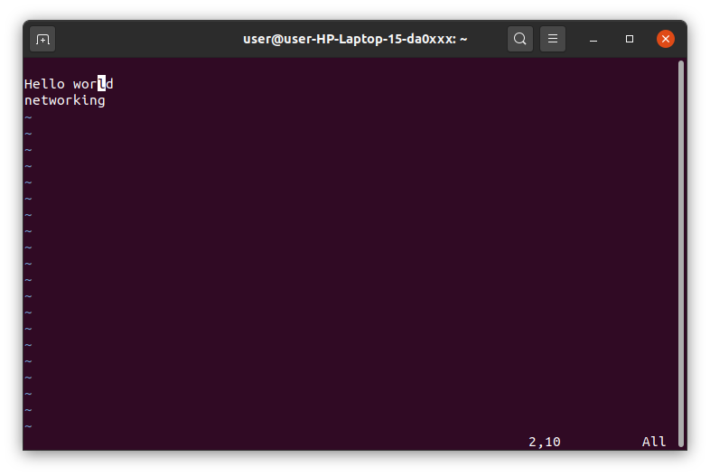

* **‘j’ command**:moves the cursor down one line.





* **‘h’ command**:moves the cursor to the left one character position.

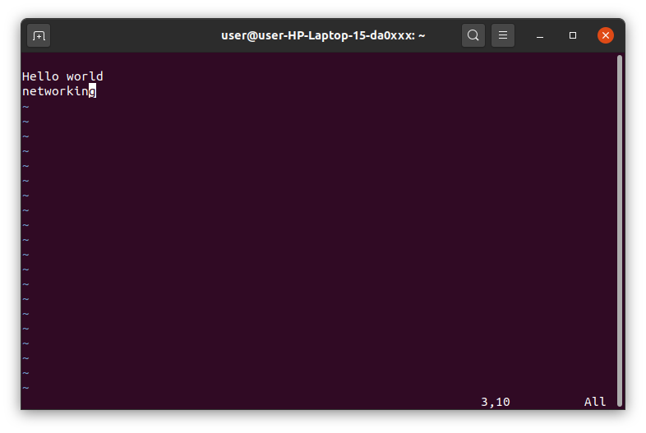

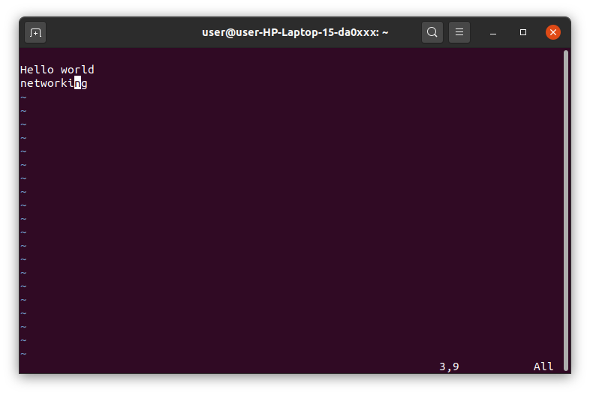

* **‘l’command**:moves the cursor to the right one character position.

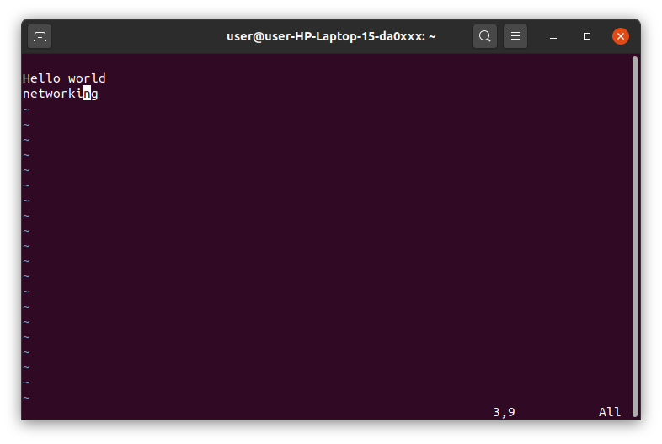



* **‘I’ command**:Insert text at the beginning of the current line.



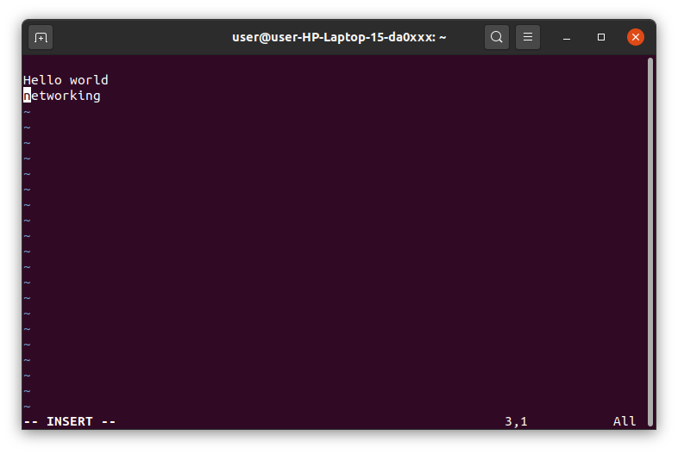

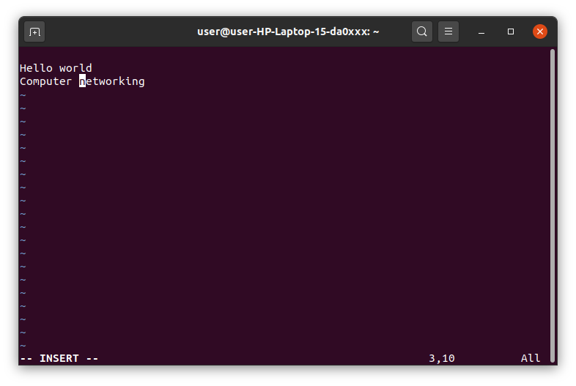

* **‘a’ command**:Insert text after the current cursor location.

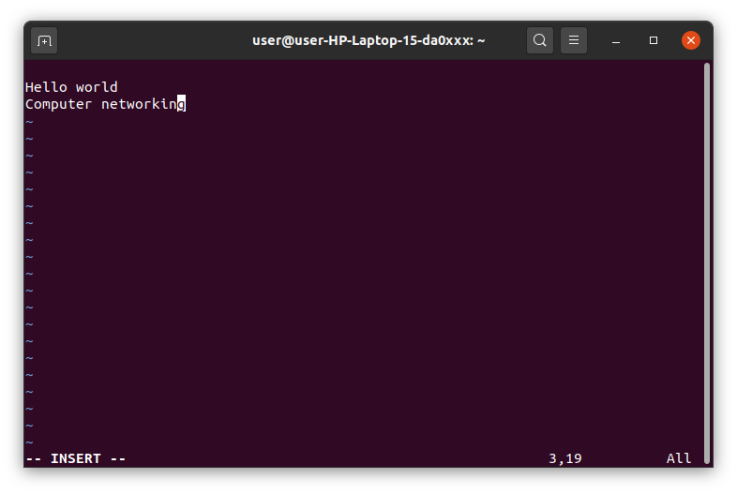

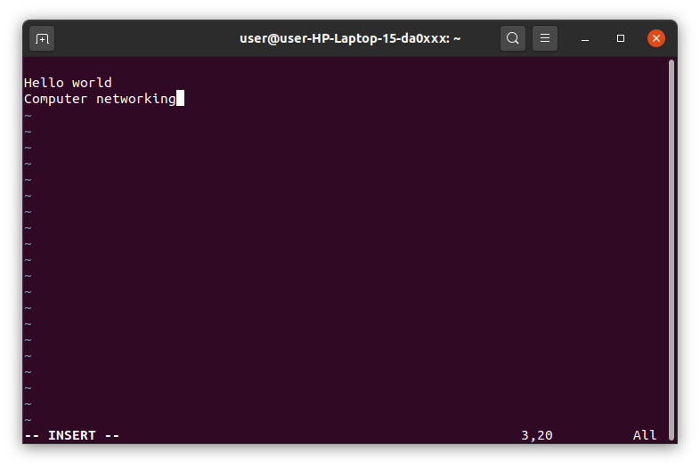

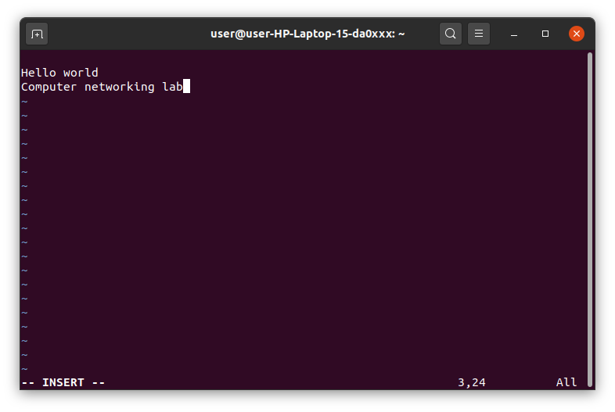

* **‘A’ command**:Insert text at the end of the current line.



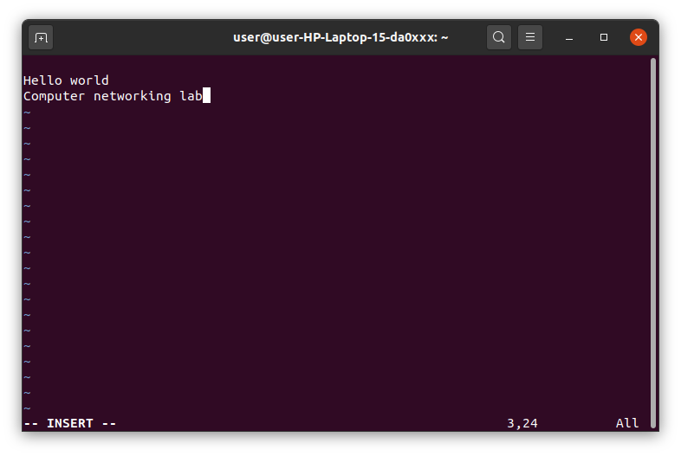

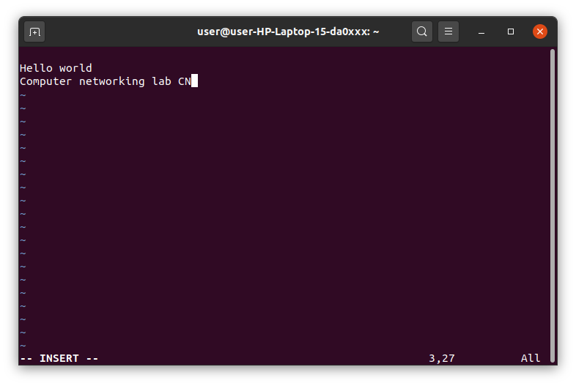

* **‘o’ command**:Creates a new line for text entry below the cursor location.



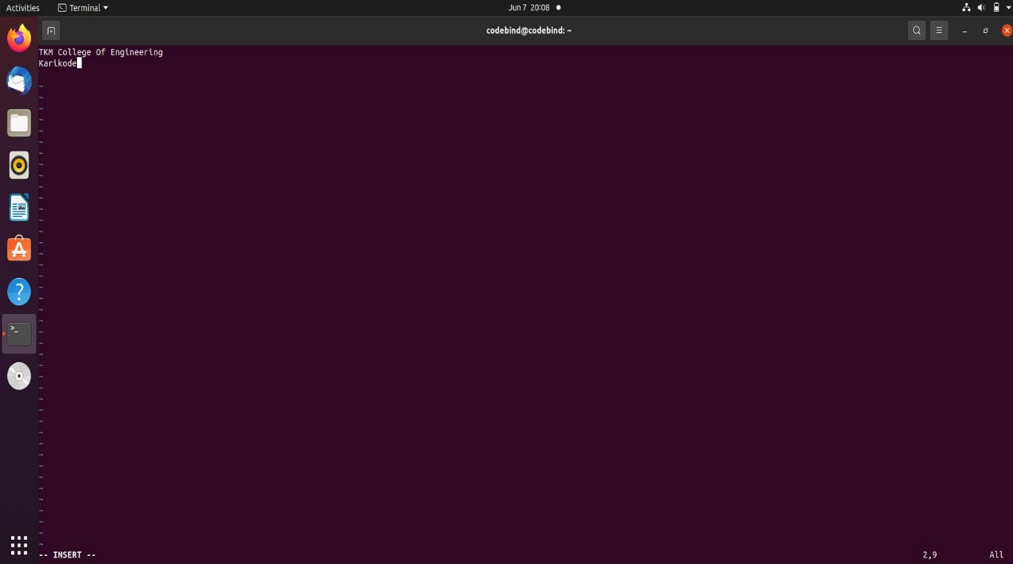

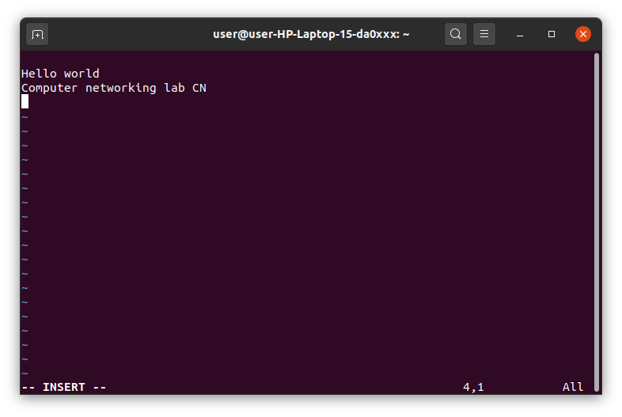

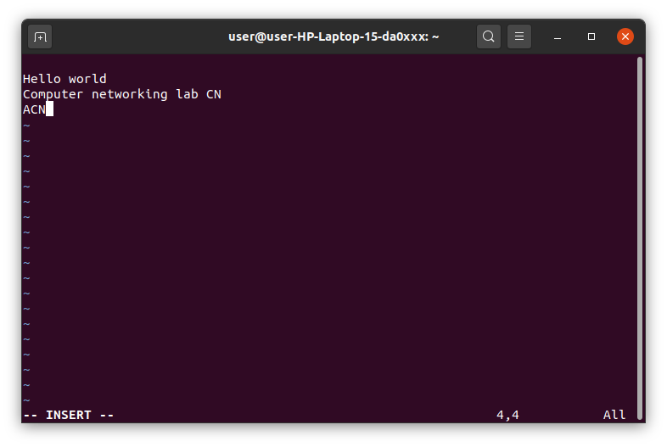

* **‘O’command**:Creates a new line for text entry above the cursor location.

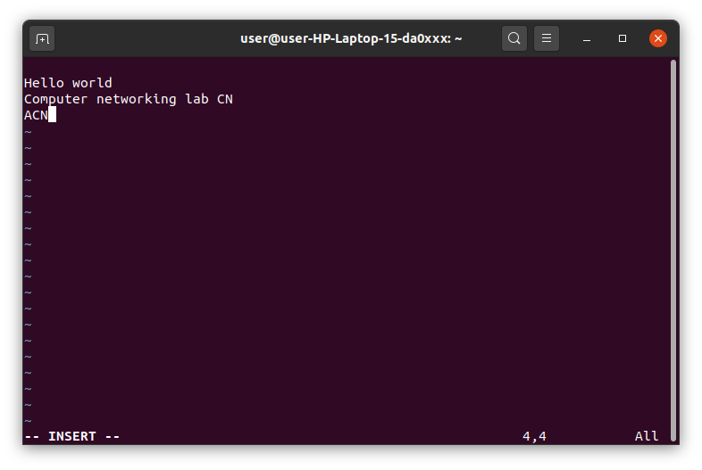

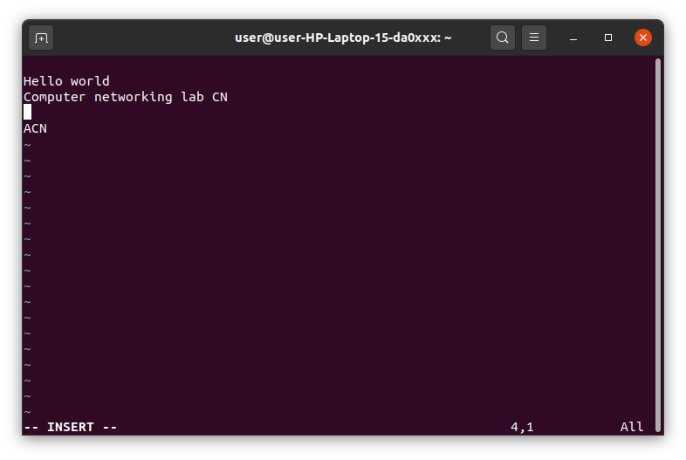

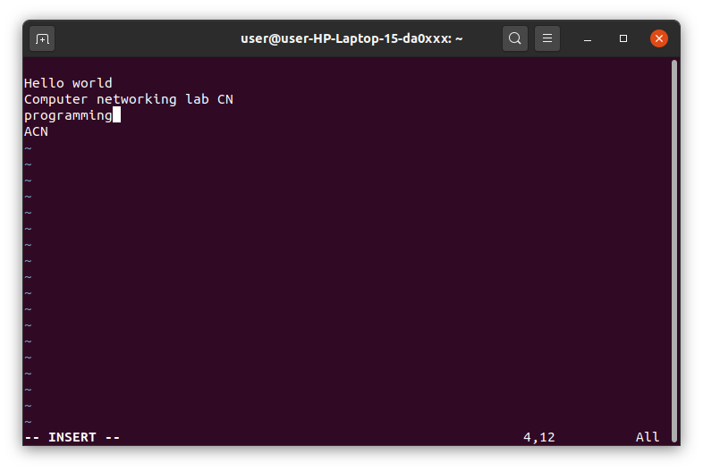

* **x command**:Deletes the character under the cursor location.

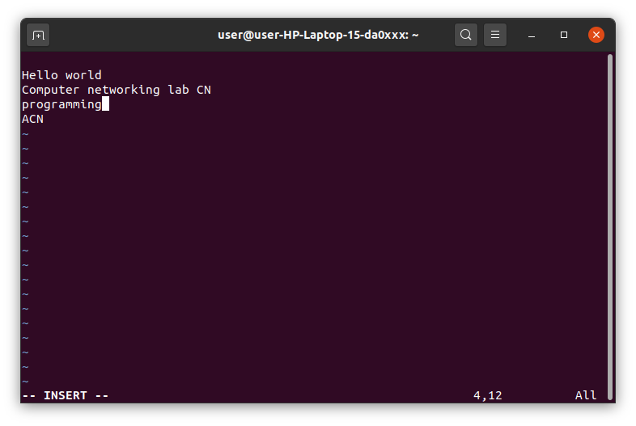

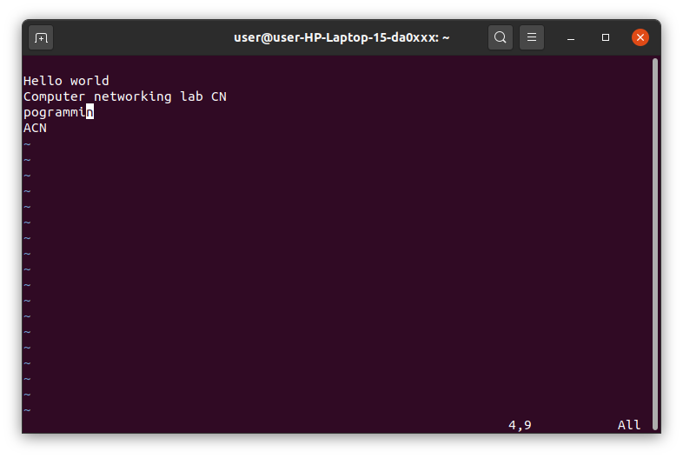

* **X command**:Delete the character before the cursor location.

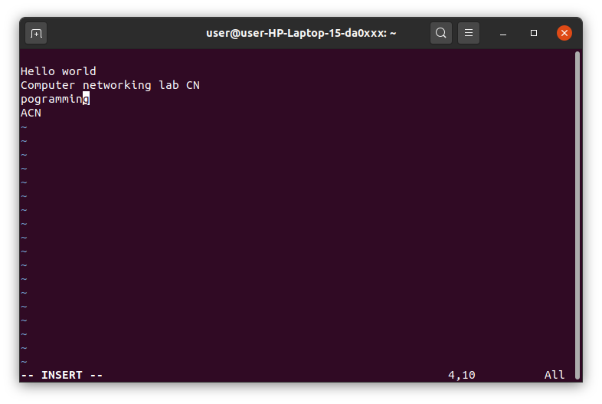

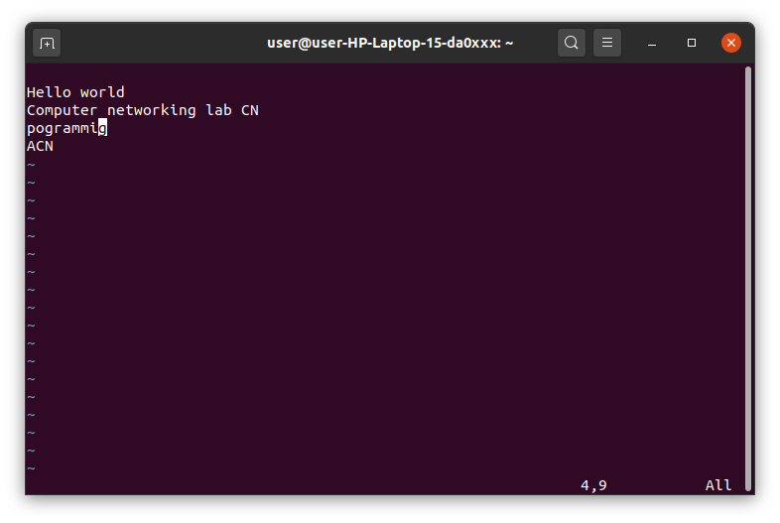

* **‘dw’ command**: Deletes from the current cursor location to the next word.

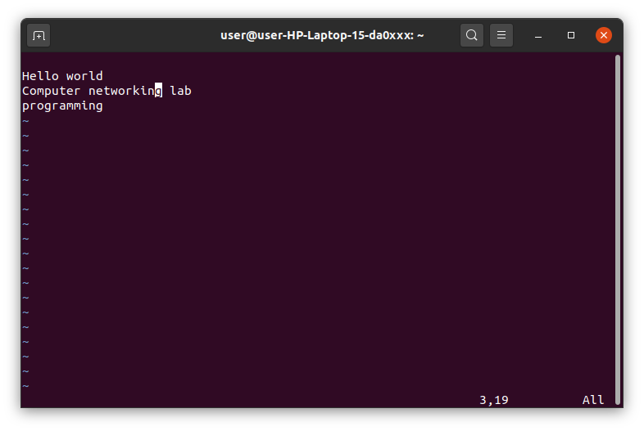

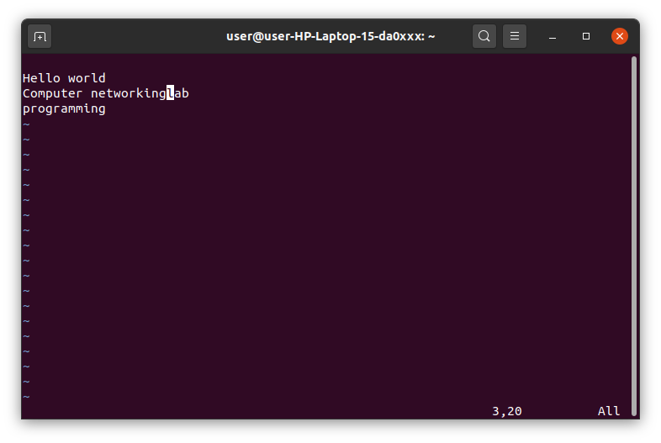

* **‘d^’ command**:Deletes from the current cursor position to the beginning of the line.

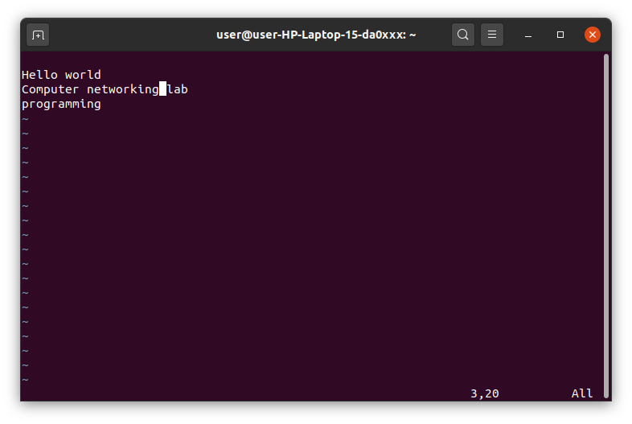

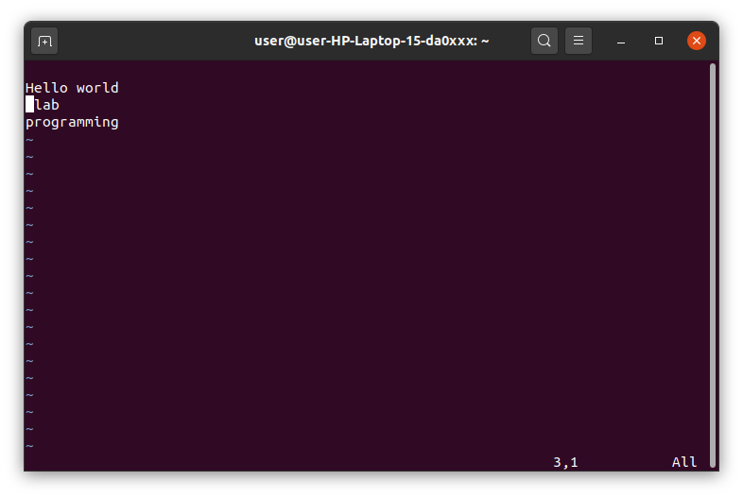

* **‘d$’ command**:Deletes from the current cursor position to the end of the line.

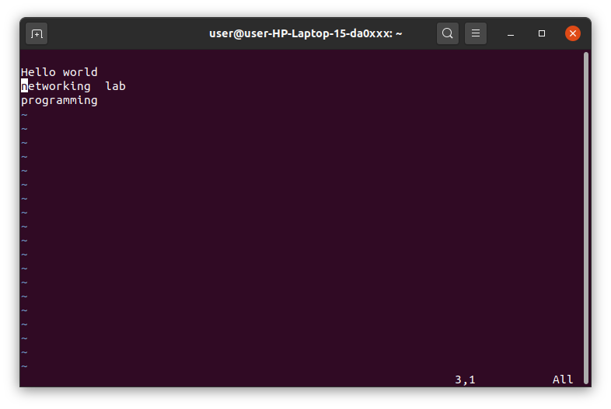

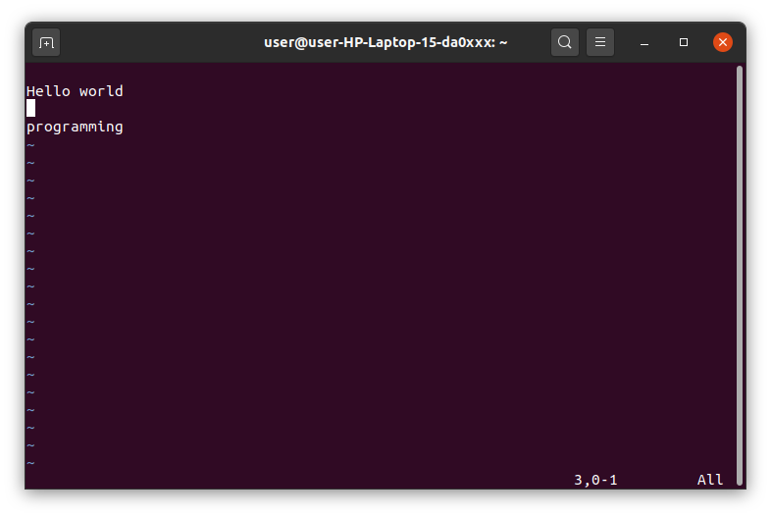

* **‘D’ command**:Deletes from the cursor position to the end of the current line.

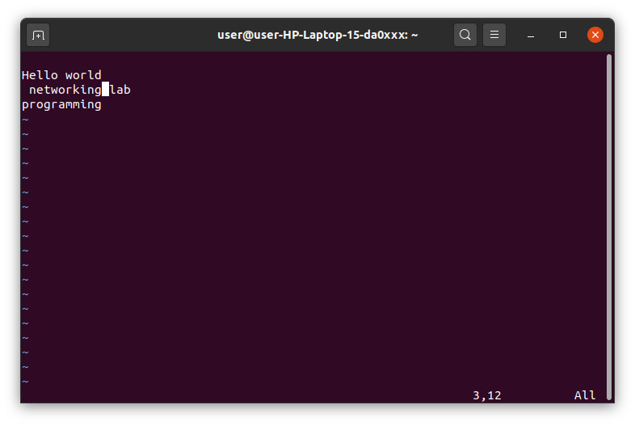

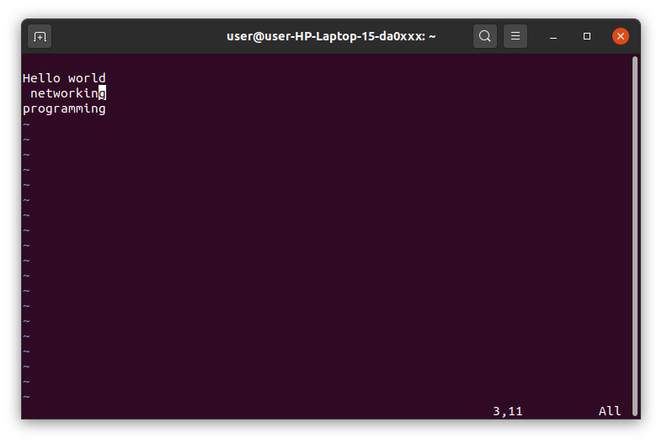

* **‘dd’ command**:Deletes the line the cursor is on.

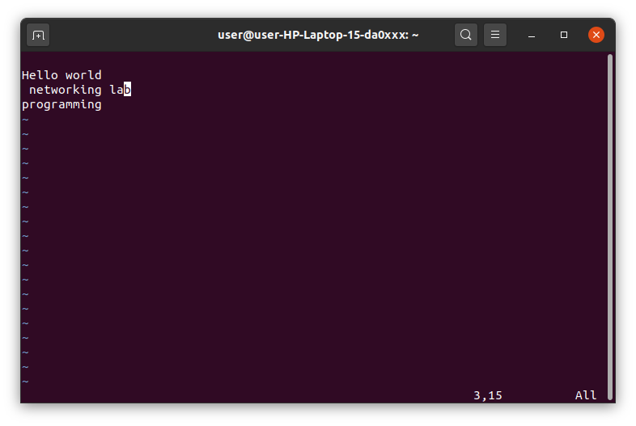

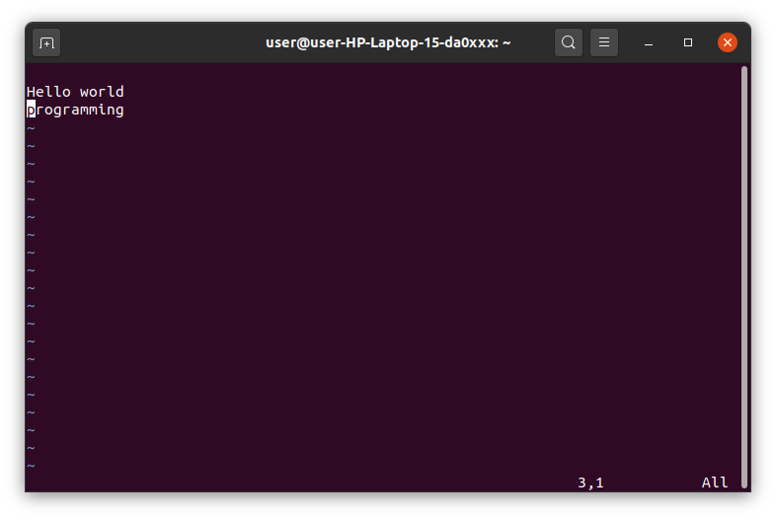

**EXPERIMENT-11**

**FAMILIARISATION OF EMACS TEXT EDITOR**

* very popular editor.
* most complex and flexible text editor than other text editors.
* freedom to the users to editing text files
* The emacs program can be running either in a terminal or in a GUI
* The main difference between text editors like vi, vim, nano, and the Emacs is that is faster, powerful, and simple in terms of usage because of its simple user interface.
* Emacs editor does not use an insert mode, and it is by default in editing mode, i.e., whatever you type will directly be written to the buffer, unless you manually enter command mode by using keyboard shortcuts.

**INSTALLING EMACS EDITOR ON UBUNTU**

**$ sudo apt-get install emacs**

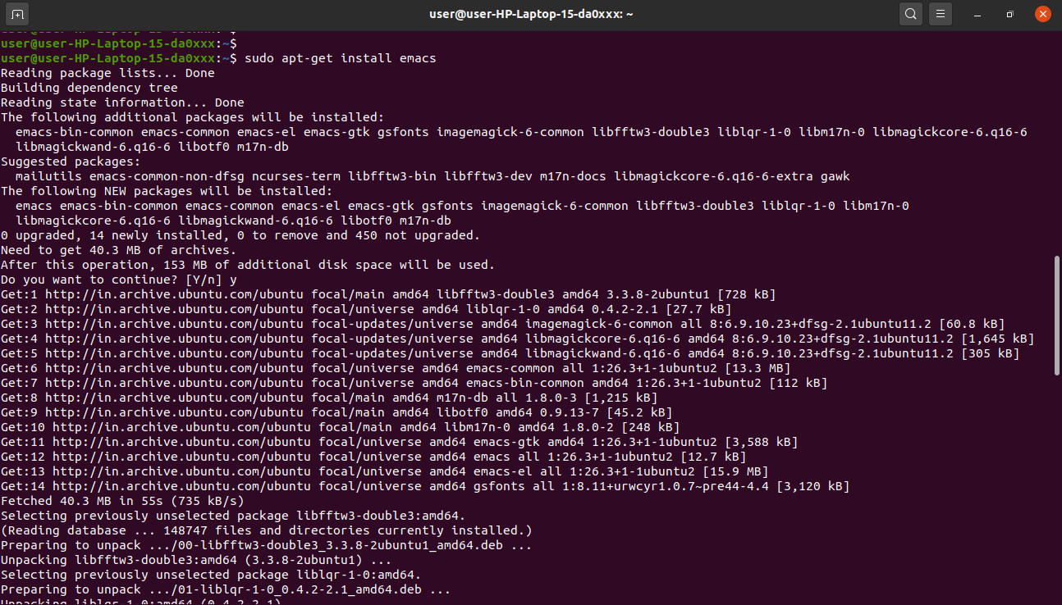

**$ emac --version**

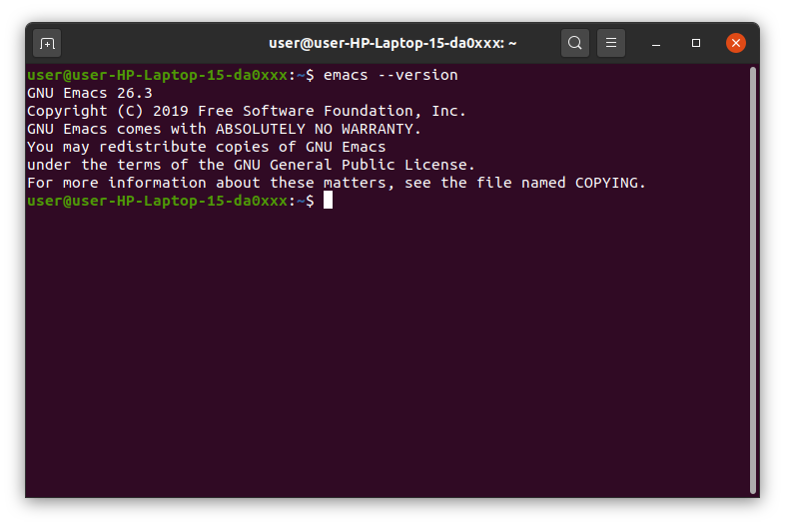

**OPEN EMACS EDITOR (IN GUI WAY)**

**$ emacs**

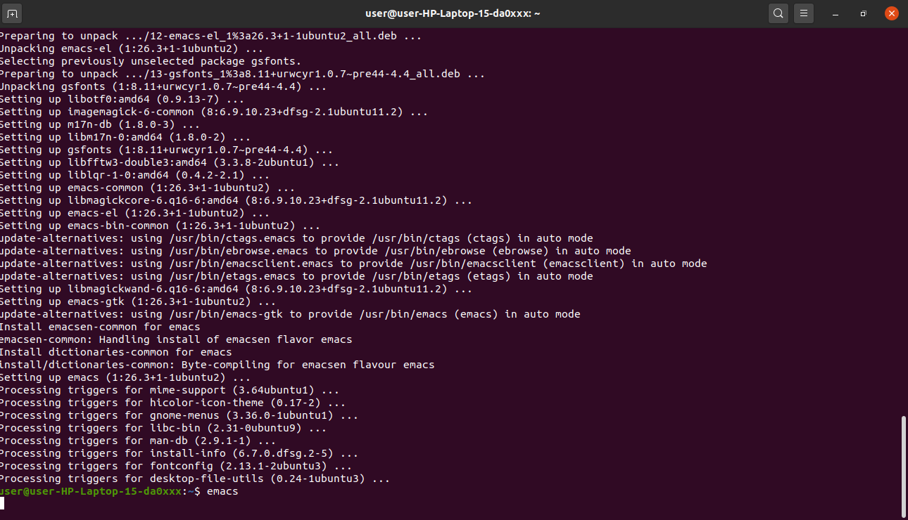

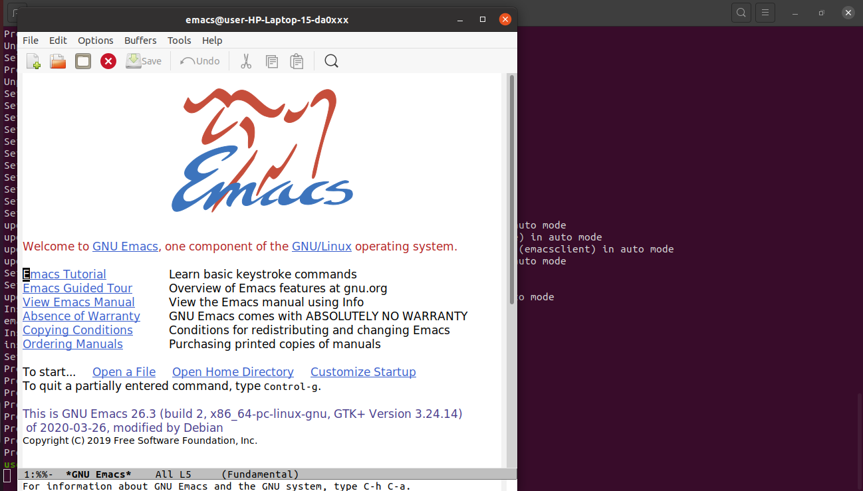

**OR YOU CAN OPEN**

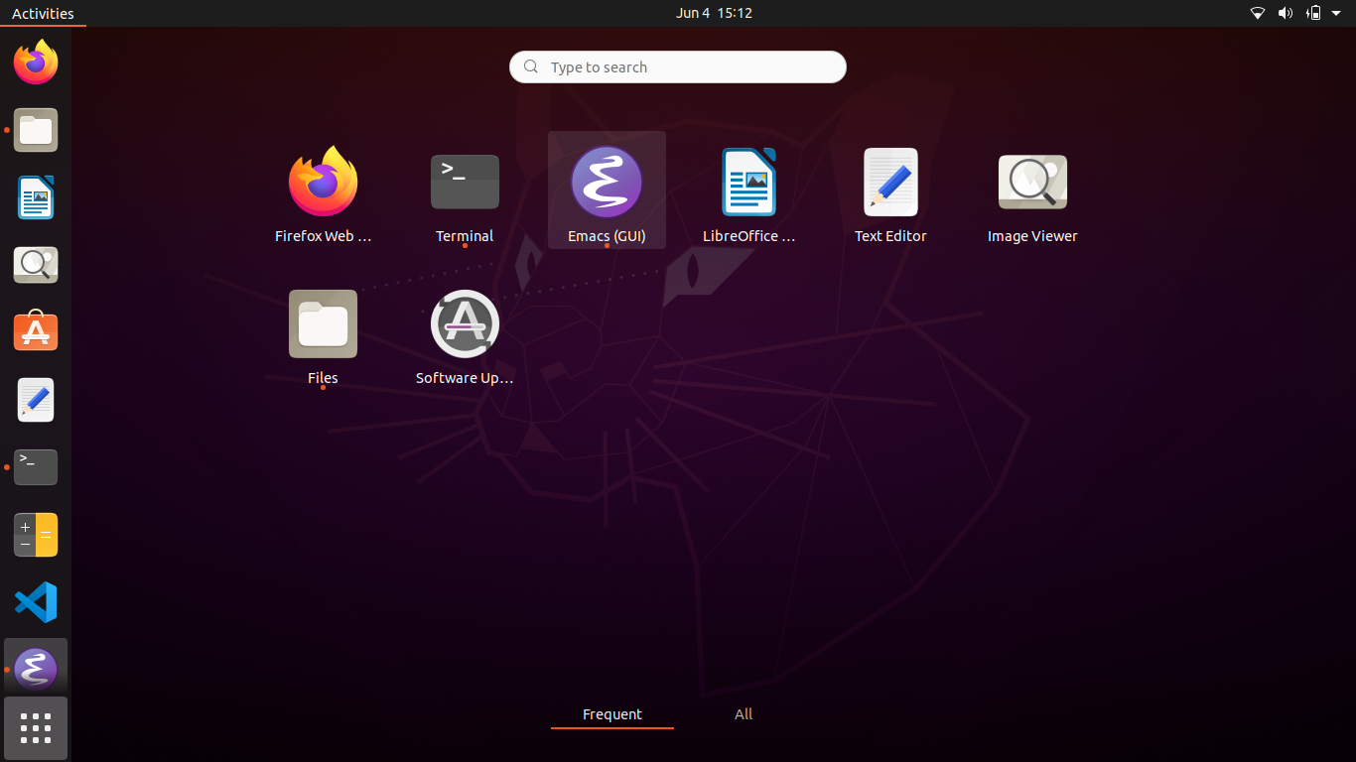



**OPEN EMACS EDITOR (IN TERMINAL)**

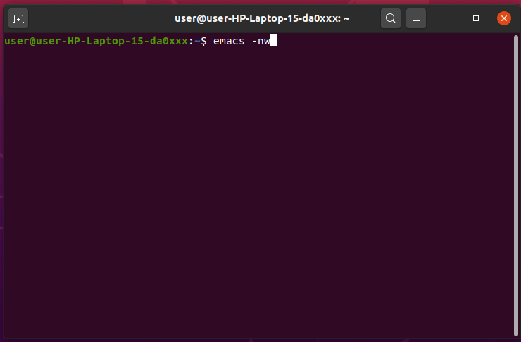

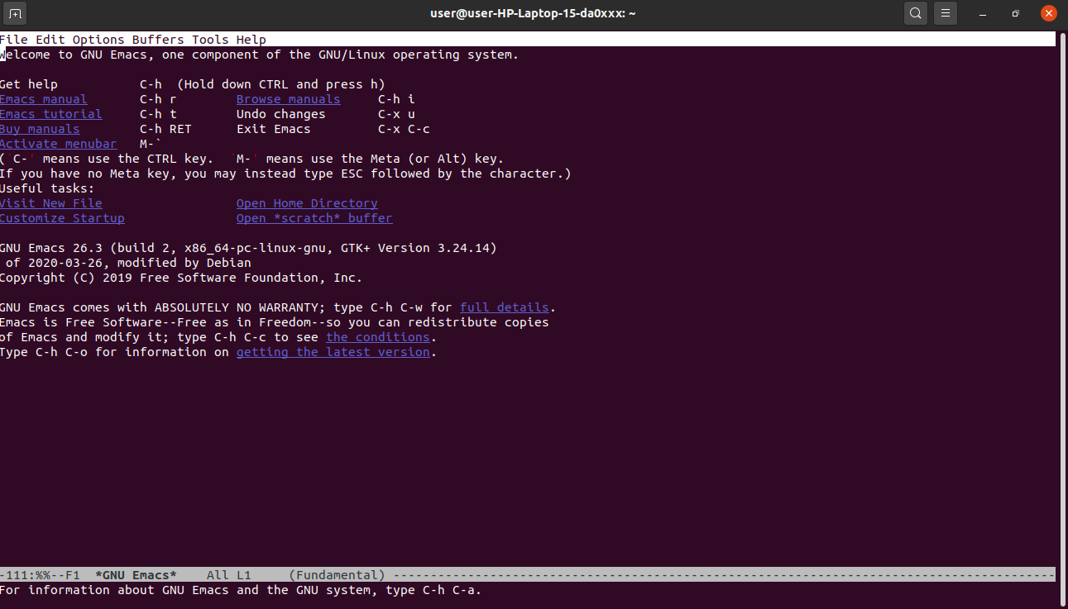

**TO CREATE A NEW FILE OR EXISTING TEXT FILE**

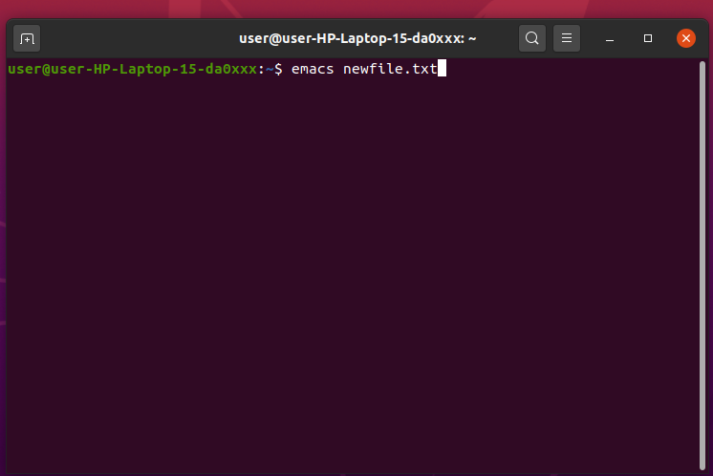

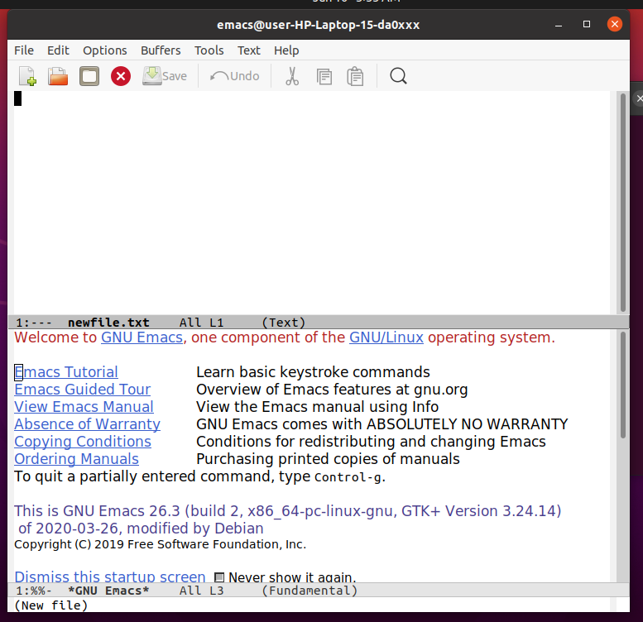

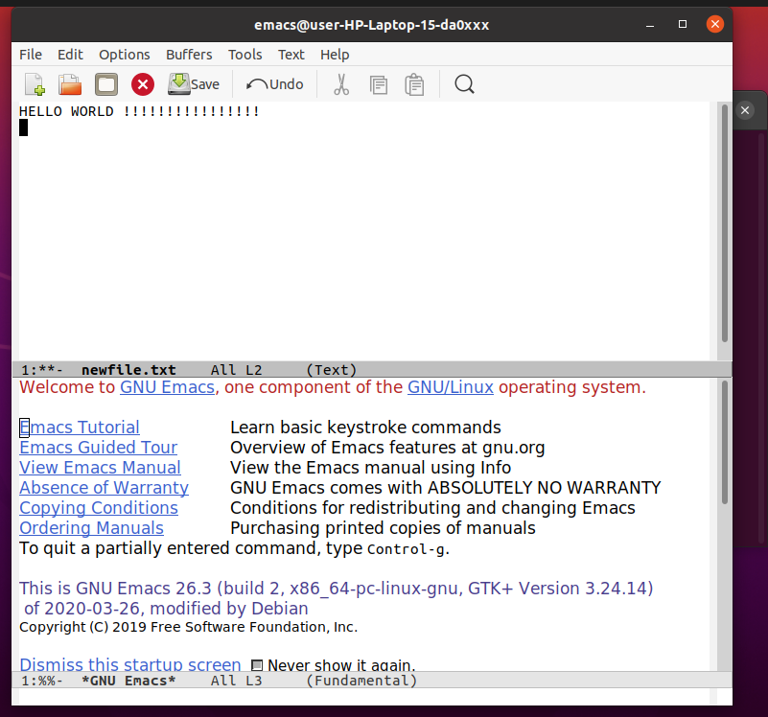

**SOME IMPORTANT COMMANDS**

|  |  |
| --- | --- |
| Commands | Actions |
| CTRL-X + CTRL-C | To exit emac |
| CTRL-H | To access help documentation |
| CTRL-X + CTRL-S | To save the current file |
| CTRL-X + CTRL-W | To save as new file |
| CTRL-X + CTRL-U | To undo the last edit |
| CTRL-G | To cancel the current command |
| CTRL-D | To delete(Kill) the character at the cursor |
| ESC -D | To delete characters from the cursor to the end of the current line |

|  |  |
| --- | --- |
| CTRL-K | To delete characters from the cursor to the end of the current line |
| ESC –W | To copy region as kill |
| CTRL-Y | To paste into the buffer what had been deleted |
| CTRL-S | To search the string from the current cursor position |
| CTRL-R | To search the string above the current cursor position |

**SOME CURSOR MOVEMENT COMMAND**

|  |  |
| --- | --- |
| Commands | Action |
| ESC-F | To move cursor forward |
| ESC-B | To move the cursor backward one word at a time |
| CTRL-A | To move the cursor to the beginning of the current line |
| CTRL-E | To move the cursor to the end of the current line |
| ESC-< | To move the cursor beginning of the buffer |
| ESC-> | To move the cursor to the end of the buffer |

**PROGRAMMING IN EMACS**

* The emacs editor provides the environment to programers develop programs such as c, java, HTML and shell script etc.
* After writing the program source code, it also compile,link,debug and execute itself in the terminal window to test it.

**EXPERIMENT-12**

**LINUX FILE SYSTEM**

A Linux file system is a structured collection of files on a disk drive or a partition.

A partition is a segment of memory and contains some specific data.

Linux file system is generally a built-in layer of a linux file system used to handle the data management of the storage.

The [Linux](https://www.javatpoint.com/linux-tutorial) file system contains the following sections:

1. The root directory (/)
2. A specific data storage format (EXT3, EXT4, BTRFS, XFS)
3. A partition or logical volume having a particular file system.

Some key features of linux file system are as following:

• Partition, Directories, and Drives

• Case Sensitivity

• File Extensions

• Hidden files

1) Ext, Ext2, Ext3 and Ext4 file system

• The file system Ext stands for Extended File System

• Ext file system is an older version, and is no longer used due to some limitations.

• Ext2 is the first Linux file system that allows managing two terabytes of data

• Ext3 is developed through Ext2; it is an upgraded version of Ext2 and contains backward compatibility.

• Ext4 file system is the faster file system among all the Ext file systems.

2) JFS File System

• JFS stands for Journaled File System

• It is an alternative to the Ext file system.

• It can also be used in place of Ext4, where stability is needed with few resources

3) ReiserFS File System

• ReiserFS is an alternative to the Ext3 file system

• It has improved performance and advanced features.

4) XFS File System

• XFS file system was considered as high-speed JFS, which is developed for parallel I/O processing.

5) Btrfs File System

• Btrfs stands for the B tree file system

• It is used for fault tolerance, repair system, fun administration, extensive storage configuration, and more

6) Swap File System

• The swap file system is used for memory paging in Linux operating system during the system hibernation

• A system that never goes in hibernate state is required to have swap space equal to its RAM size.

**LINUX FILE SYSTEM HIERARCHY**

The Linux File Hierarchy Structure or the Filesystem Hierarchy Standard (FHS) defines the directory structure and directory contents in Unix-like operating systems. It is maintained by the Linux Foundation.

· In the FHS, all files and directories appear under the root directory /, even if they are stored on different physical or virtual devices.

· Some of these directories only exist on a particular system if certain subsystems, such as the X Window System, are installed.

· Most of these directories exist in all UNIX operating systems and are generally used in much the same way; however, the descriptions here are those used specifically for the FHS and are not considered authoritative for platforms other than Linux.

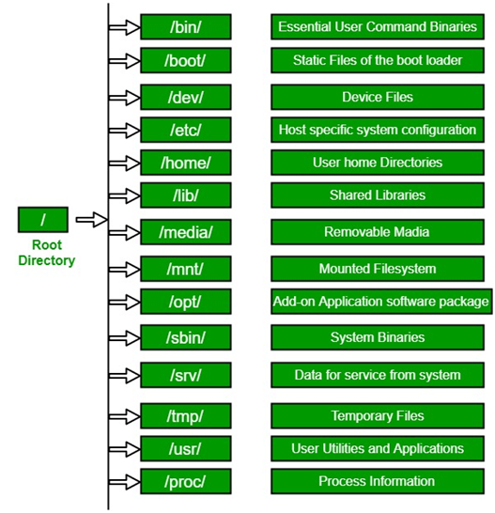

• ROOT DIRECTORY

All the directories in the Linux system comes under the root directory which is represented by a forward slash (/). Primary hierarchy root and root directory of the entire file system hierarchy.

* Every single file and directory starts from the root directory
* The only root user has the right to write under this directory
* /root is the root user’s home directory, which is not the same as /

/bin- The '/bin' directory contains user binaries, executable files, Linux commands that are used in single user model Contains binary executables

* Common linux commands you need to use in single-user modes are located under this directory.
* common commands that are used by all the users, like cat, cp, cd, ls, etc.

/sbin-'/sbin' directory also contains executable files.

but unlike '/bin' it only contains system binaries which require root privilege to perform certain tasks and are helpful for system maintenance purpose.

e.g. fsck, root, init, ifconfig, etc.

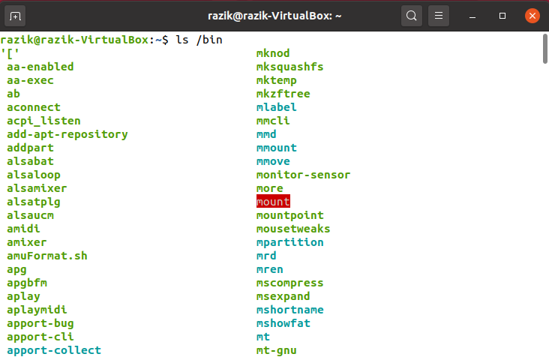

/lib-The '/lib' directory contains shared libraries which are often used by the '/bin' and '/sbin' directories.

* /lib/modules: The '/lib/modules' stores kernel modules and has a directory for each installed kernel.Modules are meant to use extra hardware support without making a new kernel.
* /lib32 and /lib64: During compilation time of libraries you'll encounter through the directories named '/lib32' and '/lib64' which will clarify register size to be used. A 64-bit system may have compatibility for 32-bit binary.

It also contains kernel module. These filenames are identable as ld* or lib*.

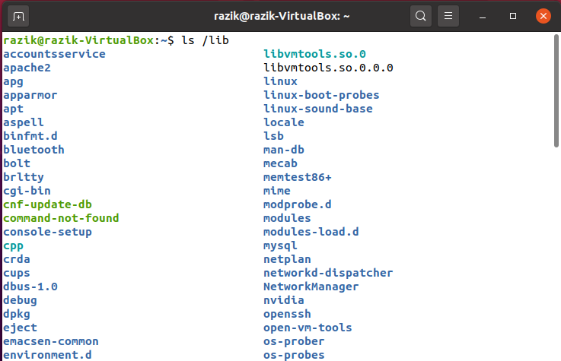

/opt- term 'opt' is short for optional.

Its main purpose is to store optional application software packages.

Add-on applications from individual vendors should be installed in '/opt’.

And so in some systems '/opt' is empty as they may not have any add-on application.

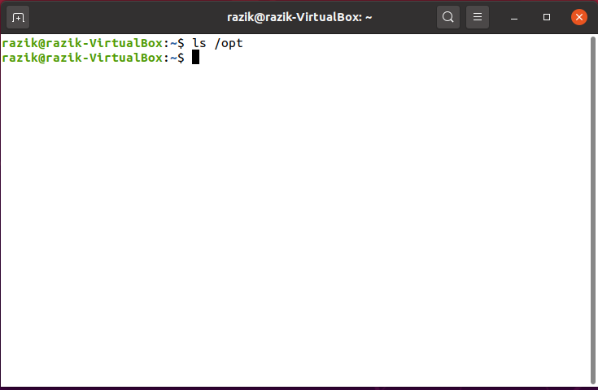

/boot-The '/boot' directory contains boot loader files which are essential to boot the system.

In other words, they only contain files which are needed for a basic Linux system to get up and going.

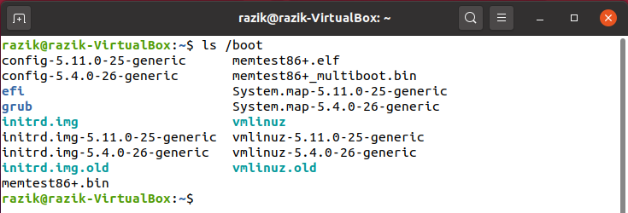

/etc-All the machine related configurtion files are kept in '/etc’.

Almost everything related to the configuration of your system is placed here.

It also contain startup and shutdown shell script which is used to start and stop a program. All the files are static and text based and no binary files can be placed in this directory.

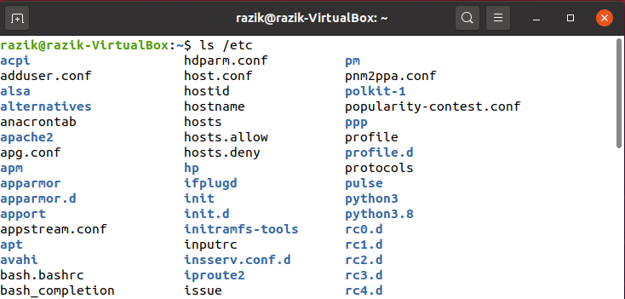

/home-The '/home' directory stores users personnel files.

After the '/home' there is a directory which is generally named at the user's name like we have '/home/username’.

Inside this directory we have our sub-directories like Desktop, Downloads, Documents, pictures, etc.

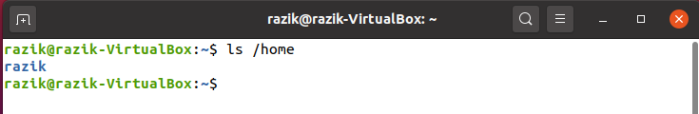

/root- The '/root' directory is the home directory of the root user.

• '/root' directory is different from (/) root.

/srv-The term 'srv' is short for service.

• The '/srv' directory contains server specific data for services provided by the system like www, cvs, rysync, ftp, etc.

/media-The '/media' directory acts as a mount point for removable media devices such as CD-Rom, floppy, USB devices, etc.

• This is newly introduced directory and hence a system can run without this directory also.

/tmp-The term 'tmp' stands for temporary.

• Data stored in '/tmp' is temporary and may use either disk space or RAM.

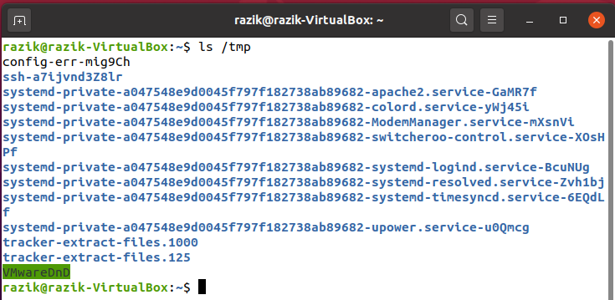

FILE PERMISSIONS:

Every file and directory on your Unix/Linux system is assigned 3 types of owner,

1.User

• A user is the owner of the file. By default, the person who created a file becomes its owner. Hence, a user is also sometimes called an owner.

2.Group

• A user- group can contain multiple users. All users belonging to a group will have the same Linux group permissions access to the file.

3.Other

• Any other user who has access to a file. This person has neither created the file, nor he belongs to a usergroup who could own the file.

• Every file and directory in your UNIX/Linux system has following 3 permissions defined for all the 3 owners

1.Read:

This permission give you the authority to open and read a file.

2.Write:

The write permission gives you the authority to modify the contents of a file. The write permission on a directory gives you the authority to add, remove and rename files stored in the directory

3.Execute:

If the execute permission is not set, you might still be able to see/modify the program code(provided read & write permissions are set), but not run it.

• chmod Linux command, used to change the read, write, and execute permissions of files and directories

• chmod +rwx filename to add permissions.

• chmod -rwx directory name to remove permissions.

• chmod +x filename to allow executable permissions.

• chmod -wx filename to take out write and executable permissions.

**EXPERIMENT-13**

**FAMILIARISATION TO LINUX SHELL AND SHELL SCRIPTING**

Shell Scripting is an open-source computer program designed to be run by the Unix/Linux shell. Shell Scripting is a program to write a series of commands for the shell to execute. It can combine lengthy and repetitive sequences of commands into a single and simple script that can be stored and executed anytime which reduces programming efforts.

**Kernel**

• The kernel is a computer program that is the core of a computer’s operating system, with complete control over everything in the system.

• It manages following resources of the Linux system –

* File management

* Process management

* I/O management

* Memory management

* Device management etc.

**Shell**

• A shell is a special user program which provides an interface to users to use operating system services.

• Shell accept human readable commands from the user and convert them into something which the kernel can understand.

• The shell gets started when the user logs in or starts the terminal.

• Shell is broadly classified into two categories:

* Command Line Shell

* Graphical shell

• The shell in the linux operation takes input in the form of commands, processes them and gives an output .

• When you are in the terminal the shell issues a command prompt.

• It is usually $ where you can type the input which is then executed by hitting Enter key.

Command Line Shell

Shell can be accessed by a user using a command line interface. A special program called Terminal in linux/macOS or Command Prompt in Windows OS is provided to type in the human readable commands such as “cat”, “ls” etc. and then it is being executed.

Graphical Shells

Graphical shells provide means for manipulating programs based on graphical user interface (GUI), by allowing for operations such as opening, closing, moving and resizing windows, as well as switching focus between windows.

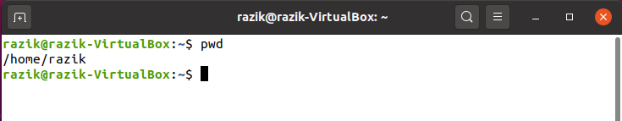

**BASH (Bourne Again Shell) :**

• It is the most widely used shell in Linux systems.

• It is used as the default login shell in Linux systems

• It can also be installed on Windows OS.

**Shell Scripting**

• Shell script is a series of command(s) stored in a plain text file.

• These files are called Shell Scripts or Shell Programs.

• Each shell script is saved with .sh file extension.

• eg: myscript.sh

**Creating a shell script**

1. Creating a file using any text editor

2. Start the script with #/bin/sh

3. Write some code

4. Save the script file as filename.sh

5. For executing the script type bash filename.sh

**Variables in Shell**

• Variables store data in the form of character and number.

• In Linux (Shell), there are two types of variable:

• System variables

- Created and maintained by Linux itself.

- This type of variable defined in CAPITAL LETTERS.

• User defined variables (UDV)

- Created and maintained by the user.

- This type of variable is defined in lower letters.

**The read Statement**

• Used to get input (data from user) from keyboard and store (data) to variables.

• Syntax:

◦ read variable1, variable2,...variableN

**Conditional Statements**

The if...else statements

If else statements are useful decision-making statements which can be used to select an option from a given set of options.

Unix Shell supports following forms of if…else statement −

• if...fi statement

• if...else...fi statement

• if...elif...else...fi statement

**•** if condition

-used for making decisions in shell script.

-If the condition is true

-Then command1 is executed.

**Syntax**:

if condition

then

command1 if condition is true or if exit status of

condition is 0

fi

if condition - Example

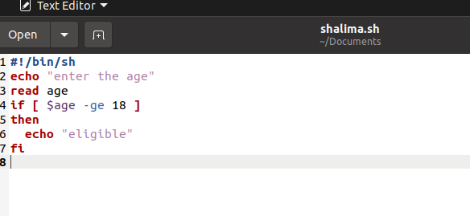

Output :

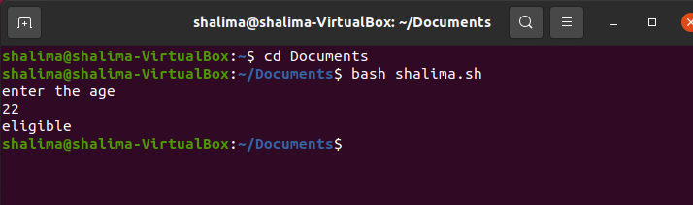

**• if...else...fi**

-If given condition is true

-Then command1 is executed

-Otherwise command2 is executed.

Syntax:

if condition

then

condition is zero (true - 0)

execute all commands up to else statement

else

if condition is not true then

execute all commands up to fi

fi

if...else…fi -Example

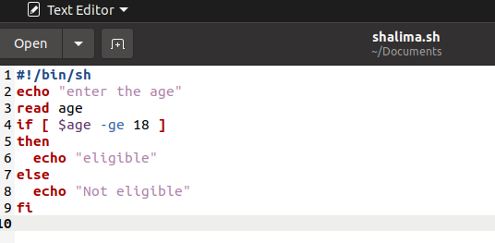

Output :

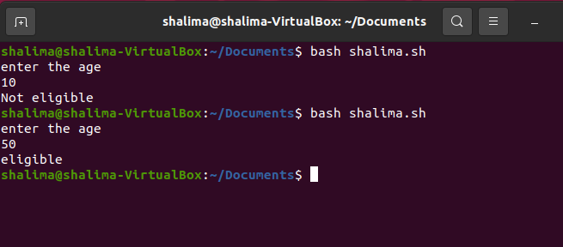



**Loops in Shell Scripts**

• Bash supports:

1. for loop

2. while loop

Note that in each and every loop,

• First, the variable used in loop condition must be initialized, then execution of the loop begins.

• A test (condition) is made at the beginning of each iteration.

• The body of the loop ends with a statement that modifies the value of the test (condition) variable.

**1. for Loop**

Syntax:

for (( expr1; expr2; expr3 ))

do

repeat all statements between do and done until

expr2 is TRUE

done

for loop - Example

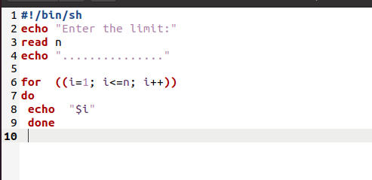

Output :

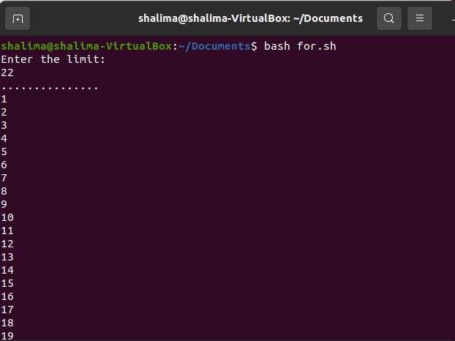

**2. while Loop**

Syntax:

while [ condition ]

do

command1

command2

..

....

done

While loop - Example

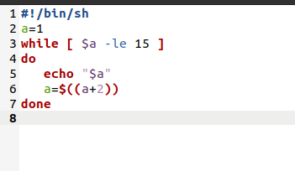

Output :

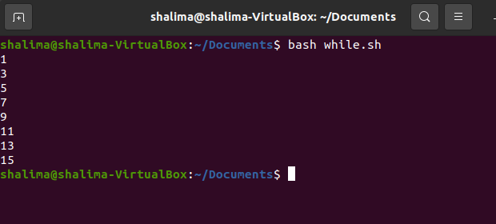

**Functions**

• Function is a series of instructions/commands.

• Function performs particular activity in shell.

• Code in a function is only executed when a function is ‘called’

Syntax:

function-name ( )

{

Function body

}

Function - Example 1

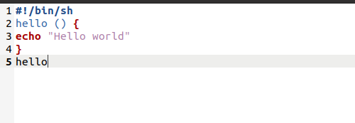

Output :

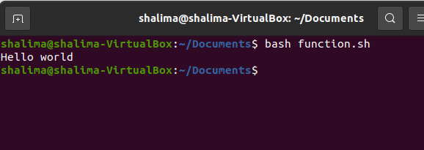

Function(using argument) - Example 2

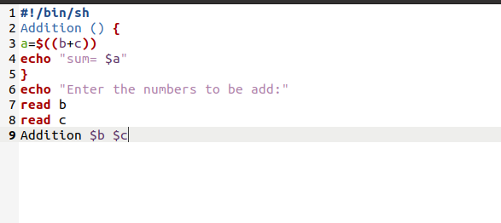

Output :

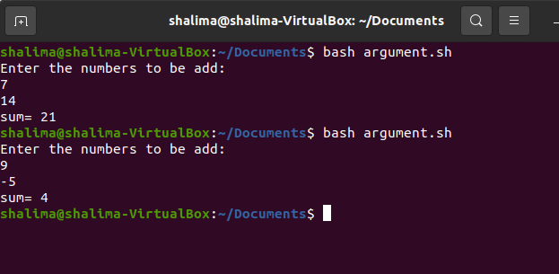

**Command Line Arguments**

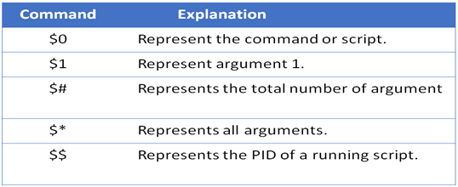

Example

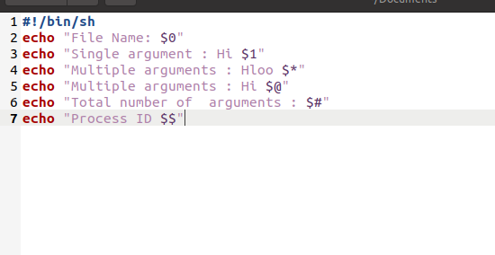

Output :

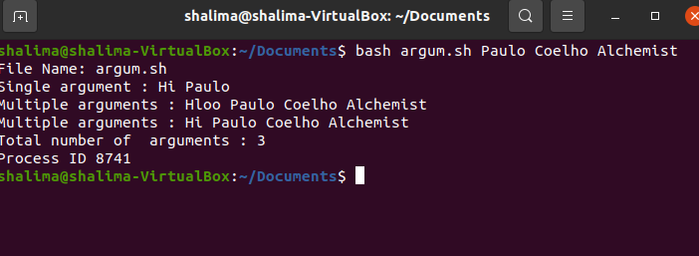

**Mathematical Operators**

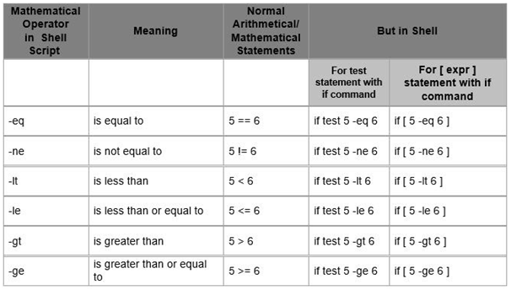

**String Operators**

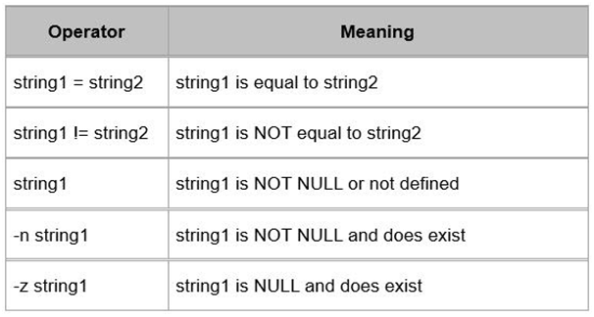

**EXPERIMENT-14**

**LINUX SHELL SCRIPTING PROBLEMS**

### 1. Write a shell script to get current date, time, username and current working?

**Ans :**

|  |
| --- |
| echo "HELLO,$LOGNAME"  echo "CURRENT DATE IS $(date)"  echo "USER IS $(whoami)"  echo "CURRENT DIRECTORY $(pwd)" |

**OUTPUT:**

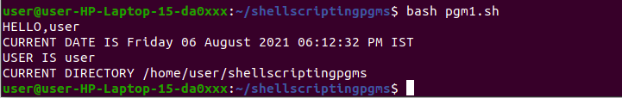

### 2. How to print the login names of all users on a system?

**Ans :**

cat /etc/passwd

**OUTPUT:**

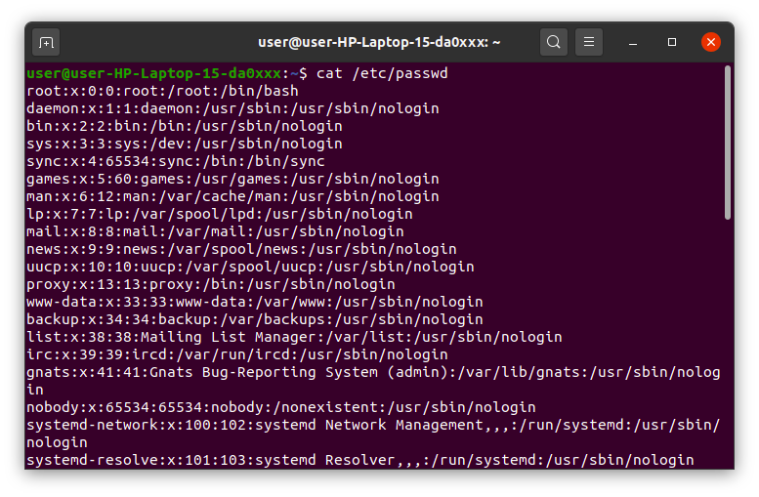

3. How can we pass arguments to a script in Linux? And how to access these

arguments from within the script?

**Ans :**

|  |
| --- |
| echo "First number : $1"  echo "Second number : $2"  echo "Third number : $3"  echo "Fourth number : $4"  echo "Fifth number : $5" |

**OUTPUT:**

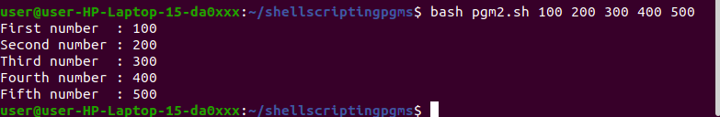

### 4. How to set an array in Linux?

**Ans :**

|  |
| --- |
| array=(hello i am ganga)  echo ${array[@]}  echo ${array[*]}  echo ${array[@]:0}  echo ${array[*]:0}  echo ${array[0]}  echo ${array[1]}  echo ${array[2]}  echo ${array[3]} |

**OUTPUT:**

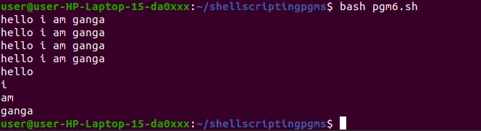

### 5. How to check if a directory exists?

**Ans :**

|  |
| --- |
| if [ -d "/home/user/shellscriptingpgms" ]  then  echo "/home/user/shellscriptingpgms exists."  else  echo "Error: Directory /home/user/shellscriptingpgms does not exists."  fi |

**OUTPUT :**



6. What is the difference between $* and $@?

**Ans:**

|  |
| --- |
| $@ treats each quoted arguments as separate arguments but $* considers  the entire set of positional parameters as a single string. |

7. Use the sed command to replace the content of the file?

**Ans:**

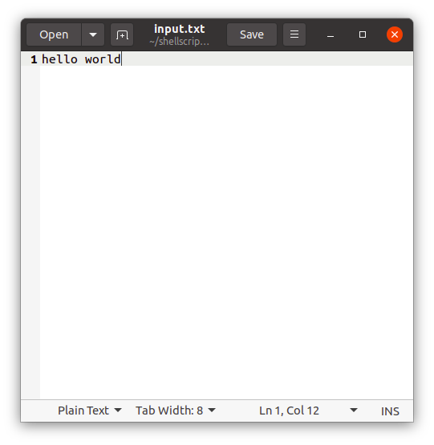



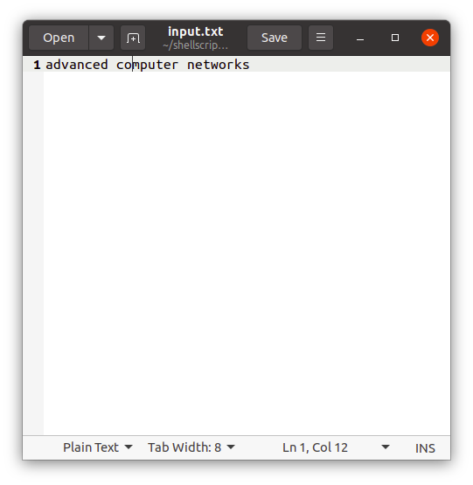

8. Write a script to compare numbers?

**Ans :**

|  |
| --- |
| var1=100  var2=200  if [ $var2 -gt $var1 ]  then  echo "$var2 is greater than $var1"  fi  #second comparison  echo "_______________________________"  if [ $var1 -gt 1000 ]  then  echo "$var1 is greater than 1000"  else  echo  echo "$var1 is less than 1000"  fi |

**OUTPUT:**

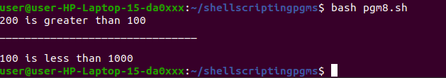

9. Write a shell script to check to see if the file “file_path” exists. If it does exist, display “file_path passwords are enabled.” Next, check to see if you can write to the file. If you can, display “You have permissions to edit “file_path.””If you cannot, display “You do NOT have permissions to edit“file_path””?

**Ans :**

|  |
| --- |
| FILE="/home/user/shellscriptingpgms/pgm1"  if [ -e "$FILE" ]  then  echo "$FILEpasswords are enabled"  fi  if [ -x "$FILE" ]  then  echo "You have permission to execute $FILE"  else  echo "You have no permission to execute $FILE"  fi |

**output :**

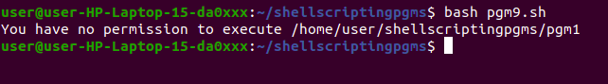

### 10. How to print all array indexes?

**Ans :**

|  |
| --- |
| arr=(10 20 30 40 50)  echo "index : value"  for((i=0;i<${#arr[@]};i++))  do  echo "$i : ${arr[$i]}"  done |

**OUTPUT :**

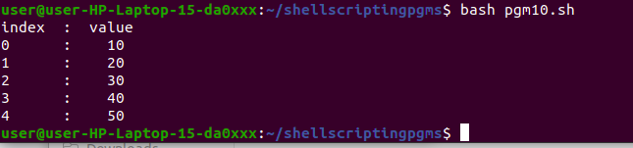

### 11 . Write a shell script to display the last updated file or the newest file in a directory?

**Ans :**

|  |
| --- |
| ls -lrt | grep ^- | awk 'END{print $NF}' |

**OUTPUT:**



### 12. Write a shell script that adds an extension “.new” to all the files in directory.

**Ans :**

|  |
| --- |
| dir=$1  for file in '$1/*'  do  mv $file $file.new  done |

### 13. Write a shell script to print a number in reverse order. It should support

### the following requirements.

### The script should accept the input from the command line.

### If you don’t input any data, then display an error message to execute the script correctly

**Ans :**

|  |
| --- |
| echo "Enter a number to be reversed :"  read n  if [ $n == 0 ]  then  echo "Please provide the correct input in the below format."  echo "Usage: $0 number"  echo " This script will reverse the given number."  echo " For eg. $0 1234, will print 4321"  exit 1  else  rev=0  sd=0  while [ $n -gt 0 ]  do  sd=`expr $n % 10`  rev=`expr $rev \* 10 + $sd`  n=`expr $n / 10`  done  echo "Reverse number is $rev"  fi |

**OUTPUT:**

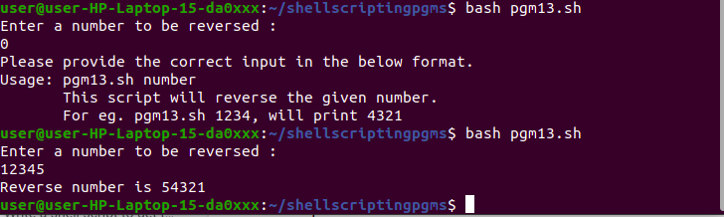

### 14. Write a shell script delete a file which has special characters in its file name.

**Ans:**

In Linux or Unix-like system, you may come across file names including the following special characters, white spaces, backslashes and more.

-

--

;

&

$

?

*

Bash shell considers most of the above special characters as commands. Thus, the “rm” command may not be able to delete such files. The simplest way to delete files having special characters in its name is by using the inode number

### 15. Write a shell script to find out the unique words in a file and also count the occurrence of each of these words. We can say that the file under consideration contains many lines, and each line has multiple words.

**Ans:**

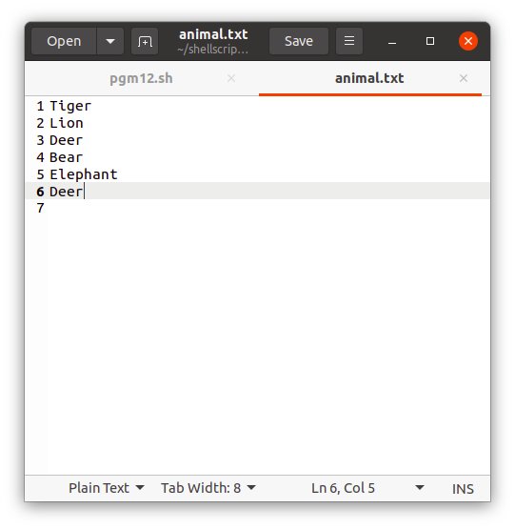

**OUTPUT:**

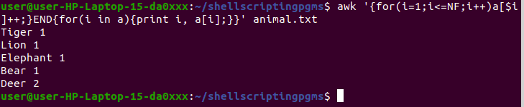

### 16. Write a script to print the first 10 elements of Fibonacci series.

**Ans :**

|  |
| --- |
| N=10  a=0  b=1  echo "The Fibonacci series is : "    for (( i=1; i<=N; i++ ))  do  echo -n "$a "  fn=$((a + b))  a=$b  b=$fn  done |

**OUTPUT:**



### 17. Write a shell script to get the total count of the word “Linux” in all the “.txt” files and also across files present in subdirectories.

**Ans :**

$ find  . -name *.txt -exec grep -c Linux '{}' \; | awk '{x+=$0;}END{print x}'

### 18. Write a shell script to validate password strength. Here are a few assumptions for the password string.

### Length  – minimum of 8 characters.Contain both alphabet and number.

### Include both the small and capital case letters.

### If the password doesn’t comply with any of the above conditions, then the script should report it as a <Weak Password>.

### 

**Ans :**

|  |
| --- |
| echo "Enter your password"  read password  len="${#password}"  if test $len -ge 8 ; then  echo "$password" | grep -q [0-9]  if test $? -eq 0 ; then  echo "$password" | grep -q [A-Z]  if test $? -eq 0 ; then  echo "$password" | grep -q [a-z]  if test $? -eq 0 ; then  echo "Strong Password"  else  echo "Weak Password -> Should include a lower case letter."  fi  else  echo "Weak Password -> Should include a capital case letter."  fi  else  echo "Weak Password -> Should use numbers in your password."  fi  else  echo "Weak Password -> Password length should have at least 8 characters."  Fi |

**OUTPUT:**

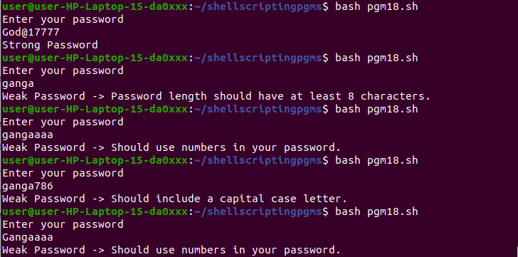

**EXPERIMENT-15**

**INSTALLATION OF LAMP ON UBUNTU**

**Introduction**

A “LAMP” stack is a group of open-source software that is typically installed together to enable a server to host dynamic websites and web apps. This term is actually an acronym which represents the Linux operating system, with the Apache web server. The site data is stored in a MySQL database, and dynamic content is processed by PHP

## Step 1 — Installing Apache and Updating the Firewall

First, make sure your apt cache is updated with:

**$ sudo apt update**

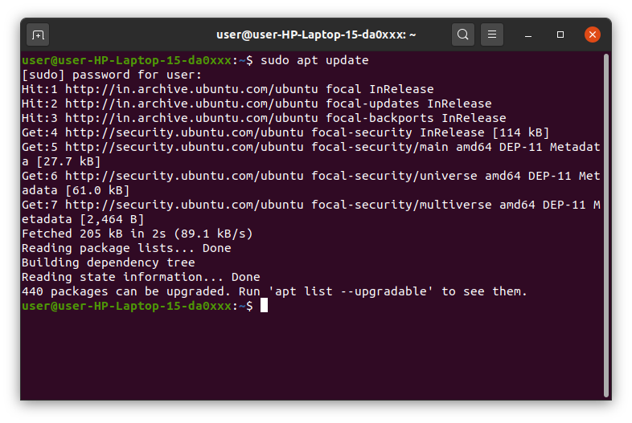

Once the cache has been updated, you can install Apache with:

**$ sudo apt install apache2**

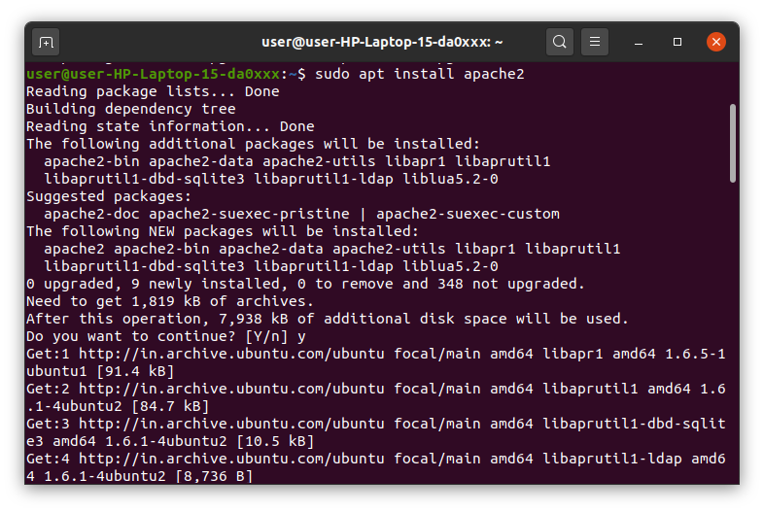

### Adjust the Firewall to Allow Web Traffic

**$ sudo ufw app list**

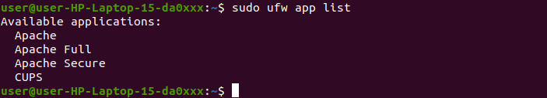

If you look at the Apache Full profile details, you’ll see that it enables traffic to ports 80 and 443:

**$ sudo ufw app info "Apache Full"**

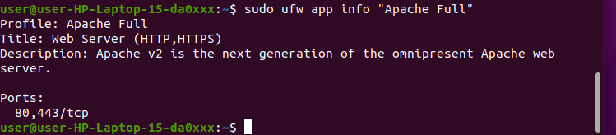

To allow incoming HTTP and HTTPS traffic for this server, run:

**sudo ufw allow "Apache Full"**



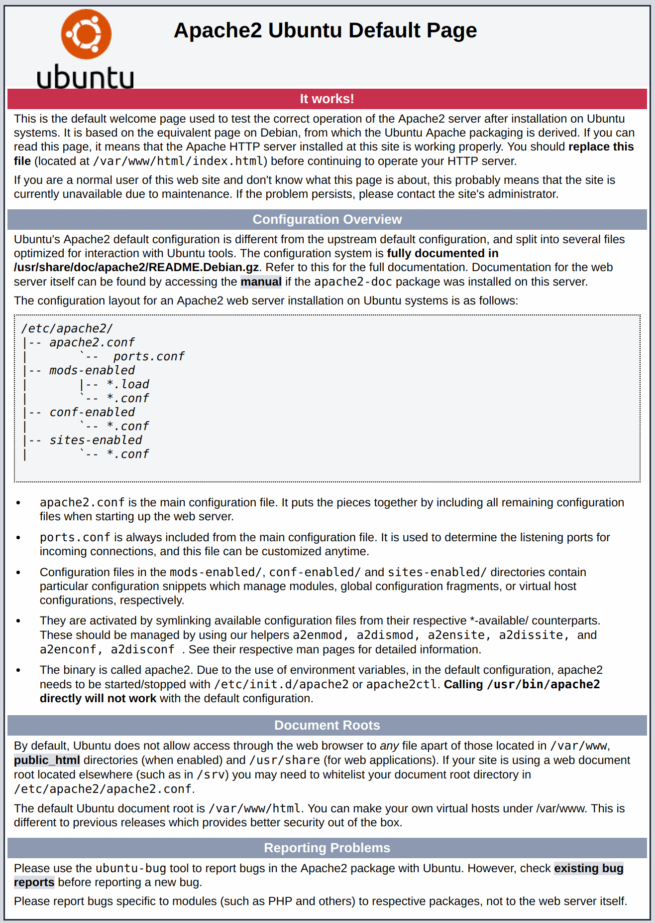

**Step 2 — Installing MySQL**

Now that you have your web server up and running, it is time to install MySQL.

MySQL is a database management system. Basically,

it will organize and provide access to databases where your site can store information.

Again, use apt to acquire and install this software:

**$ sudo apt install mysql-server**

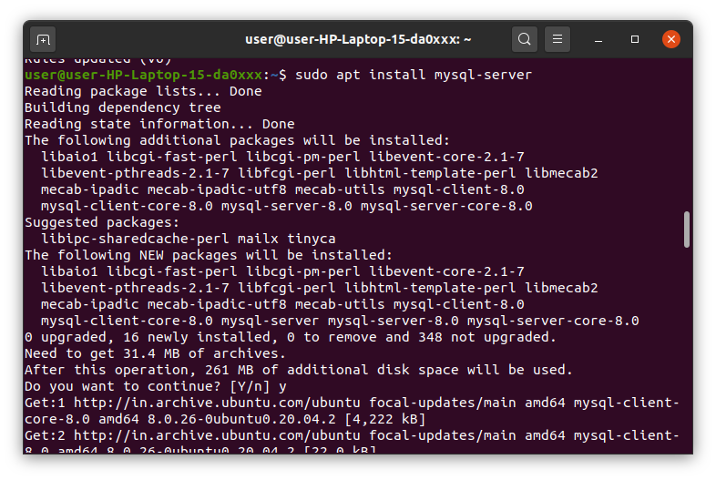

When the installation is complete, run a simple security script that comes pre-installed with MySQL which

will remove some dangerous defaults and lock down access to your database system.

Start the interactive script by running:

**$ sudo mysql_secure_installation**

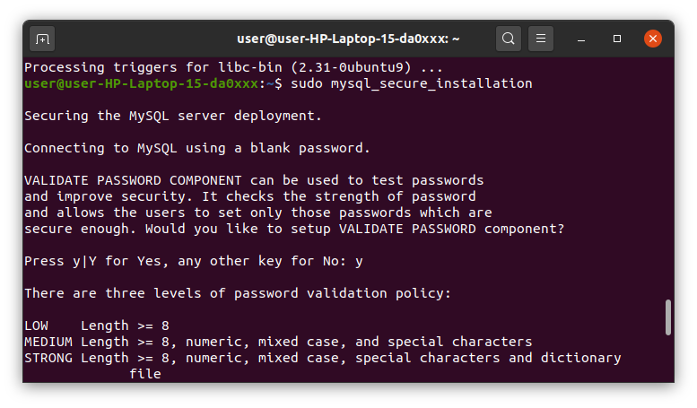

This will ask if you want to configure the VALIDATE PASSWORD PLUGIN.

Answer Y for yes, or anything else to continue without enabling

When you’re finished, test if you’re able to log in to the MySQL console by typing:

**$ sudo mysql**

To exit the MySQL console, type:

**$ exit**

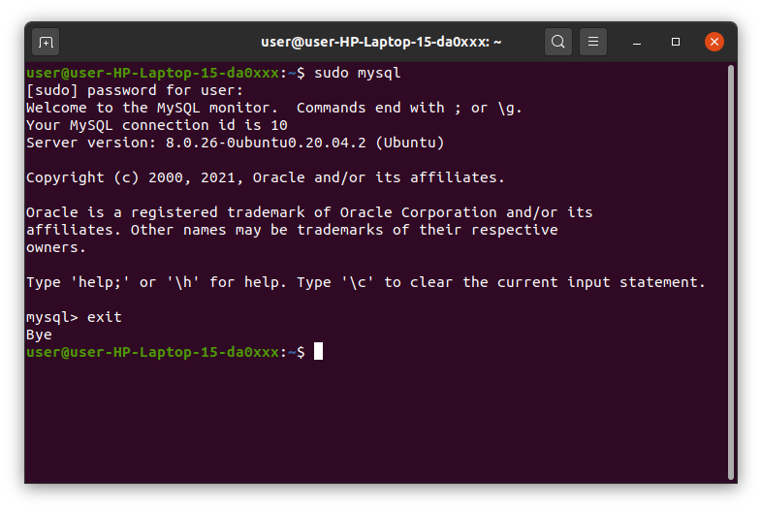

## Step 3 — Installing PHP

Once again, leverage the apt system to install PHP.

In addition to the php package, you’ll also need libapache2-mod-php to integrate PHP into Apache,

and the php-mysql package to allow PHP to connect to MySQL databases.

Run the following command to install all three packages and their dependencies:

**$ sudo apt install php libapache2-mod-php php-mysql**

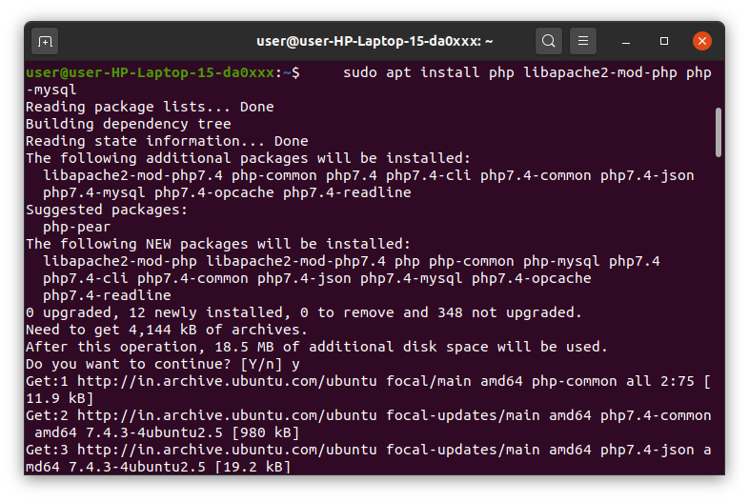

This should install PHP without any problems. We’ll test this in a moment.

## Step 4 — Testing PHP Processing on your Web Server

In order to test that your system is properly configured for PHP, create a PHP script called info.php.

In order for Apache to find this file and serve it correctly, it must be saved to your web root directory.

Create the file at the web root you created in the previous step by running:

**sudo nano /var/www/your_domain/info.php**

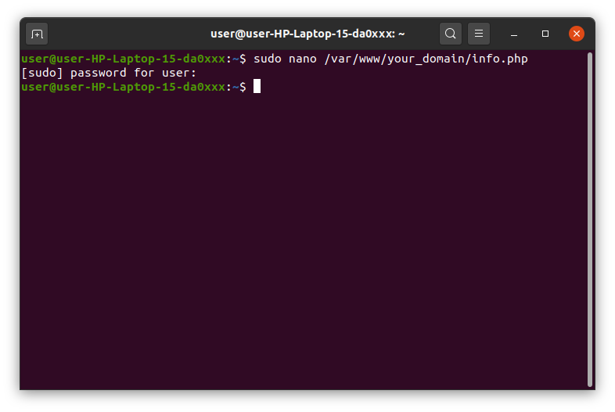

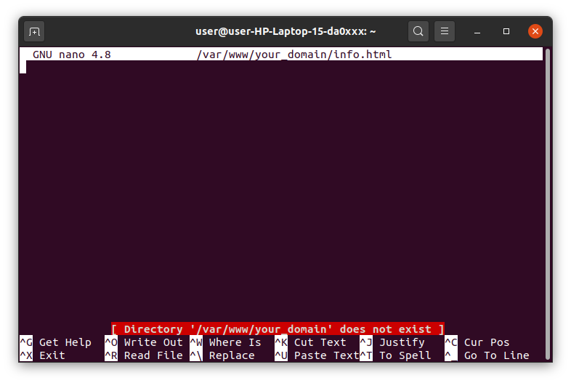

This will open a blank file. Add the following text, which is valid PHP code, inside the file:

|  |
| --- |
| <?php phpinfo(); ?> |

The address you will want to visit is:

**http://your_domain/info.php**

**EXPERIMENT-16**

**INSTALLATION OF LARAVEL**

**LARAVEL**

•Laravel is an open-source PHP framework, which is robust and easy to understand. It follows a model-view-controller design pattern. Laravel reuses the existing components of different frameworks which helps in creating a web application. The web application thus designed is more structured and pragmatic.

•Laravel offers a rich set of functionalities which incorporates the basic features of PHP frameworks like CodeIgniter, Yii and other programming languages like Ruby on Rails. Laravel has a very rich set of features which will boost the speed of web development.

•If you are familiar with Core PHP and Advanced PHP, Laravel will make your task easier. It saves a lot of time if you are planning to develop a website from scratch. Moreover, a website built in Laravel is secure and prevents several web attacks.

**ADVANTAGES OF LARAVEL**

•Laravel offers you the following advantages, when you are designing a web application based on it −

•The web application becomes more scalable, owing to the Laravel framework.

•Considerable time is saved in designing the web application, since Laravel reuses the components from other frameworks in developing web applications.

•It includes namespaces and interfaces, thus help to organize and manage resources.

**COMPOSER**

•Composer is a tool for dependency management in PHP. It allows you to declare the libraries your project depends on and it will manage (install/update) them for you.

**INSTALLATION OF LARAVEL**

•Step 1 − Visit the following URL and download composer to install it on your system.

<https://getcomposer.org/download/>

Remember to set the path of the composer to the php.exe file in the php/xampp/C:

•Step 2 − After the Composer is installed, check the installation by typing the Composer command in the command prompt as shown in the following screenshot.

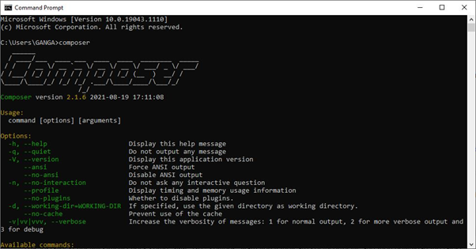

•Step 3 − Create a new directory anywhere in your system for your new Laravel project. After that, move to the path where you have created the new directory and type the following command there to install Laravel.

composer create-project –prefer-dist laravel/laravel folder_name

But the latest version(currently 8.x) just requires you to type

composer create-project laravel/laravel folder_name

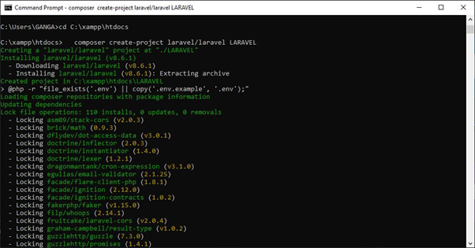

•Step 4 − The above command will install Laravel in the current directory. Start the Laravel service by executing the following command.

php artisan serve

•Step 5 − After executing the above command, you will see a screen as shown below –

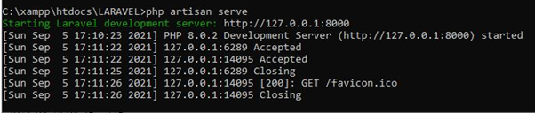

•Step 6 − Copy the URL underlined in gray in the above screenshot and open that URL in the browser. If you see the following screen, it implies Laravel has been installed successfully.

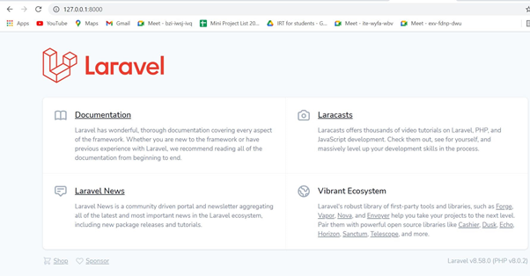

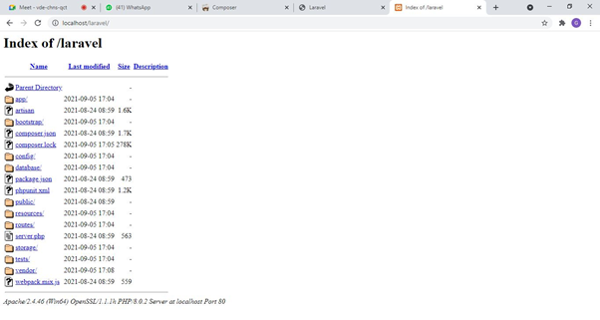

•Step 7 − The following screen indicates the laravel framework has been successfully installed in your device.

**INTRODUCTION TO COMMAND LINE TOOL FOR NETWORKING**

**NETWORK COMMANDS**

The operating system consists of various built-in, command-line networking utilities that are used for network troubleshooting.

1. Ping

2. Hostname

3.netstat

4. If Config

5. Nslookup

6. Traceroute

7.Route

PING

* PACKET INTERNET GROPER
* Most widely used utility tool to troubleshoot
* It sends packets of information to the user-defined source. If the packets are received , the destination device sends packets back.
* Ping can be used for two purposes

- Network connection can be established

- Speed of the connection

* Ping is used to test a network host capacity to interact with another host. Just enter the command Ping, followed by the target host’s name or IP address.

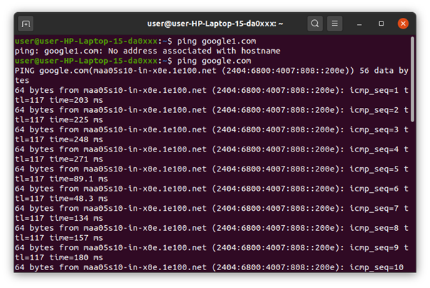

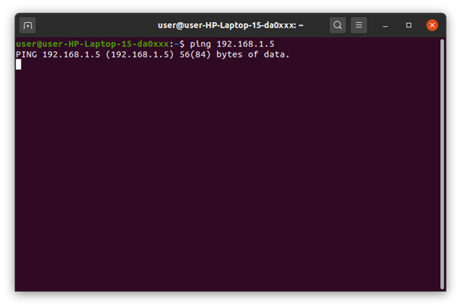

HOSTNAME

* Hostname :displays the machine hostname
* Hostname –f :displays the fully qualified host and domain name
* Hostname –I :displays the ip address for the current machine

NETSTAT

* Netstat command displays various network related information such as network connections, routing tables, interface statistics, multicast memberships etc.
* netstat -a : To show both listening and non-listening sockets
* netstat -at : To list all tcp ports.
* netstat -au : To list all udp ports.
* netstat -l : To list only the listening ports.
* netstat -lt : To list only the listening tcp ports
* netstat -lu : To list only the listening udp ports.
* netstat -lx : To list only the listening UNIX ports.
* netstat -s : To list the statistics for all ports

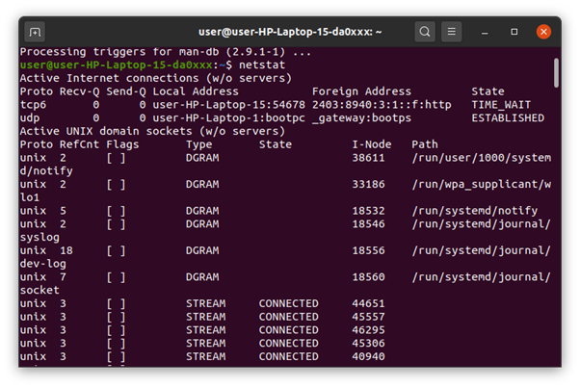

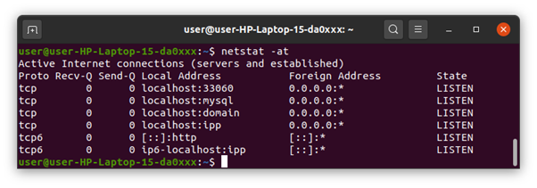

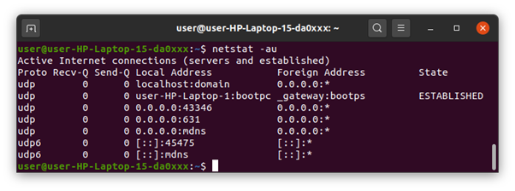

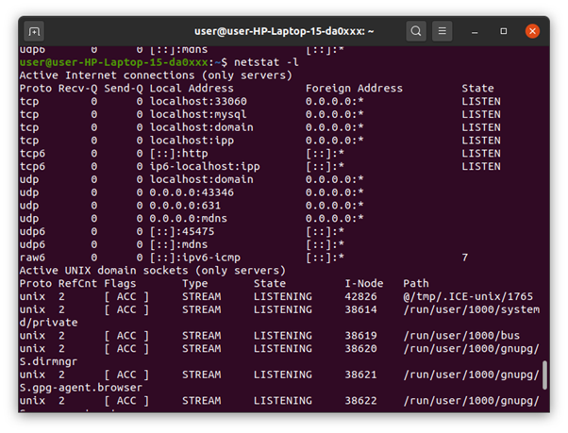

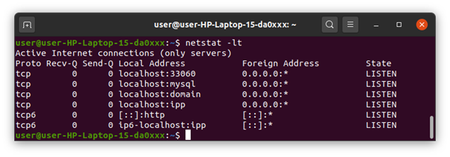

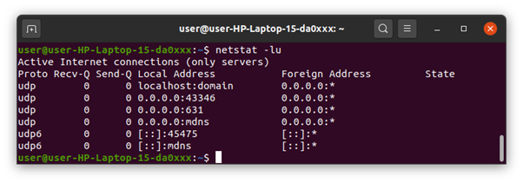

If config

* The if config commands is used for displaying current network configuration information , setting up an ip address , netmask or broadcast address to an network interface , creating an alias for network interface , setting up hardware address and enable or disable network interface
* ifconfig –a :This option is used to display all the interfaces available, even if they are down.
* ifconfig -s : Display a short list, instead of details
* ifconfig interface up :This option is used to activate the driver for the given interface
* ifconfig interface down :This option is used to deactivate the driver for the given interface.

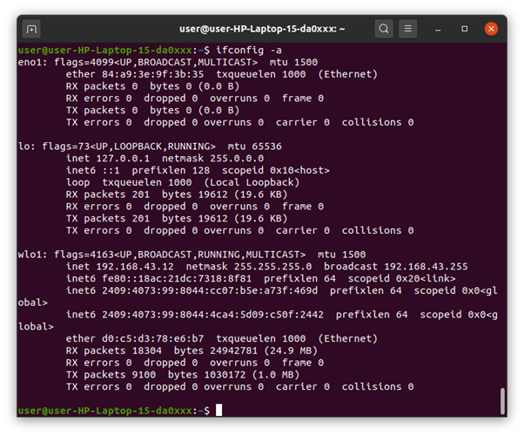

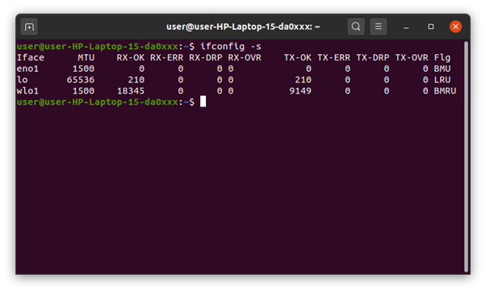

Ip config

* Displays all current TCP/IP network configuration values and refreshes Dynamic Host Configuration Protocol (DHCP) and Domain Name System (DNS) settings.
* Used without parameters, ipconfig displays Internet Protocol version 4 (IPv4) and IPv6 addresses, subnet mask, and default gateway for all adapters.

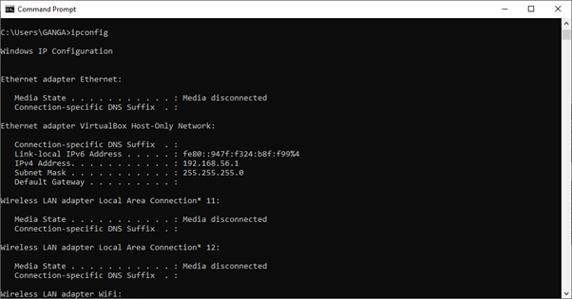

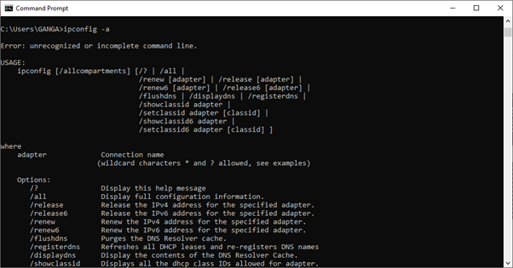

Nslookup

* Nslookup (stands for “Name Server Lookup”) is a useful command for getting information from a DNS server. It is a network administration tool for querying the Domain Name System (DNS) to obtain domain name or IP address mapping or any other specific DNS record. It is also used to troubleshoot DNS related problems.
* nslookup google.com :nslookup followed by the domain name will display the “A Record” (IP Address) of the domain. Use this command to find the address record for a domain. It queries domain name servers and gets the details.
* nslookup 192.168.0.10 : Reverse DNS lookup we can also do the reverse DNS look-up by providing the IP Address as argument to nslookup.

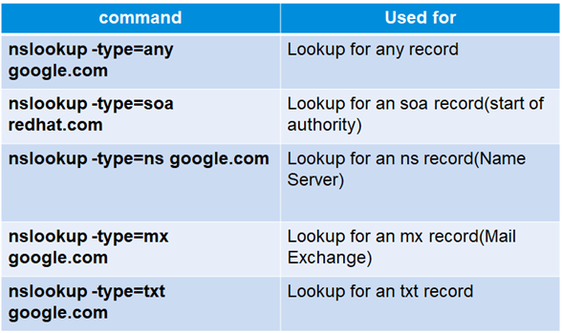

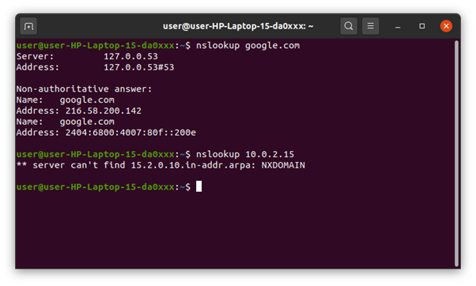

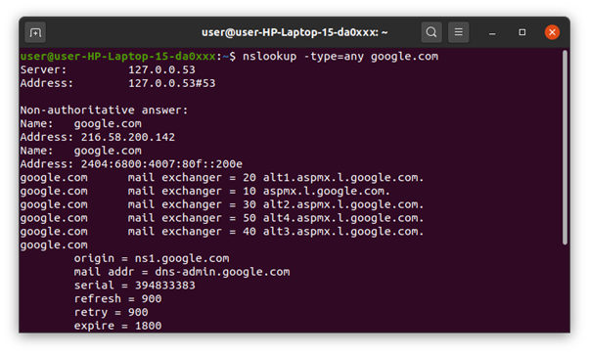

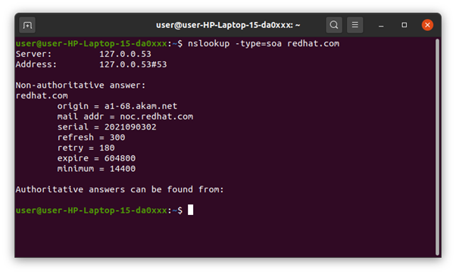

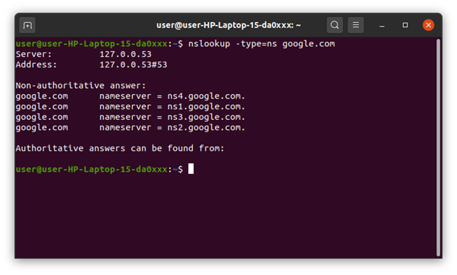

Traceroute

* Traceroute command prints the route that a packet takes to reach the host. This command is useful when we want to know about the route and about all the hops that a packet takes

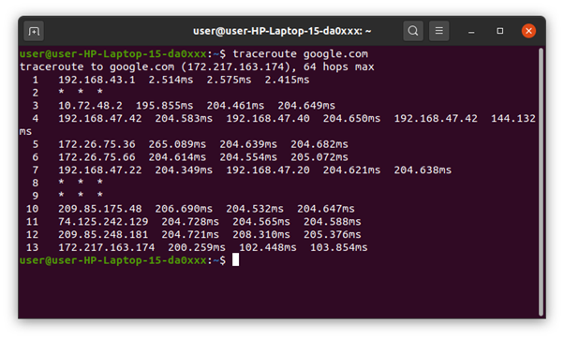

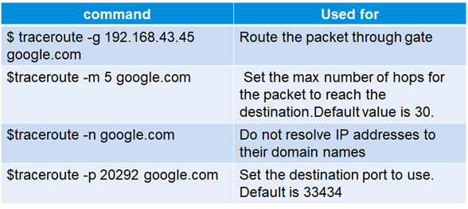

Route

* Route command in Linux is used when you want to work with the IP/kernel routing table. It is mainly used to set up static routes to specific hosts or networks via an interface. It is used for showing or updating the IP/kernel routing table.
* install net-tools by $sudo apt-get install net-tools

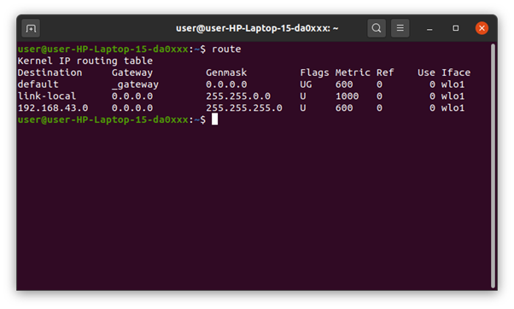

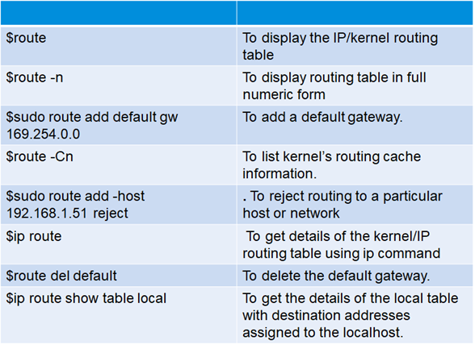

STATIC AND DYNAMIC IP

* A fixed IP address is called static IP address , i.e. it never changes.
* It is required to set up an Ubuntu static IP address in order to access a device remotely and without losing a connection over the network.
* It is used to connect to an IP camera, home file server, game server, and many other devices.
* A static IP address is necessary only for servers and not for personal PCs

STEPS FOR SETTING STATIC IP

Click on the top right network icon and select settings of the network interface you wish to configure to use a static IP address on Ubuntu.

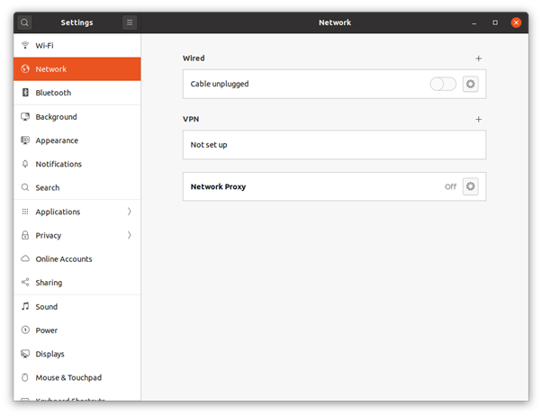

* Select manual and enter your desired IP address, netmask, gateway and DNS settings.
* Once ready click the Apply button.
* Turn OFF and ON switch to apply your new network static IP configuration settings.
* Click on the network settings icon once again to confirm your new static IP address settings.

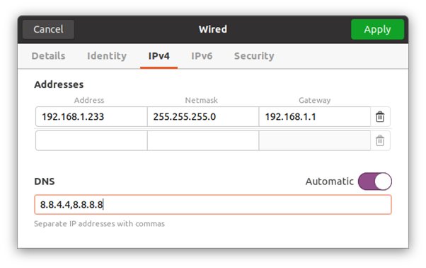

DYNAMIC IP

* A dynamic IP address as its name suggests is a temporary IP address assigned by a DHCP server for every new network.
* A dynamic IP address is used due to the shortage of IP addresses on IPV4.
* A single dynamic IP address can be used between many devices

*Configuring a dynamic ip address*

Step1: type the command in the terminal

sudo nano /etc/netplan/01-network-manager-all.yaml

Step2:Now find the name of the network interface you want to configure and insert the following lines:

* dhcp4: yes
* dhcp6: yes

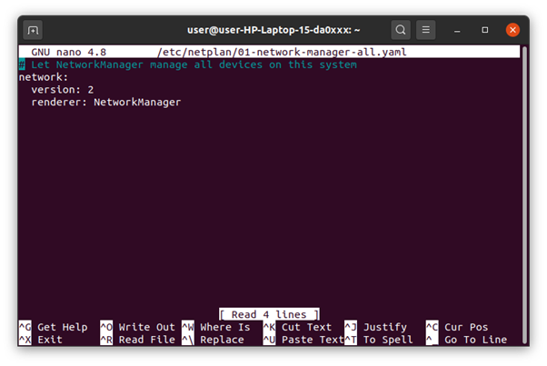

Step3:Apply the changes with sudo netplan apply command

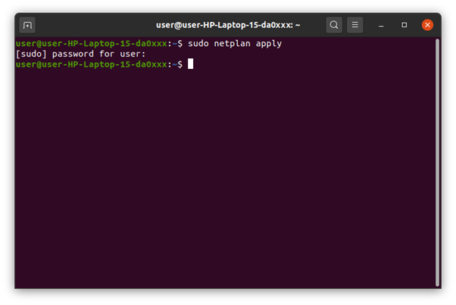

**SETTING UP A FIREWALL FOR LAN**

* The default firewall configuration tool for Ubuntu is ufw.
* Developed to ease iptables firewall configuration.
* ufw provides a user-friendly way to create an IPv4 or IPv6 host-based firewall.
* ufw by default is initially disabled.
* ufw is not intended to provide complete firewall functionality via its command interface, but instead provides an easy way to add or remove simple rules.
* It is currently mainly used for host-based firewalls.”
* To ENABLE ufw

Step1:check current firewall status

sudo ufw status

Step2:to enable firewall

sudo ufw enable

Step3:to check status

sudo ufw status

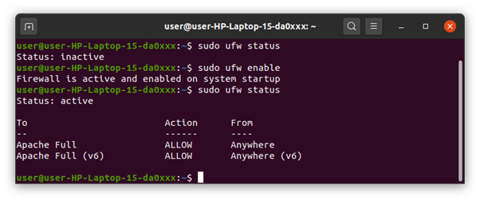

* To Disable ufw

Step1:To disable firewall

sudo ufw disable

Step2:to check status

sudo ufw status

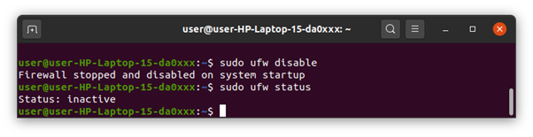

**FAMILIARISATION OF STATIC AND DYNAMIC IP**

**STATIC IP:**

1. A fixed IP address is called static IP address , i.e. it never changes.
2. It is required to set up an Ubuntu static IP address in order to access a device remotely and without losing a connection over the network.
3. It is used to connect to an IP camera, home file server, game server, and many other devices.
4. A static IP address is necessary only for servers and not for personal PCs.

**STEPS FOR SETTING STATIC IP:**

1. Click on the top right network icon and select settings of the network interface you wish to configure to use a static IP address on Ubuntu.
2. Click on the settings icon to start IP address configuration Select IPv4 tab.
3. Select manual and enter your desired IP address, netmask, gateway and DNS settings.
4. Once ready click Apply button.
5. Turn OFF and ON switch to apply your new network static IP configuration settings.
6. Click on the network settings icon once again to confirm your new static IP address settings.

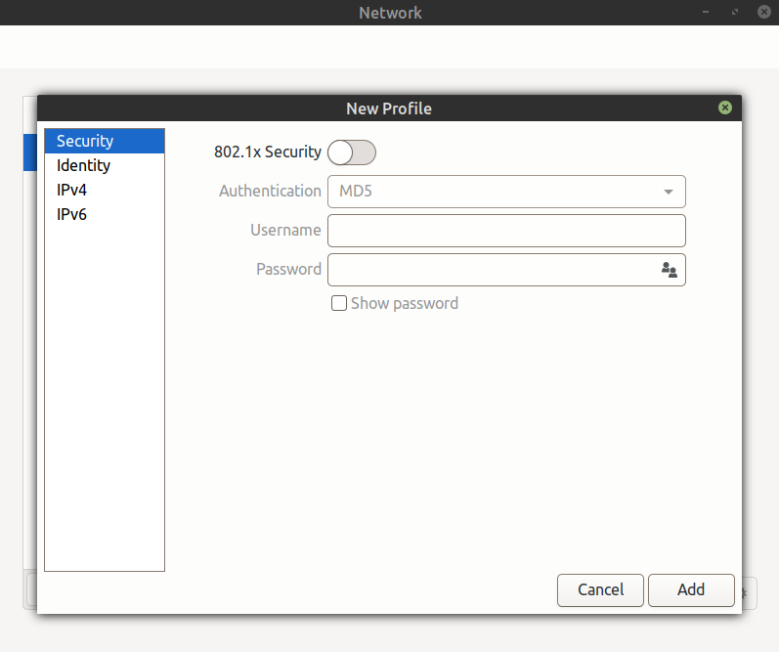

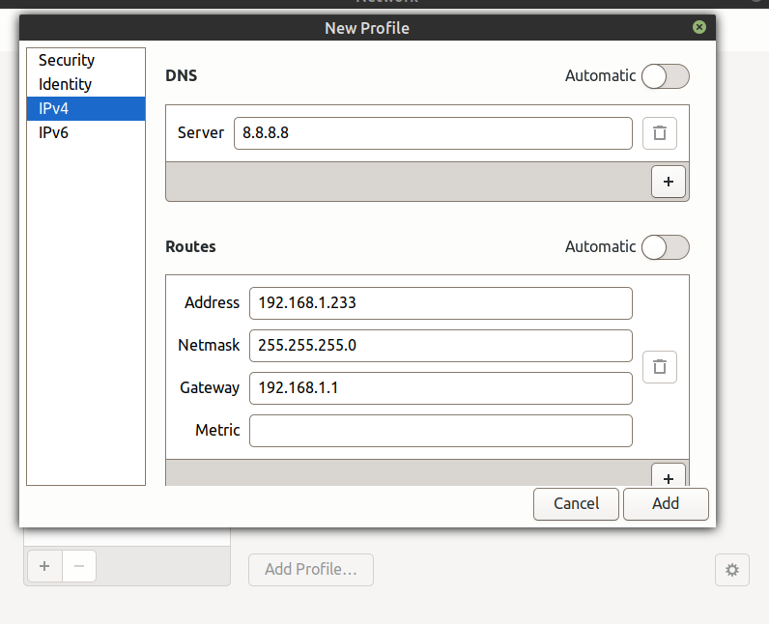

**DYNAMIC IP**

1. A dynamic IP address as its name suggests is a temporary IP address assigned by a DHCP server for every new network.
2. A dynamic IP address is used due to the shortage of IP addresses on IPV4.
3. A single dynamic IP address can be used between many devices.

Configuring a dynamic ip address

**Step1:** type the command in the terminal

sudo nano /etc/netplan/01-network-manager-all.yaml

**Step2**:Now find the name of the network interface you want to configure and insert the following lines:

dhcp4: yes

dhcp6: yes

**Step3**:Apply the changes with sudo netplan apply command.

**CONCEPT OF SUBNETS AND CIDR ADDRESS SCHEME**

**SUBNETS:**

The process of dividing a network into smaller network sections is called subnetting. This can be useful for many different purposes and helps isolate groups of hosts from each other to deal with them more easily. By default, each network has only one subnet, which contains all of the host addresses defined within. A netmask is basically a specification of the amount of address bits that are used for the network portion. A subnet mask is another netmask within used to further divide the network.

Each bit of the address that is considered significant for describing the network should be represented as a “1” in the netmask. For instance, the address we discussed above, 192.168.0.15 can be expressed like this, in binary:

1100 0000 - 1010 1000 - 0000 0000 - 0000 1111

As we described above, the network portion for class C addresses is the first 3 octets, or the first 24 bits. Since these are the significant bits that we want to preserve, the netmask would be:

1111 1111 - 1111 1111 - 1111 1111 - 0000 0000

This can be written in the normal IPv4 format as 255.255.255.0. Any bit that is a “0” in the binary representation of the netmask is considered part of the host portion of the address and can be variable. The bits that are “1” are static, however, for the network or subnetwork that is being discussed. We determine the network portion of the address by applying a bitwise AND operation to between the address and the netmask. A bitwise AND operation will save the networking portion of the address and discard the host portion. The result of this on our above example that represents our network is:

1100 0000 - 1010 1000 - 0000 0000 - 0000 0000

This can be expressed as 192.168.0.0. The host specification is then the difference between these original value and the host portion. In our case, the host is 0000 1111 or 15. The idea of subnetting is to take a portion of the host space of an address, and use it as an additional networking specification to divide the address space again. For instance, a netmask of 255.255.255.0 as we saw above leaves us with 254 hosts in the network (you cannot end in 0 or 255 because these are reserved).

So, continuing with our example, the networking portion is:

1100 0000 - 1010 1000 - 0000 0000

The host portion is:

0000 1111

We can use the first bit of our host to designate a subnetwork. We can do this by adjusting the subnet mask from this:

1111 1111 - 1111 1111 - 1111 1111 - 0000 0000

To this:

1111 1111 - 1111 1111 - 1111 1111 - 1000 0000

In traditional IPv4 notation, this would be expressed as 192.168.0.128. What we have done here is to designate the first bit of the last octet as significant in addressing the network. This effectively produces two subnetworks. The first subnetwork is from 192.168.0.1 to 192.168.0.127. The second subnetwork contains the hosts 192.168.0.129 to 192.168.0.255.

**CIDR NOTATION:**

A system called Classless Inter-Domain Routing, or CIDR, was developed as an alternative to traditional subnetting. For example, we could express the idea that the IP address 192.168.0.15 is associated with the netmask 255.255.255.0 by using the CIDR notation of 192.168.0.15/24. This means that the first 24 bits of the IP address given are considered significant for the network routing.

This allows us some interesting possibilities. We can use these to reference “supernets”. In this case, we mean a more inclusive address range that is not possible with a traditional subnet mask. For instance, in a class C network, like above, we could not combine the addresses from the networks 192.168.0.0 and 192.168.1.0 because the netmask for class C addresses is 255.255.255.0. However, using CIDR notation, we can combine these blocks by referencing this chunk as 192.168.0.0/23. This specifies that there are 23 bits used for the network portion that we are referring to. So the first network (192.168.0.0) could be represented like this in binary:

1100 0000 - 1010 1000 - 0000 0000 - 0000 0000

While the second network (192.168.1.0) would be like this:

1100 0000 - 1010 1000 - 0000 0001 - 0000 0000

The CIDR address we specified indicates that the first 23 bits are used for the network block we are referencing. This is equivalent to a netmask of 255.255.254.0, or:

1111 1111 - 1111 1111 - 1111 1110 - 0000 0000

As you can see, with this block the 24th bit can be either 0 or 1 and it will still match, because the network block only cares about the first 23 digits. CIDR allows us more control over addressing continuous blocks of IP addresses. This is much more useful than the subnetting we talked about originally.

**CONCEPT OF SUBNET MASK**

The subnet mask is used by the TCP/IP protocol to determine whether a host is on the local subnet or on a remote network. In TCP/IP, the parts of the IP address that are used as the network and host addresses aren't fixed. Unless you have more information, the network and host addresses above can't be determined. This information is supplied in another 32-bit number called a subnet mask. The subnet mask is 255.255.255.0 in this example. It isn't obvious what this number means unless you know 255 in binary notation equals 11111111. So, the subnet mask is 11111111.11111111.11111111.00000000.

Lining up the IP address and the subnet mask together, the network, and host portions of the address can be separated:

11000000.10101000.01111011.10000100 - IP address (192.168.123.132)

11111111.11111111.11111111.00000000 - Subnet mask (255.255.255.0)

The first 24 bits (the number of ones in the subnet mask) are identified as the network address. The last 8 bits (the number of remaining zeros in the subnet mask) are identified as the host address. It gives you the following addresses:

11000000.10101000.01111011.00000000 - Network address (192.168.123.0)

00000000.00000000.00000000.10000100 - Host address (000.000.000.132)

So now you know, for this example using a 255.255.255.0 subnet mask, that the network ID is 192.168.123.0, and the host address is 0.0.0.132. When a packet arrives on the 192.168.123.0 subnet (from the local subnet or a remote network), and it has a destination address of 192.168.123.132, your computer will receive it from the network and process it.Almost all decimal subnet masks convert to binary numbers that are all ones on the left and all zeros on the right.

Some other common subnet masks are:

Decimal Binary 255.255.255.192 1111111.11111111.1111111.11000000 255.255.255.224

1111111.11111111.1111111.11100000

Internet RFC 1878 (available from InterNIC-Public Information Regarding Internet Domain Name Registration Services) describes the valid subnets and subnet masks that can be used on

TCP/IP networks

**SETTING UP OF FIREWALL ON LAN**

**ufw-uncomplicated firewall:**

1. The default firewall configuration tool for Ubuntu is ufw.
2. Developed to ease iptables firewall configuration.
3. ufw provides a user-friendly way to create an IPv4 or IPv6 host-based firewall.
4. ufw by default is initially disabled.
5. ufw is not intended to provide complete firewall functionality via its command interface,but instead provides an easy way to add or remove simple rules.
6. It is currently mainly used for host-based firewalls.

**To Enable uf:**

* **Step1:**check current firewall status

sudo ufw status

* **Step2:**to enable firewall

sudo ufw enable

* **Step3**:to check status

sudo ufw status

**To Disable ufw:**

* **Step1:**To disable firewall

sudo ufw disable

* **Step2**:to check status

sudo ufw status

**WIRESHARK AND TCPDUMP**

**WHAT IS WIRESHARK?**

•Network packet protocol analyzer

•A network packet analyzer will try to capture network packets and try to display that packet data as detailed as possible.

• One of the best open source packet analyzers available today for UNIX and Windows

**WHERE IT USE ?**

• Network administrators use it to troubleshoot network problems

• Network security engineers use it to examine security problems

• Developers use it to debug protocol implementations

• Testers use it to detect defects

• People use it to learn network protocol internals

**STEPS TO INSTALL WIRESHARK**

Step1: Go to [www.wireshark.org](http://www.wireshark.org/) ->download 64-bit package

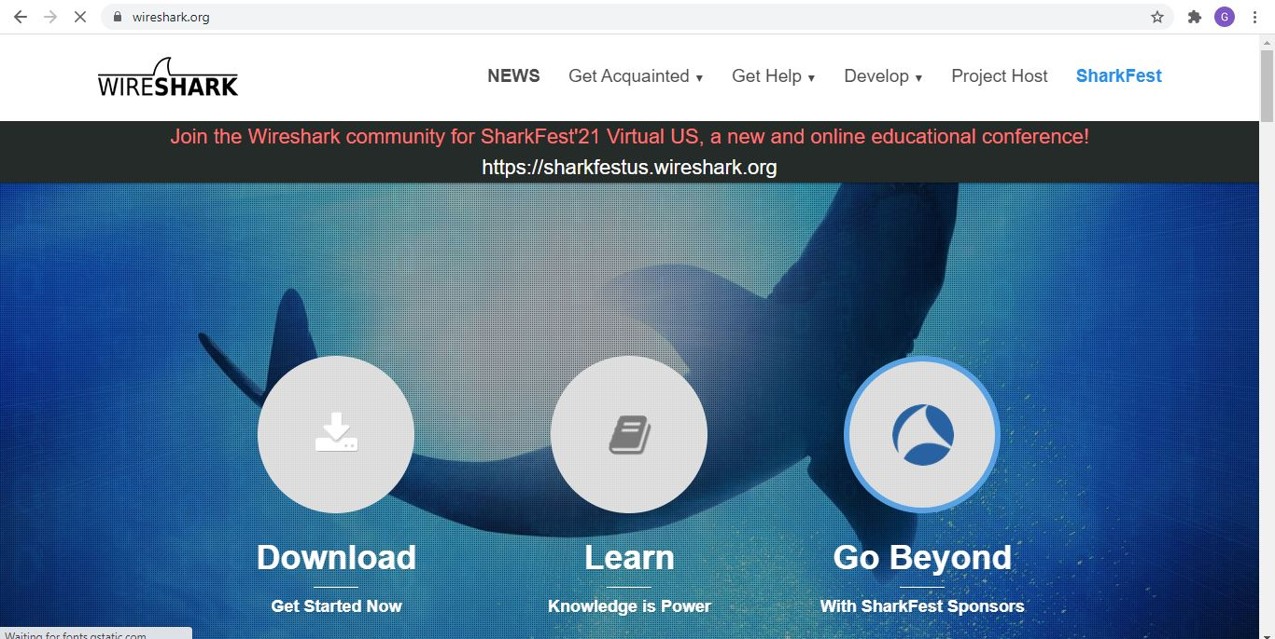

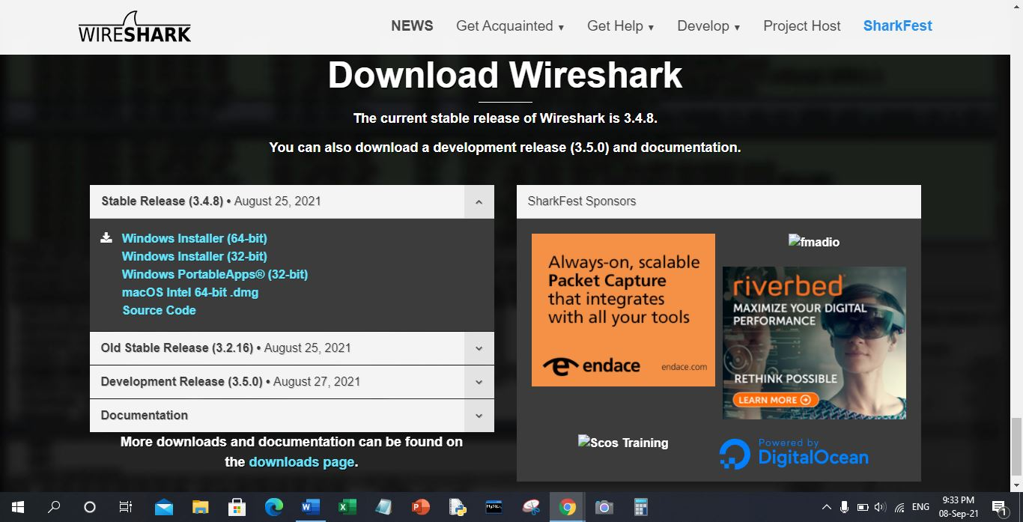

Step 2 : run application and click on noted

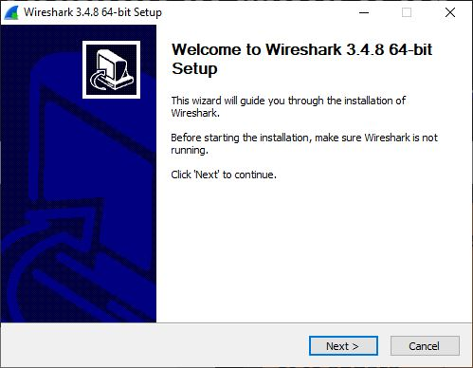

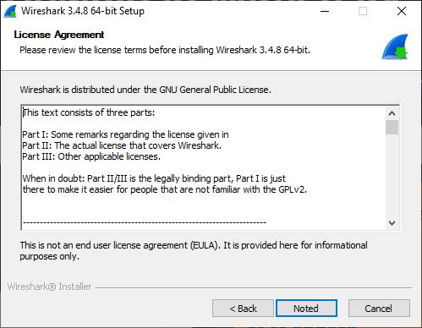

Step 3 :select components and click next

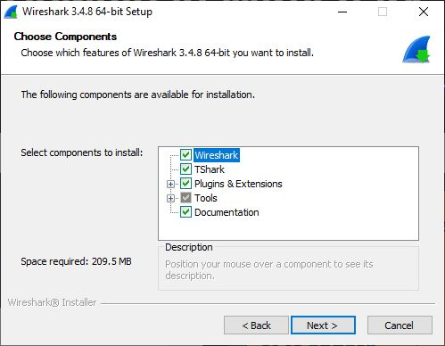

Step 4: choose default destination location

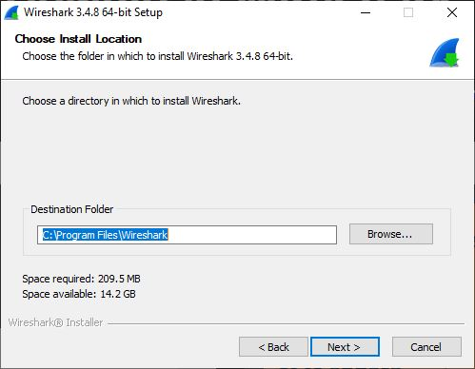

Step 5: installation start running

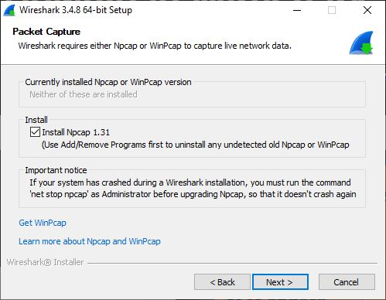

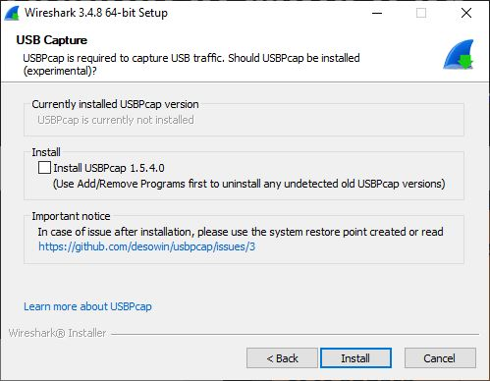

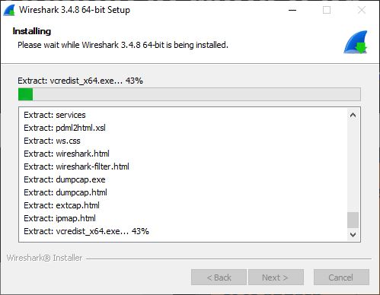

step 6 : click on I agree

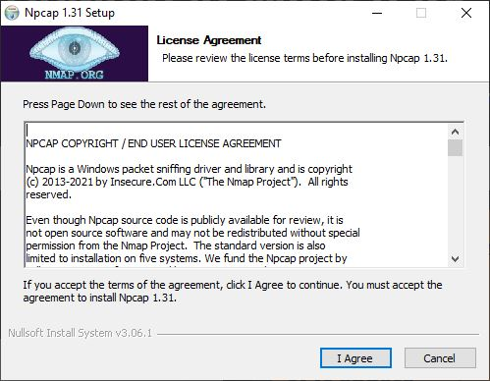

Step 7 : complete installation part and click finish

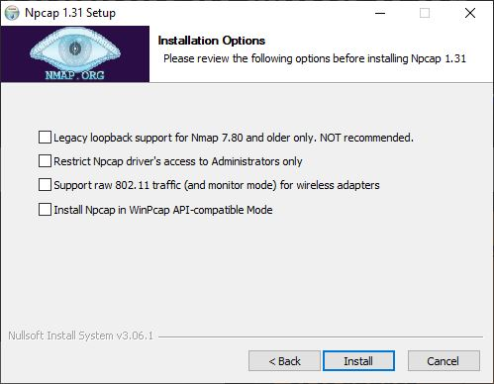

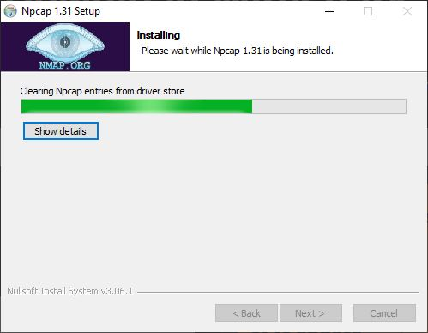

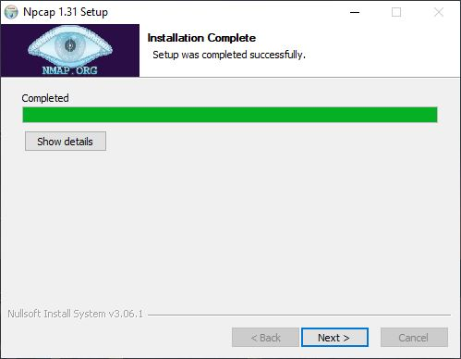

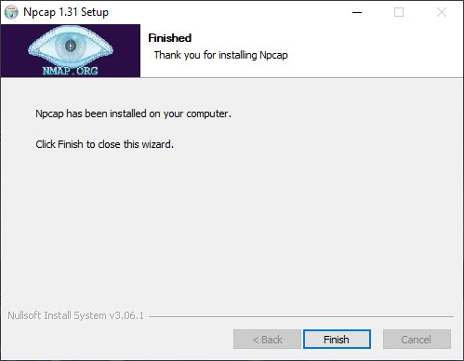

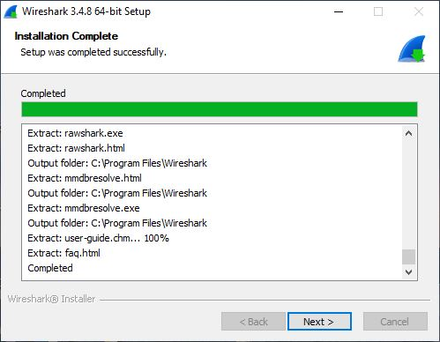

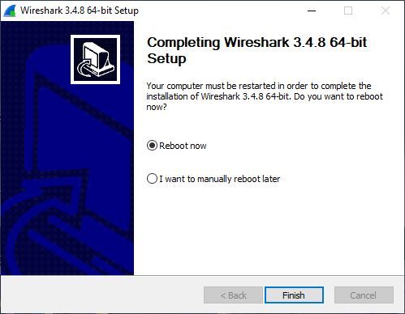

**HOMESCREEN**

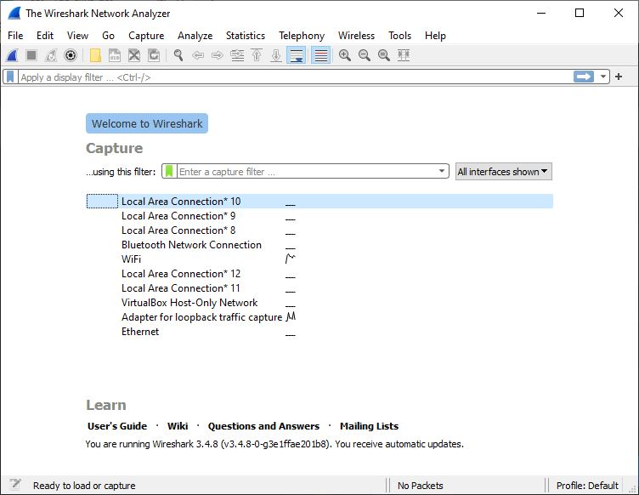

**HOW IT CAPTURE PACKETS?**

•Wireshark captures packets and lets you examine their contents

•Select any interface to capture its packet

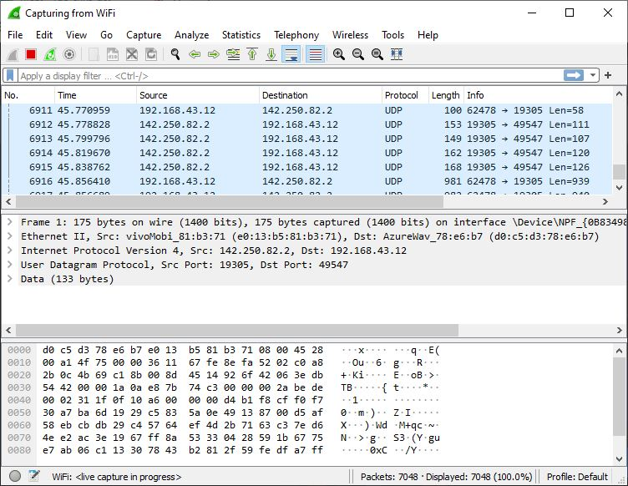

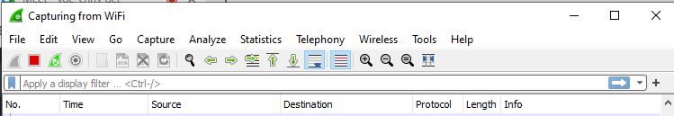

•No. shows the number of captured packet or index number.

•Time shows the time of capture

•Source shows the source ip of the packet or the packet is originally generated from which source ip.

•Destination shows the destination ip where the packet is going.

•Protocol shows which kind of protocol communication is held between the source and destination.

• Info shows the data payload in the packet

**FEATURES OF WIRESHARK**

•Available for UNIX and Windows.

•Capture live packet data from a network interface.

• Import packets from text files containing hex dumps of packet data.

•Display packets with very detailed protocol information.

•Save packet data captured.

•Export some or all packets in a number of capture file formats.

• Filter packets on many criteria.

• Search for packets on many criteria.

• Colorize packet display based on filters.

• Create various statistics.

**TCPDUMP**

•It is an ip utility tool used for real-time packet sniffing(Network).

• Command line program comes in built in a Unix based system.

•Programs like ethereal(Wireshark) provide an alternative to Tcpdump in GUI environment

**STEPS TO INSTALL TCPDUMP**

•Install tcpdump by entering the following commands in the terminal:

sudo apt update

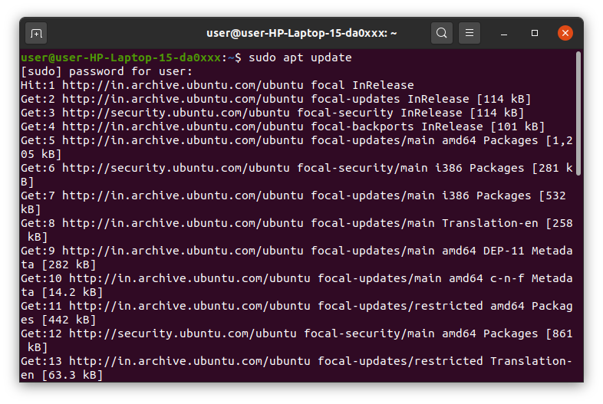

sudo apt install tcpdump

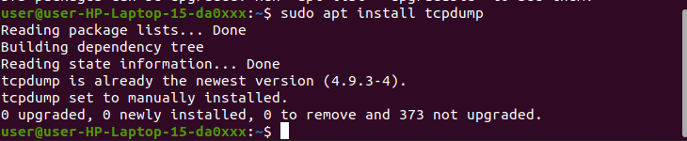

**TCPDUMP COMMAND EXAMPLES**

1. Display Available Interfaces

# tcpdump –D

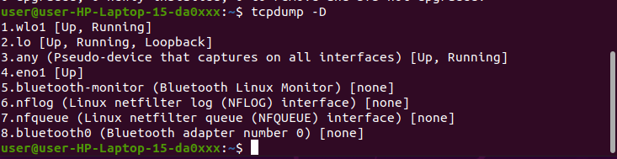

2. Capture Packets from Specific Interface

# tcpdump -i any

•The command screen will scroll up until you interrupt and when we execute the tcpdump command it will captures from all the interfaces, however with -i switch only capture from the desired interface

3.Print Captured Packets in ASCII

•The below tcpdump command with the option -A displays the package in ASCII format. It is a character-encoding scheme format.

•# tcpdump -A -i any

4.Capture Only N Number of Packets

•When you run the tcpdump command it will capture all the packets for the specified interface, until you hit the cancel button. But using -c option, you can capture a specified number of packets.

•# tcpdump -c 5 -i any

5.Display Captured Packets in HEX and ASCII

•The following command with option -XX capture the data of each packet, including its link level header in HEX and ASCII format.

•# tcpdump -XX -i any

6.Capture and Save Packets in a File

•As we said, that tcpdump has a feature to capture and save the file in a .Pcap format, to do this just execute the command with -w option.

•# tcpdump -w 0001.Pcap -i any

**Testing network services with Netcat [nc]**

•Use the netcat command, nc, to access the service. If you don’t have nc installed, type the following command on the command line

Step 1: $ sudo apt-get install netcat

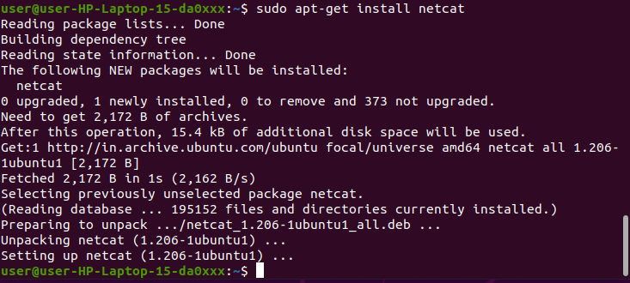

Step 2: After the installation is done type ‘nc -h’

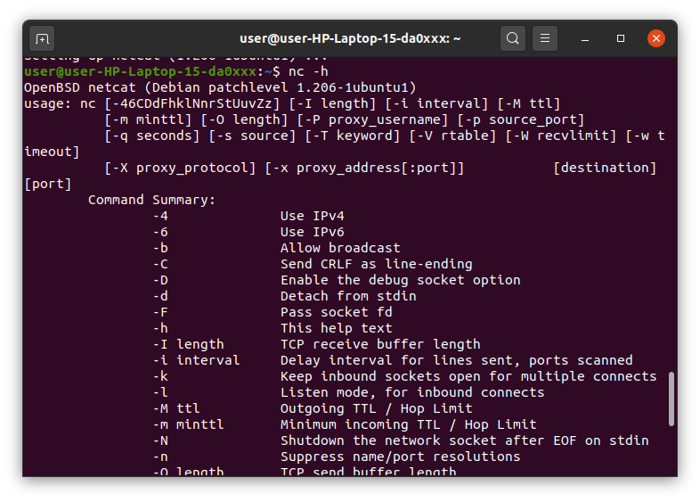

Step3:Set up the server using netcat in listening mode.

We will use port 12345 and will specify the port number with -p option.

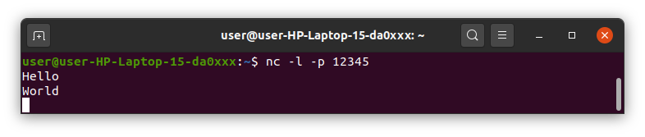

Step 4:Creating the server with netcat

•The command ‘nc hostname port’ puts netcat in client mode and connects to the specified hostname on the specified port. Open a new terminal window and type ‘nc localhost 12345’

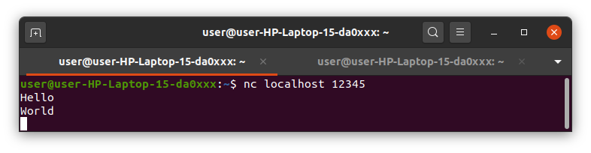

Step 5 : Now that we are connected to the server we can start chatting

**Introduction to Hypervisors and VMs, Xen or KVM**

**Virtual Machine**

* A virtual machine is a virtual representation, or emulation, of a physical computer. They are often referred to as a guest while the physical machine they run on is referred to as the host.
* Virtualization makes it possible to create multiple virtual machines, each with their own operating system (OS) and applications, on a single physical machine. A VM cannot interact directly with a physical computer. Instead, it needs a lightweight software layer called a hypervisor to coordinate between it and the underlying physical hardware.

**HYPERVISOR**

* Hypervisor is a software program that manages multiple operating systems (or multiple instances of the same operating system) on a single computer system.
* The hypervisor manages the system's processor, memory, and other resources to allocate what each operating system requires.
* Hypervisors are designed for a particular processor architecture and may also be called virtualization managers.

**Hypervisor Types**

Type 1: native (bare-metal) hypervisors

The Hypervisor runs directly on the host's hardware to control the hardware and to manage guest operating systems.

E.g., Xen, VMWare ESXi, Microsoft Hyper-V

Type 2: hosted hypervisors

These hypervisors run on a conventional operating system just as other computer programs do.

Eg. VMWare Workstation, VirtualBox

**HYPERVISOR TYPES**

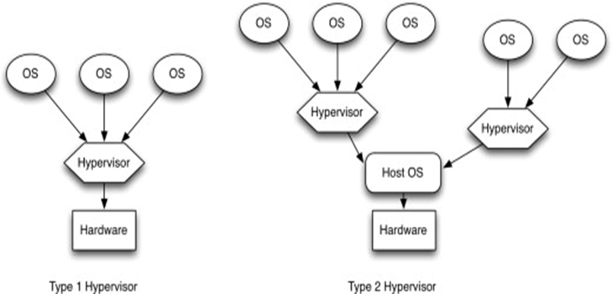

**Benefits of hypervisor**

* Speed
* Efficiency
* Flexibility
* Portability

**Popular Hypervisors**

* Xen
* KVM(Kernel Based VM)
* SAN
* NAS
* Xen

**What is Xen?**

* “Xen is an open-source paravirtualization technology that provides a platform for running multiple operating systems in parallel on one physical hardware resource”
* Originally developed in 2003 at the University of Cambridge Computer Laboratory.

**XEN**

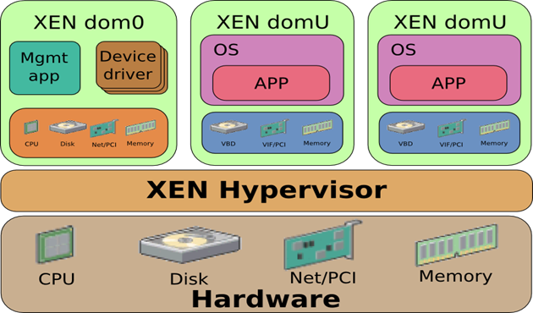

**Kernel-based Virtual Machine (KVM)**

* Kernel-based Virtual Machine (KVM) is an open source virtualization technology built into Linux. Specifically, KVM lets you turn Linux into a hypervisor that allows a host machine to run multiple, isolated virtual environments called guests or virtual machines (VMs).
* KVM converts Linux into a type-1 (bare-metal) hypervisor. All hypervisors need some operating system-level components—such as a memory manager, process scheduler, input/output (I/O) stack, device drivers, security manager, a network stack, and more—to run VMs. KVM has all these components because it’s part of the Linux kernel. Every VM is implemented as a regular Linux process, scheduled by the standard Linux scheduler, with dedicated virtual hardware like a network card, graphics adapter, CPU(s), memory, and disks.

**KVM**

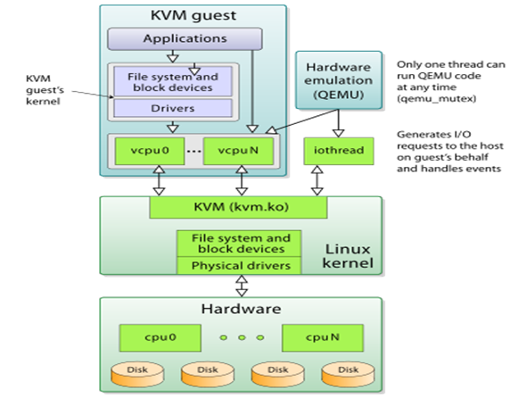

**DOCKER**

**Docker overview**

* Docker is an open platform for developing, shipping, and running applications.
* Docker enables you to separate your applications from your infrastructure so you can deliver software quickly.
* With Docker, you can manage your infrastructure in the same ways you manage your applications.
* By taking advantage of Docker’s methodologies for shipping, testing, and deploying code quickly, you can significantly reduce the delay between writing code and running it in production.

**What is a container?**

* Docker provides the ability to package and run an application in a loosely isolated environment called a container.
* The isolation and security allow you to run many containers simultaneously on a given host.
* Containers are lightweight and contain everything needed to run the application, so you do not need to rely on what is currently installed on the host.
* You can easily share containers while you work, and be sure that everyone you share with gets the same container that works in the same way.

**What is a Docker image?**

* A Docker image is a file used to execute code in a Docker container. Docker images act as a set of instructions to build a Docker container, like a template.
* Docker images also act as the starting point when using Docker. An image is comparable to a snapshot in virtual machine (VM) environments.

**The Role of Images and Containers**

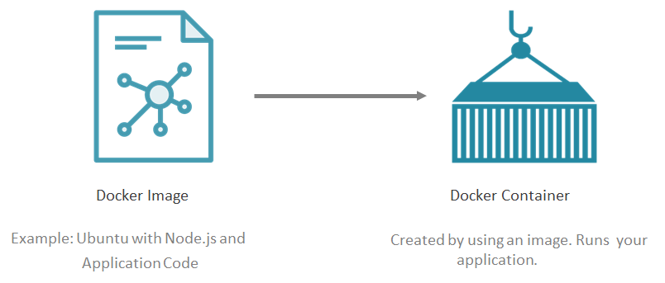

**Docker is better…**

*Docker installation*

---->$ sudo apt install docker.io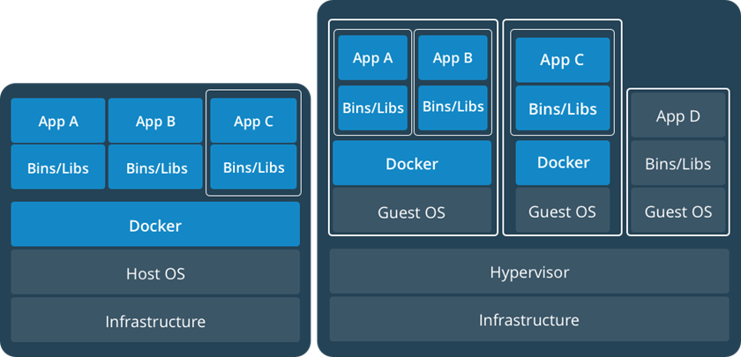

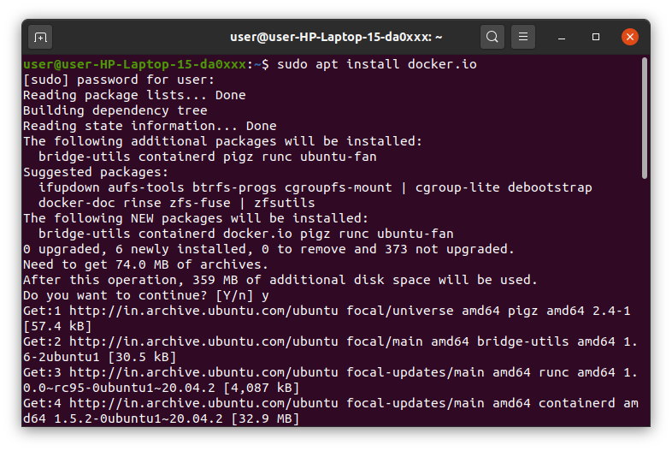

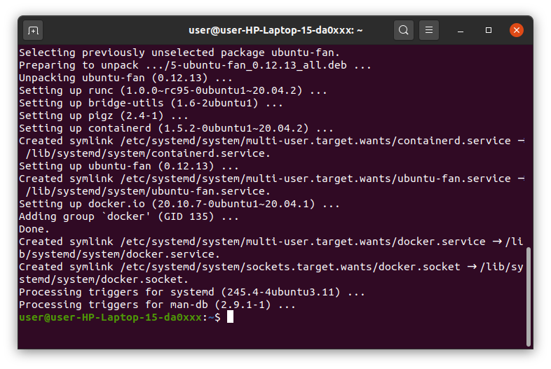

*Version check*

------->$ docker --version



*Check whether it is running or not*

----->$ sudo systemctl status checker

*If not active*

------->$ sudo systemctl enable –now docker

*List all the images you have locally*

------->$ sudo docker images



*Pull an image from the Docker registry*

---->$ sudo docker pull <image_name>:<tag>

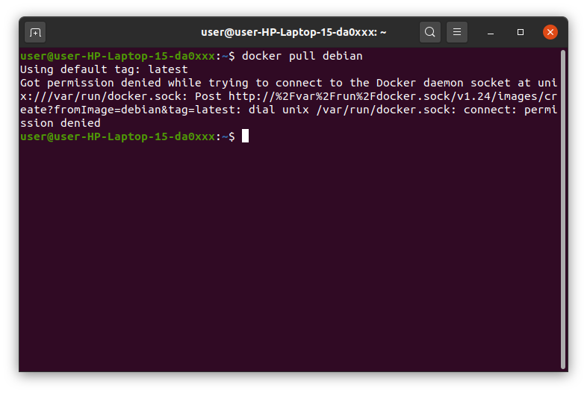

*List all the running containers*

----->$ sudo docker ps -a

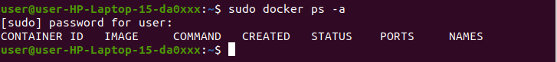

*Remove a container*

------->$ sudo docker rm <container id>

**Installing Software from Source Code**

* Source code software must be compiled and installed.
* Usually comes in a compressed archive, called a tarball with .tar or .tar.gz ending.
* Archive includes source, configure script, makefile,and install scripts.

*Package Managers*

* Automate the installation, removal, and management of the software applications.
* Only track software installed using the package manager.
* Similar to Add/Remove programs control panel in MS Windows

---> *Configure Script:*

* Inspects system for requirements and configures the “makefile” .

----> *Make:*

* Automates the compilation of programming source code for the target system.
* “makefile” defines the necessary steps to build the application.
* They are far from perfect.
* There is no central database to track applications installed with make.
* Removal of applications may or may not be supported by the make file.
* “makefile” contains installation parameters, variables,and setup instructions.
* “make” and “make install” commands are run to compile and install software.

----->*Make Command:*

* Source code distributed as “gzipped tarballs”.
* After unpacking the code you must check the README file for specific install instructions.

$ configure

$ make

$ make install

**Installation Steps:**

Step 1: Open the Linux terminal and enter

*sudo apt update*

This command is used to install the latest versions of the packages currently installed on the user's system from the sources enumerated in /etc/apt/sources. The installed packages which have new packages available are retrieved and installed.

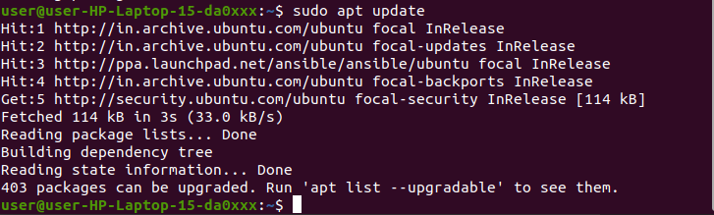

Step 2: Enter

*sudo apt install build-essential*

build-essential is called a meta-package. It in itself does not install anything. Instead, it is a link to several other packages that will be installed as dependencies. In the case of the build-essential meta-package, it will install everything required for compiling basic software written in C and C++..

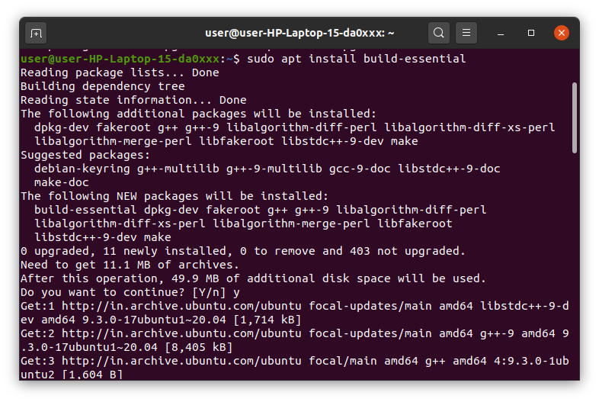

Step 3: Enter

*cd /usr/local/src/*

The cd command, also known as chdir (change directory), is a command-line shell command used to change the current working directory in various operating systems.

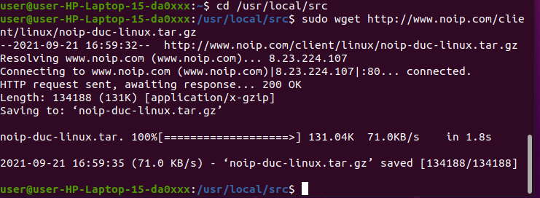

Step 4: Enter

*sudo wget http://www.noip.com/client/linux/noip-duc-linux.tar.gz*

The wget command is a command line utility for downloading files from the Internet. It supports downloading multiple files, downloading in the background, resuming downloads, limiting the bandwidth used for downloads and viewing headers.



Step 5: Enter

*sudo tar xf noip-duc-linux.tar.gz and cd noip-2.1.9-1/*

The Linux ‘tar’ stands for tape archive, is used to create Archive and extract the Archive files. tar command in Linux is one of the important commands which provides archiving functionality in Linux. We can use Linux tar command to create compressed or uncompressed Archive files and also maintain and modify them.

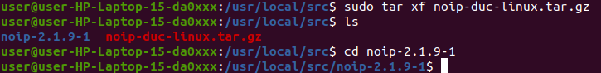

Step 6: Enter

*sudo make install*

The make install command will copy the built program, and its libraries and documentation, to the correct locations.

**Deploy Linux VM using Ansible Playbook**

**What is Ansible ?**

* Ansible is a simple open source IT engine which automates application deployment, intra service orchestration, cloud provisioning and many other IT tools.
* Ansible is easy to deploy because it does not use any agents or custom security infrastructure.
* Ansible uses playbook to describe automation jobs, and playbook uses very simple language i.e. YAML (It’s a human-readable data serialization language & is commonly used for configuration files, but could be used in many applications where data is being stored)which is very easy for humans to understand, read and write. Hence the advantage is that even the IT infrastructure support guys can read and understand the playbook and debug if needed (YAML – It is in human readable form).
* Ansible is designed for multi-tier deployment. Ansible does not manage one system at a time, it models IT infrastructure by describing all of your systems as interrelated. Ansible is completely agentless which means Ansible works by connecting your nodes through ssh(by default). But if you want another method for connection like Kerberos, Ansible gives that option to you.
* After connecting to your nodes, Ansible pushes small programs called “Ansible Modules”. Ansible runs that module on your nodes and removes them when finished. Ansible manages your inventory in simple text files (These are the hosts file). Ansible uses the hosts file where one can group the hosts and can control the actions on a specific group in the playbooks.

**How do Ansible playbooks work?**

* Ansible works by connecting to your nodes and pushing out small programs, called "Ansible modules" to them. Ansible then executes these modules (over SSH by default), and removes them when finished. Your library of modules can reside on any machine, and there are no servers, daemons, or databases required.

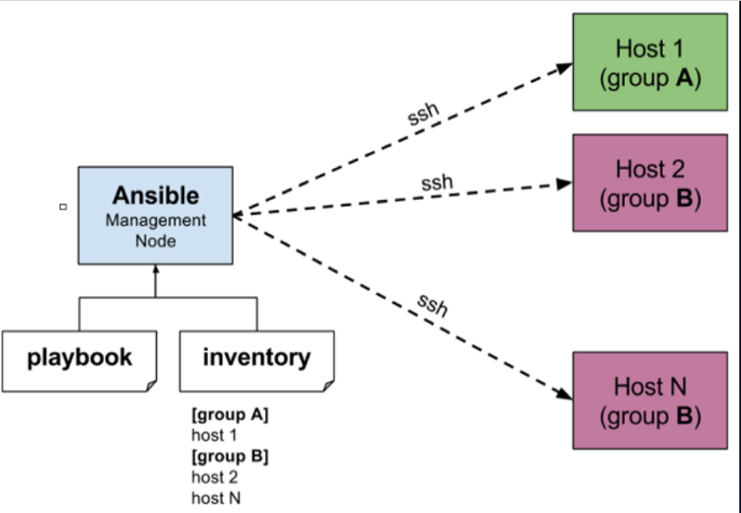

**Installation Process**

* Ansible can be run from any machine with Python 2 (versions 2.6 or 2.7) or Python 3 (versions 3.5 and higher) installed.
* Ansible can be installed on control machines which have above mentioned requirements in different ways. You can install the latest release through Apt, yum, pkg, pip, OpenCSW, pacman,etc.

**Installation through Apt on Ubuntu Machine**

* For installing Ansible you have to configure PPA on your machine. For this, you have to run the following line of code:

*sudo apt-add-repository ppa:ansible/ansible*

*sudo apt update*

*sudo apt install ansible*

**Setting up Inventory File**

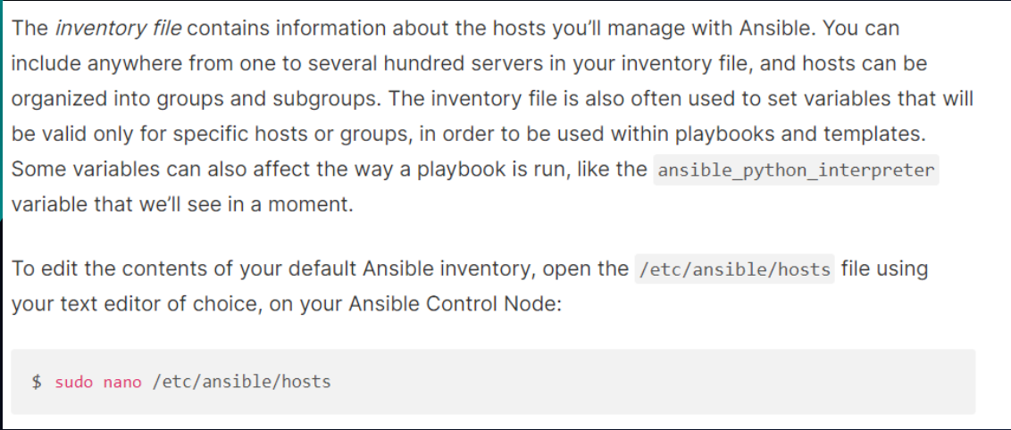

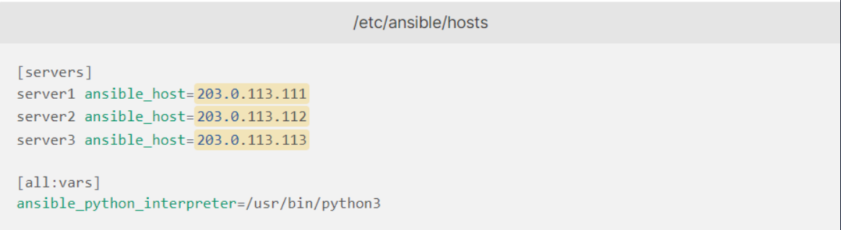

*ansible-inventory --list -y*

**Testing Connection**

* After setting up the inventory file to include your servers, it’s time to check if Ansible is able to connect to these servers and run commands via SSH.
* You can use the -u argument to specify the remote system user. When not provided, Ansible will try to connect as your current system user on the control node.

*ansible all -m ping -u root*

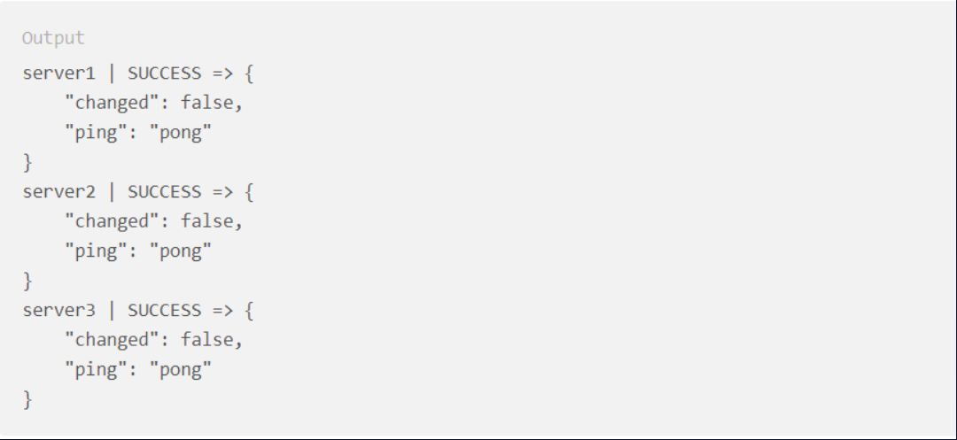

**PaaS (Platform-as-a-Service)**

* Platform-as-a-service (PaaS) is a model of cloud service delivery where a third-party cloud service provider delivers some hardware and software tools, often those needed for application hosting or development, to customers over the internet. The key benefit of the PaaS model is that it enables users to access hardware and software that can be used to develop and run applications without having to purchase, install and maintain the infrastructure.

**Microsoft Azure**

* Microsoft Azure, formerly known as Windows Azure, is Microsoft's public cloud computing platform. It provides a range of cloud services, including compute, analytics, storage and networking. Users can pick and choose from these services to develop and scale new applications, or run existing applications in the public cloud.
* The Azure platform aims to help businesses manage challenges and meet their organizational goals. It offers tools that support all industries -

- including e-commerce, finance and a variety of Fortune 500 companies

-- and is compatible with open source technologies. This provides users with the flexibility to use their preferred tools and technologies. In addition, Azure offers 4 different forms of cloud computing: infrastructure as a service (IaaS), platform as a service (PaaS), software as a service (SaaS) and serverless.

**What is Microsoft Azure used for?**

* Microsoft Azure consists of numerous service offerings, its use cases are extremely diverse. Running virtual machines or containers in the cloud is one of the most popular uses for Microsoft Azure. These compute resources can host infrastructure components, such as domain name system (DNS) servers; Windows Server services -- such as Internet Information Services (IIS); or third-party applications. Microsoft also supports the use of third-party operating systems, such as Linux.
* Azure is also commonly used as a platform for hosting databases in the cloud. Microsoft offers serverless relational databases such as Azure SQL and non-relational databases such as NoSQL.
* In addition, the platform is frequently used for backup and disaster recovery. Many organizations use Azure storage as an archive in order to meet their long-term Data retention requirements.

**AZURE SERVICES**

* Microsoft sorts Azure cloud services into nearly two dozen categories, including:
* **Compute.** These services enable a user to deploy and manage VMs, containers and batch jobs, as well as support remote application access. Compute resources created within the Azure cloud can be configured with either public IP addresses or private IP addresses, depending on whether the resource needs to be accessible to the outside world.
* **Mobile.** These products help developers build cloud applications for mobile devices, providing notification services, support for back-end tasks, tools for building application program interfaces (APIs) and the ability to couple geospatial context with data.
* **Web.** These services support the development and deployment of web applications. They also offer features for search, content delivery, API management, notification and reporting.
* **Storage.** This category of services provides scalable cloud storage for structured and unstructured data. It also supports big data projects, persistent storage and archival storage.
* **Analytics.** These services provide distributed analytics and storage, as well as features for real-time analytics, big data analytics, data lakes, machine learning (ML), business intelligence (BI), internet of things (IoT) data streams and data warehousing.
* **Networking.** This group includes virtual networks, dedicated connections and gateways, as well as services for traffic management and diagnostics, load balancing, DNS hosting and network protection against distributed denial-of-service (DDoS) attacks.
* **Media and content delivery network (CDN).** These CDN services include on-demand streaming, digital rights protection, encoding and media playback and indexing.
* **Integration.** These are services for server backup, site recovery and connecting private and public clouds.
* **Identity.** These offerings ensure only authorized users can access Azure services and help protect encryption keys and other sensitive information in the cloud. Services include support for Azure Active Directory and multifactor authentication (MFA).
* **Internet of things.** These services help users capture, monitor and analyze IoT data from sensors and other devices. Services include notifications, analytics, monitoring and support for coding and execution.
* **DevOps.** This group provides project and collaboration tools, such as Azure DevOps -- formerly Visual Studio Team Services -- that facilitate DevOps software development processes. It also offers features for application diagnostics, DevOps tool integrations and test labs for build tests and experimentation.
* **Development.** These services help application developers share code, test applications and track potential issues. Azure supports a range of application programming languages, including JavaScript, Python, .NET and Node.js. Tools in this category also include support for Azure DevOps, software development kits (SDKs) and blockchain.
* **Security.** These products provide capabilities to identify and respond to cloud security threats, as well as manage encryption keys and other sensitive assets.
* **Artificial intelligence (AI) and machine learning.** This is a wide range of services that a developer can use to infuse artificial intelligence, machine learning and cognitive computing capabilities into applications and data sets.
* **Containers.** These services help an enterprise create, register, orchestrate and manage huge volumes of containers in the Azure cloud, using common platforms such as Docker and Kubernetes.
* **Databases.** This category includes Database as a Service (DBaaS) offerings for SQL and NoSQL, as well as other database instances -- such as Azure Cosmos DB and Azure Database for PostgreSQL. It also includes Azure SQL Data Warehouse support, caching and hybrid database integration and migration features. Azure SQL is the platform's flagship database service. It is a relational database that provides SQL functionality without the need for deploying a SQL server.
* **Migration**. This suite of tools helps an organization estimate workload Migration costs and perform the actual migration of workloads from local data centers to the Azure cloud.
* **Management and governance.** These services provide a range of backup, recovery, compliance, automation, scheduling and monitoring tools that can help a cloud administrator manage an Azure deployment.
* **Mixed reality.** These services are designed to help developers create content for the Windows Mixed Reality environment.
* **Blockchain.** The Azure Blockchain Service allows you to join a blockchain consortium or to create your own.

**VM DEPLOYMENT WITHOUT ANSIBLE**

*HOME PAGE OF AZURE*

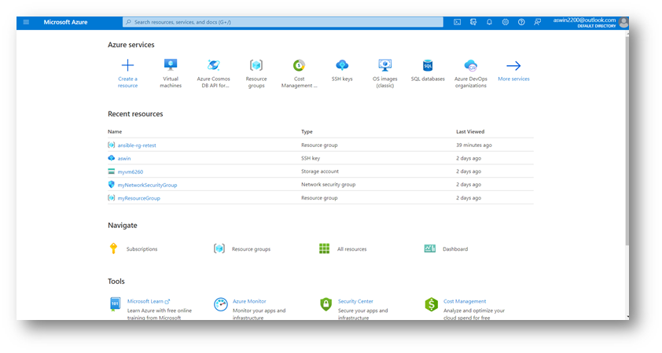

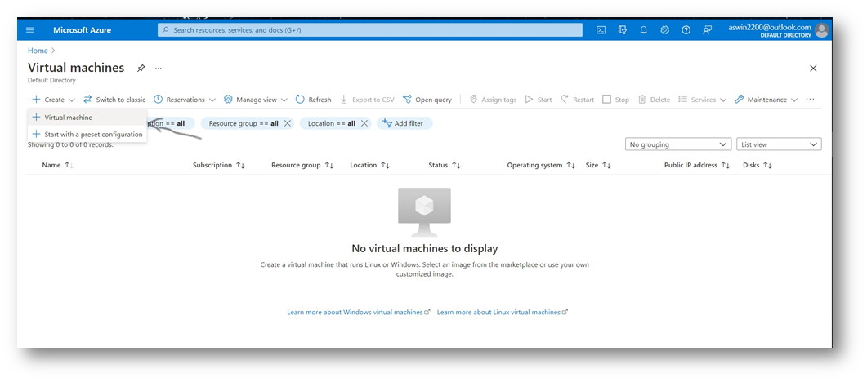

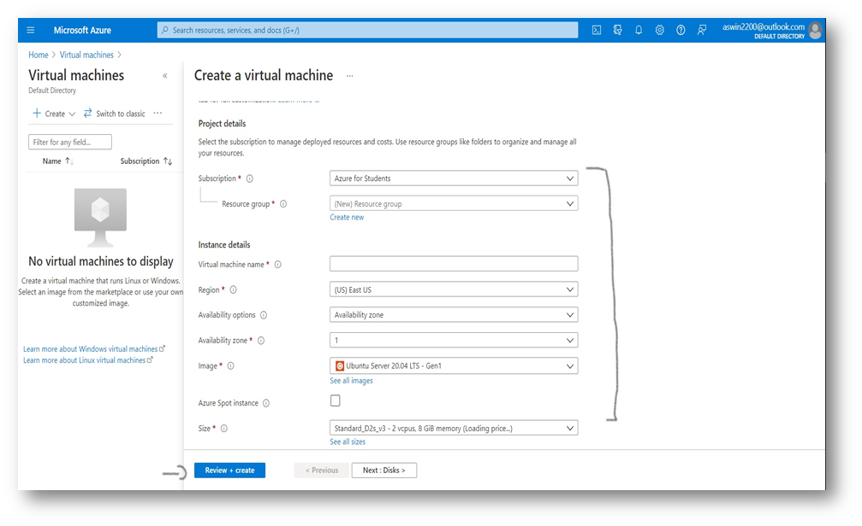

**USING ANSIBLE**

* For Queries, go to:

https://docs.microsoft.com/en-us/azure/developer/ansible/vm-configure?tabs=ansible

* To Configure LINUX VM Using Ansible Playbook ,

First we need an azure account, to get a free account:

https://azure.microsoft.com/en-in/free/

* Create a resource group
* Create a virtual network
* Create a public IP address
* Create a network security group
* Create a virtual network interface card
* Create a virtual machine

-Open The Azure Shell, we can directly run Ansible in Azure Cloud Shell, where Ansible is pre-installed.

-In case not installed,

# Update all packages that have available updates.

*sudo yum update –y*

# Install Python 3 and pip.

*sudo yum install -y python3-pip*

# Upgrade pip3.

*sudo pip3 install --upgrade pip*

# Install Ansible.

*pip3 install "ansible==2.9.17“*

# Install Ansible azure_rm module for interacting with Azure.

*pip3 install ansible[azure]*

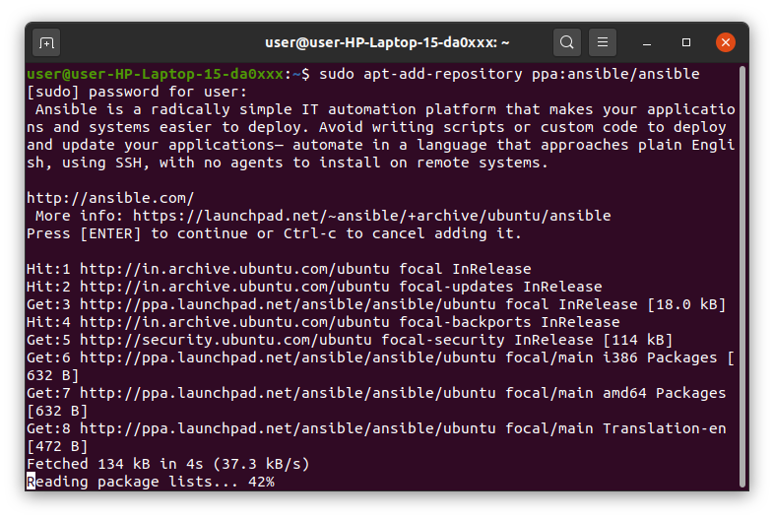

**ASSIGNMENT**

**1.** List 3 different protocols that appear in the protocol column in the unfiltered packet-listing window. Support your answer with an appropriate screenshot from your computer.

**SOLUTION**

The following protocols appeared in the protocol column in the unfiltered packet listing window after downloading a webpage: TCP, UDP, HTTP, DNS.

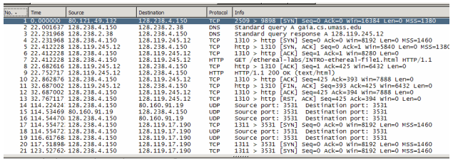

**2**. How long did it take from when the HTTP GET message was sent until the HTTP OK reply was received? (By default, the value of the Time column in the packet-listing window is the amount of time, in seconds, since Wireshark tracing began. To display the Time field in time-of-day format, select the Wireshark View pull down menu, then select Time Display Format, then select Time-of-day.)

**SOLUTION**

If we look at the frame section of the GET request we see that the time the packet arrived is 11:43:13.422848000

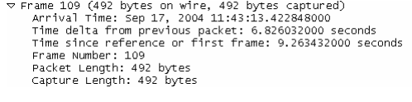

The same section for the HTTP OK shows an arrival time of

11:43:13.43960400

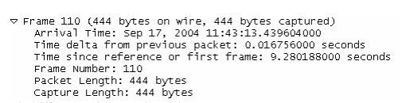

The difference of these 2 times gives .43960400 - .426032000 = 0.013572 seconds

**3.** What is the Internet address of the gaia.cs.umass.edu? What is the Internet address of your computer? Support your answer with an appropriate screenshot from your computer.

**SOLUTION**

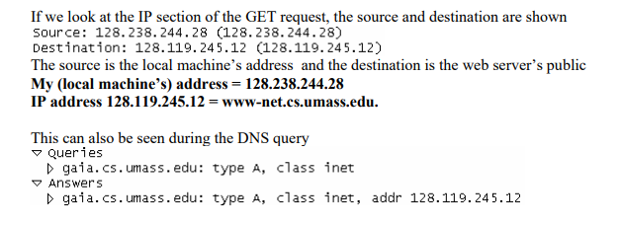

**4.** Print the two HTTP messages (GET and OK) referred to in question 2 above. To do so, select Print from the Wireshark File command menu, and select the “Selected Packet Only” and “Print as displayed” radial buttons, and then click OK

**SOLUTION**

Here is the information for the HTTP GET and OK packets:

**HTTP GET:**

Frame 4 (862 bytes on wire, 862 bytes captured)

Ethernet II, Src: Netgear_61:8e:6d (00:09:5b:61:8e:6d), Dst: WestellT_9f:92:b9

(00:0f:db:9f:92:b9)

Internet Protocol, Src: 192.168.1.46 (192.168.1.46), Dst: 128.119.245.12

(128.119.245.12)

Transmission Control Protocol, Src Port: 1474 (1474), Dst Port: http (80), Seq: 1,

Ack: 1, Len: 808

Hypertext Transfer Protocol

GET /wireshark-labs/INTRO-wireshark-file1.html HTTP/1.1\r\n

Host: gaia.cs.umass.edu\r\n

User-Agent: Mozilla/5.0 (Windows; U; Windows NT 5.1; en-US; rv:1.8.1.4)

Gecko/20070515 Firefox/2.0.0.4\r\n

Accept:

text/xml,application/xml,application/xhtml+xml,text/html;q=0.9,text/plain;q=0.8,im

age/png,*/*;q=0.5\r\n

Accept-Language: en-us,en;q=0.5\r\n

Accept-Encoding: gzip,deflate\r\n

Accept-Charset: ISO-8859-1,utf-8;q=0.7,*;q=0.7\r\n

Keep-Alive: 300\r\n

Connection: keep-alive\r\n

**HTTP OK:**

Frame 6 (439 bytes on wire, 439 bytes captured)

Ethernet II, Src: WestellT_9f:92:b9 (00:0f:db:9f:92:b9), Dst: Netgear_61:8e:6d

(00:09:5b:61:8e:6d)

Internet Protocol, Src: 128.119.245.12 (128.119.245.12), Dst: 192.168.1.46

(192.168.1.46)

Transmission Control Protocol, Src Port: http (80), Dst Port: 1474 (1474), Seq: 1,

Ack: 809, Len: 385

Hypertext Transfer Protocol

HTTP/1.1 200 OK\r\n

Date: Thu, 07 Jun 2007 18:09:01 GMT\r\n

Server: Apache/2.0.52 (CentOS)\r\n

Last-Modified: Thu, 07 Jun 2007 18:08:01 GMT\r\n

ETag: "d6c69-50-cb94a240"\r\n

Accept-Ranges: bytes\r\n

Content-Length: 80

Keep-Alive: timeout=10, max=100\r\n

Connection: Keep-Alive\r\n

Content-Type: text/html; charset=ISO-8859-1\r\n

\r\n

Line-based text data: text/html

**5.** How many HTTP GET request messages did your browser send? Which packet number in the trace contains the GET message for the Bill or Rights?Which packet number in the trace contains the status code and phrase associated with the response to the HTTP GET request? What is the status code and phrase in the response?

**SOLUTION**

**●** My browser only sent 1 HTTP GET request to the server. The Packet that contained the GET message was packet number 4730

●The packet that contains the status code and phrase which the server sent in response to the GET message was packet number 4733

● The code and phrase in the response was 304 Not Modified

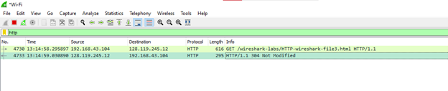

**6.** How many data-containing TCP segments were needed to carry the single HTTP response and the text of the Bill of Rights?Is there any HTTP header information in the transmitted data associated with TCP segmentation? For this question you may want to think about at what layer each protocol operates, and how the protocols at the different layers interoperate.

**SOLUTION**

The data was sent in 1 TCP segments to the browser

